Upcoming Events/Reminders
Author visit, Connie Reza - November 20
Thanksgiving Holidays – November 21-23
Kindergarten Formative Assessment – November 19 and 20
Conscious Discipline training – November 19 and 26
November AttenDANCE and teacher drawing – November 30
Health Screening – December 3

Ms. Blessinger’s session on Attendance during early release provided everyone an opportunity to brainstorm some strategies to increase our daily attendance rate.

This is a very special time of the year in which we show how much we care about our family and friends through the act of sharing a meal. Think about the simplicity of the action, but the great meaning it truly conveys. It is not about presents. It is about the gift of time. Take the time to thank someone in your life.
I give thanks for having the privilege of working with such dedicated individuals.

What are you thankful for?

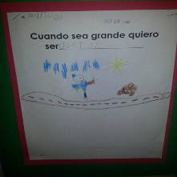
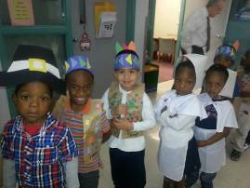
Halpin Early Childhood Center
Faculty and Staff Newsletter
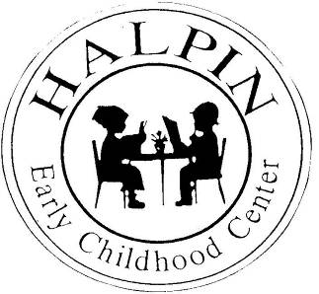
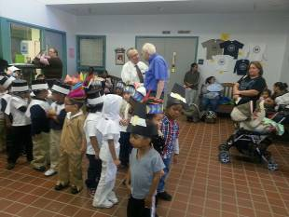

Attendance Goal

95%

Weekly
Attendance %

8/27 | 96.9%
9/4 | 94.4%
9/10 | 94.31%
9/17 | 92.79%
9/24 | 92.87%
10/1 | 95.6%
10/8 | 94.8%
10/15 | 94.6%
10/22 | 93.8%
10/29 | 94.4%
11/5 | 94.07%
11/12 | 93.6%

November 19, 2012
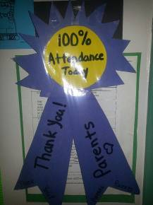
Ms. Turner provides hands-on experiences as it relates to fairy tales.
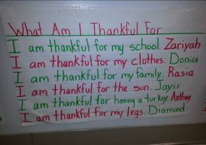
Ms. Smith’s class gives thanks.
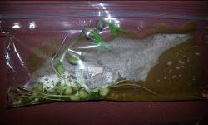
Thank you Ms. Turner for getting us started on the right path to creating a school-wide discipline management tool kit. The information shared during our early release is vital in understanding by law what we are allowed and not allowed to do. Now we will form our Discipline Committee to discuss and create our school-wide system utilizing Conscious Discipline strategies.
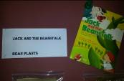
Houston Community Service Club helps 150 Halpin families with Thanksgiving meals
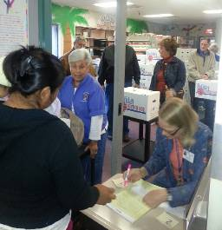
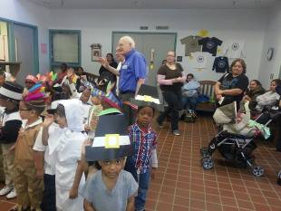
Thank you, Ms. Lorence for organizing this wonderful event for our community.
Ms. Leyva celebrates perfect attendance.
Ms. Lin connects student current PK goals with long-term goals.
Ms. Sonier proudly displays student Language Arts and Science connection outside her classroom.

