Upcoming Events/Reminders
Early Voting starts today, October 22nd – November 2nd.
Early Release on October 24th. Topic: PK will have Hatch training and
Kindergarten will start Report Card conferences.
Remind students of Popcorn Treat on Fridays if the class has 100% attendance.
Remember we announce and celebrate daily attendance.
“Scare Away Drugs” parade this Friday, October 26th.
October 30th and November 15th – Team Created Kindergarten Diagnostic Assessments will be administered for Language Arts and Mathematics.

Thank you Ms. Blessinger for taking a vision and making it a reality!!!
Thanks to everyone that participated in the creation of this wonderful celebration board.

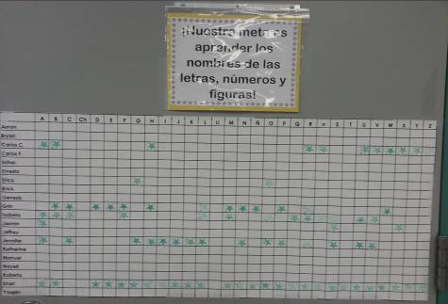
So many opportunities for learning!
NOW
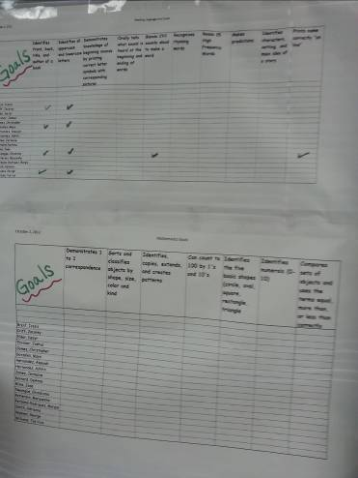
Halpin Early Childhood Center
Faculty and Staff Newsletter
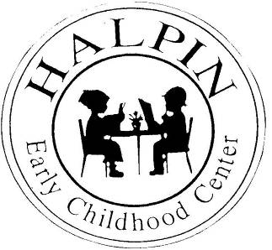
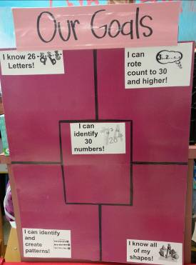
Attendance Goal

95%

Weekly
Attendance %

8/27 | 96.9%
9/4 | 94.4%
9/10 | 94.31%
9/17 | 92.79%
9/24 | 92.87%
10/1 | 95.6%
10/8 | 94.8%
10/15 | 94.6%

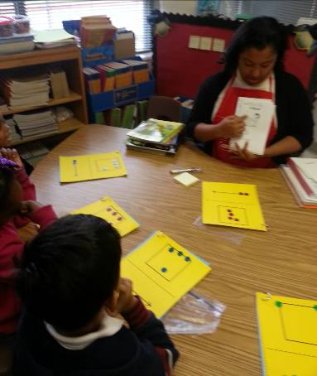
October 22, 2012
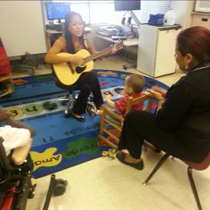
Neuhaus: Small Group
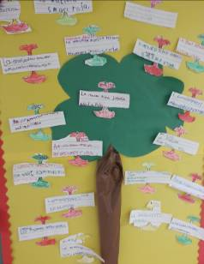
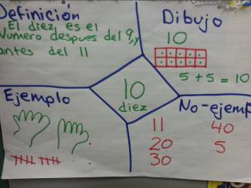
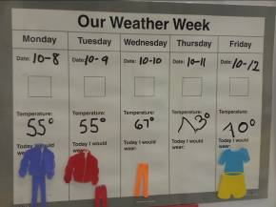
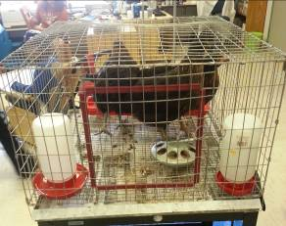

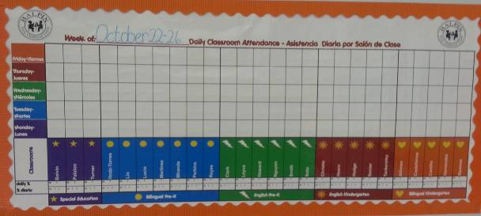
Please use the daily attendance celebration board to place your
Halpin Logo
and proudly display your daily participation in the 100% Perfect Attendance Club.

