Assessing Asthma Severity:
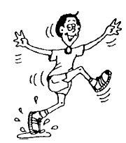

Well controlled asthma:
No cough
No wheeze
No chest tightness
No limitation of activity
Peak flow within 20% of personal best

Mild asthma symptoms:
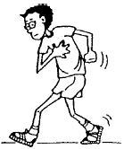
Requires medical attention if persistent.
Child should not engage in vigorous activity.
Occasional cough
Slight wheeze
May be a tickle in the throat
Peak flow 50% to 80% of personal best

Moderate to severe asthma symptoms –
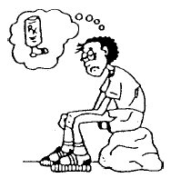
Requires URGENT medical attention – Call parents!
Persistent cough
Persistent wheeze
Breathing faster than normal (more than 30 breaths in a minute)
Waking at night due to difficulty breathing
Peak flow near 50% of personal best

Danger signs:
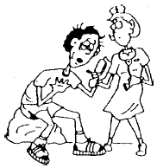
Requires IMMEDIATE medical attention – call 911!!
Difficulty speaking more than 1 or 2 words between breaths
Hard to walk more than a few steps due to difficulty breathing
Chest or belly sucking in with each breath
Nostrils flaring out with each breath
Breathing very fast (more than 40 breaths in a minute)
Lips or fingers turning blue
Peak flow significantly below 50% of personal best

A child who is having breathing problems from asthma should NEVER be left alone!!

