Rice Storytelling
Congrats to Ms. Nguyen for participating in this project this year!

houstonisd.org/yourvoice
Today, May 20th, is the last day to fill out the survey!


Halpin Early Childhood Center
Faculty and Staff Newsletter
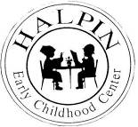
Attendance Goal
95%

Weekly
Attendance %
3/18 | 95.3%
3/25 | 95.3%
4/01 | 95.3%
4/08 | 95%
4/15 | 96.2%
4/22 | 95.3%
4/29 | 95.1%
5/06 | 95.6%
5/13 | 94%

May 20, 2013
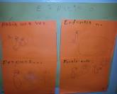
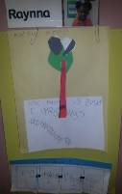
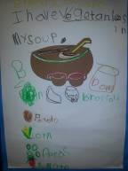
Upcoming events

Faculty Meeting – Monday, May 20th at 3:45
Award Ceremony Practice – Tuesday, May 21st
PLC Meetings: PK on Tuesday, May 21st (Review Handbook)
K on Wednesday, May 22nd (Tinsley Guided Reading in Parent Center and Review Handbook)
SDMC Meeting – Wednesday, May 22nd at 3:45
Ms. Lorence’s Retirement Reception – Friday, May 24th Café Piquet
Memorial Day Holiday – Monday, May 27
PK Planning Meeting – Thursday, May 30th at 3:45
Kinder Planning Meeting – Saturday, June 1st from 9:00 to 2:00
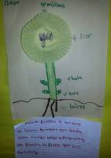
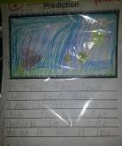
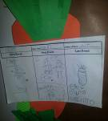
Writing and Science
Connections Everywhere!
