We hope that you truly feel appreciated this and every week here at Halpin. I know the work cannot happen without your passion and dedication of setting high expectations for our students. You sometimes don’t see or hear the positive impact you have on students. Just last week, Ms. Lorence, received a phone call from a former PK student inviting her to his high school graduation. Amazing!!!
YOU MAKE A DIFFERENCE EVERY DAY IN THE LIFE OF STUDENTS!
Teacher Appreciation Breakfast
We have many things planned for you this week. A flyer was placed in your box. Additional surprised are not on the flyer.

Halpin Early Childhood Center
Faculty and Staff Newsletter

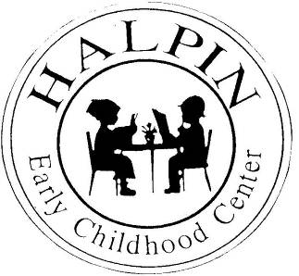
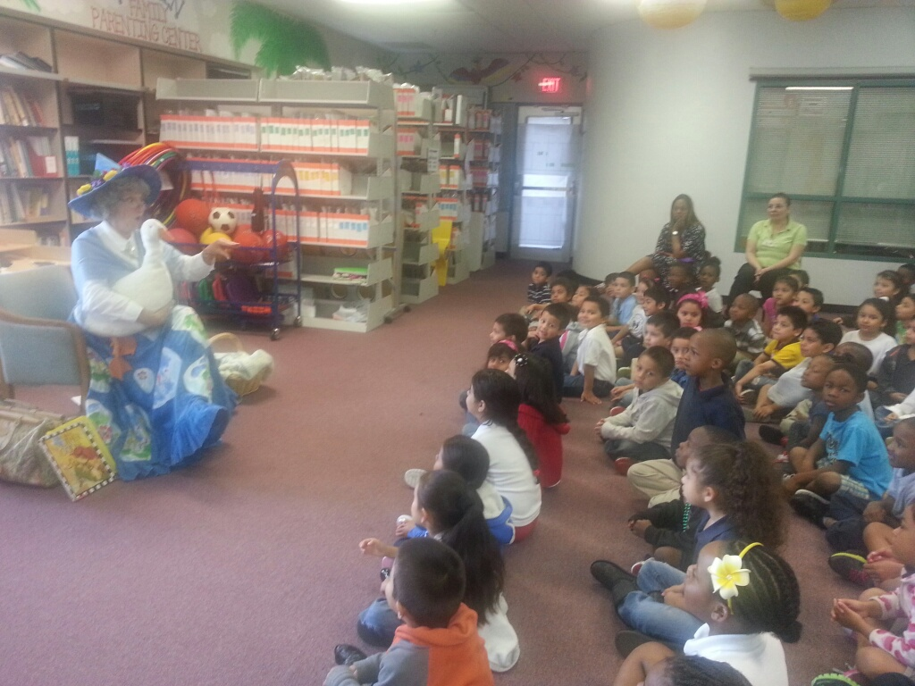
May 6, 2013
Attendance Goal
95%

Weekly
Attendance %
3/18 | 95.3%
3/25 | 95.1%
4/01 | 95.2%
4/08 | 95.9%
4/15 | 96%
4/22 | 95.3%
4/29 | 95%

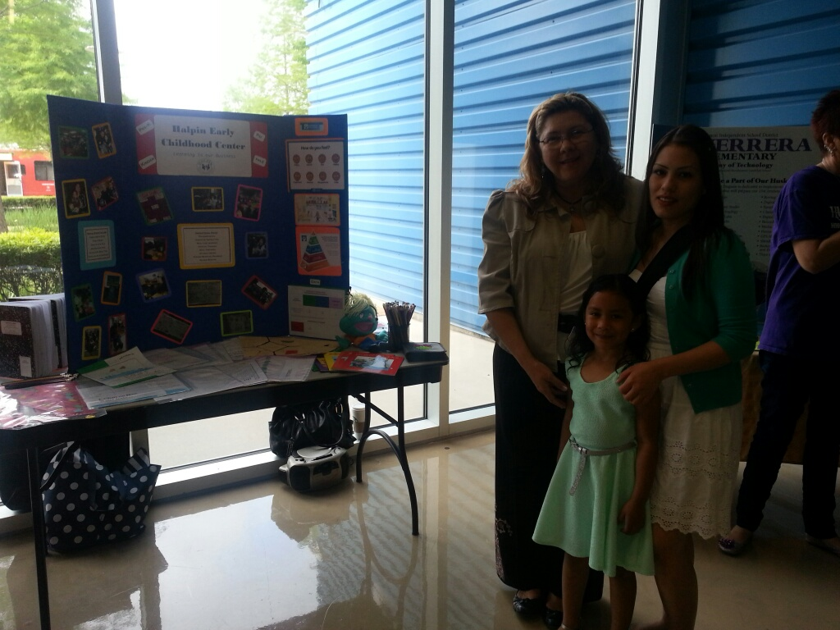
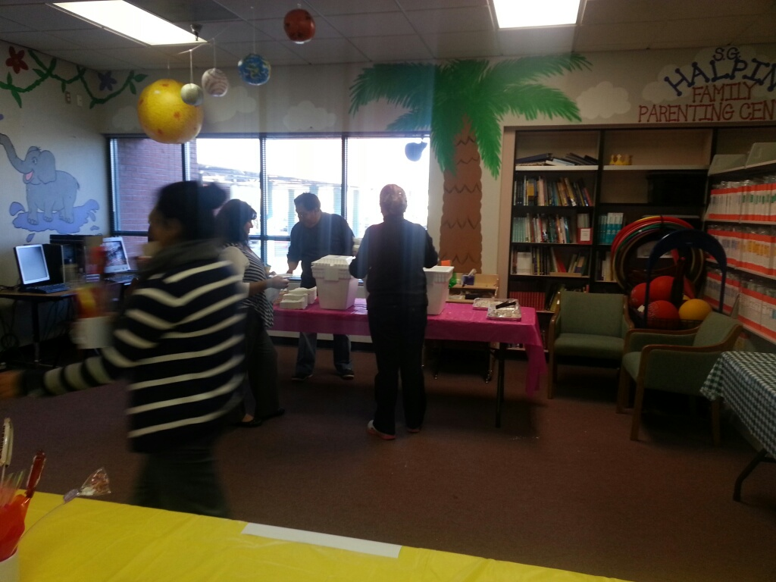
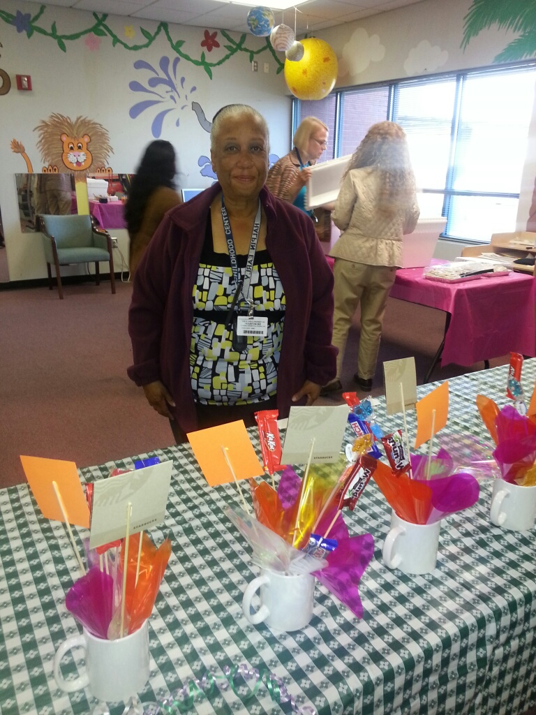
Upcoming events

Teacher Appreciation Week – May 6 - 10
SMART Board Training – Monday, May 13 and Wednesday, May 15


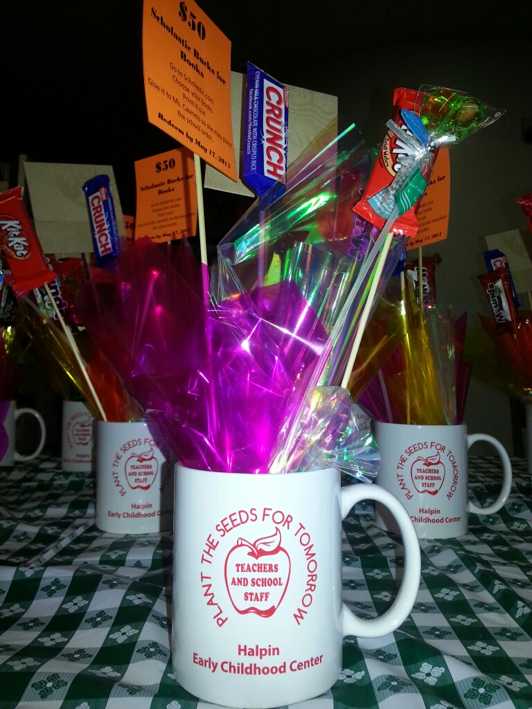
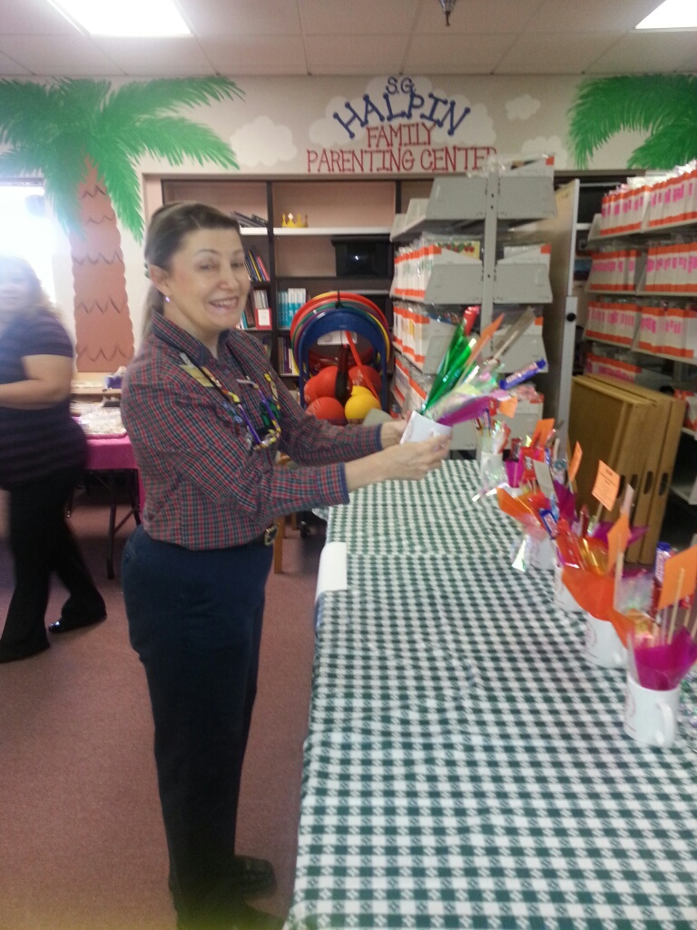
School Choice Fair
Mother Goose
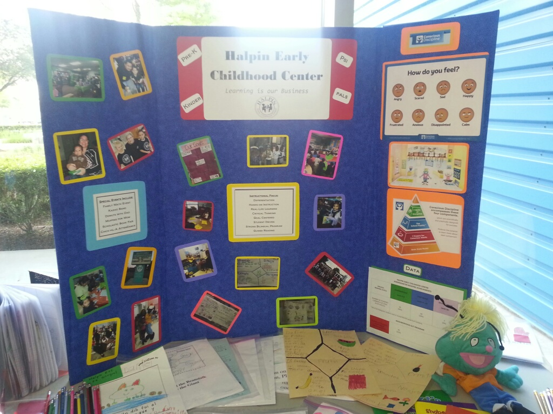
Halpin’s 2013 Teachers of the Year

Ms. Sonier
Ms. Y. Hernandez
Ms. Lucio
Ms. Nguyen
THANK YOU!!!

