*******************

Cheerleader/Mascot

Constitution

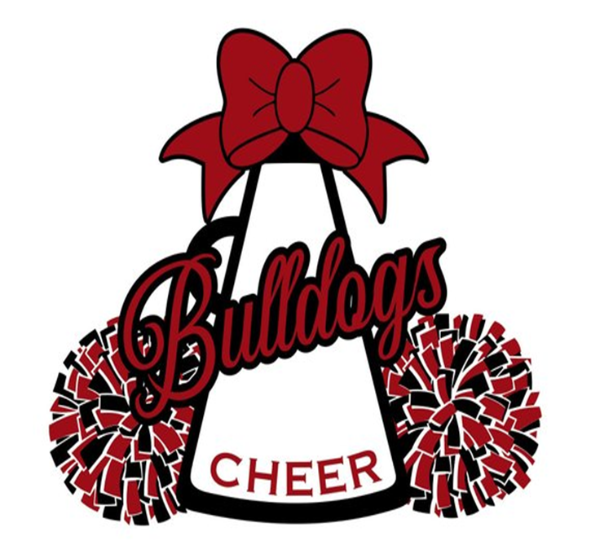

***2022-2023***

***Uniform Payment Schedule***

It must be understood that expenses will be incurred in cheerleading. Much of this expense must be borne by the

individual and his/her family. Those things purchased by the individual will become his/her own property. Those

things purchased by the school or the cheerleading organization will become the property of the Heights High

School Cheerleading organization. Every cheerleader will be expected to support all fundraising events that support the team.

Companies who sell cheerleader uniforms and supplies require payment before custom uniforms and camp wear

are made. Since we need our camp wear in July, we must have payment turned by Friday, May 6, 2022.

Being on **Varsity**, you will be expected to pay the total payment of **$950** to Heights Cheer/Mascot Booster Club on **May 6, 2022**. If selected on **JV**, you be expected to pay the total payment of **$850.** If selected to be the **Mascot**, you will be expected to pay the total payment of **$500** to Heights Cheer/Mascot Booster on **May 6**. The fitting will also be held on May 6. The specified total amount must be paid at the correct time to assure that the uniforms arrive on time; otherwise, your Heights High School Cheer Squad will not be able to perform during the scheduled games for the season. You may pay at an earlier time during the parent meeting **March 26, 2022**.

***Extracurricular Activities Agreement***

Participation in extracurricular activities is a privilege, not a right! Extracurricular activities are offered as extensions of a student's educational, social, and emotional needs. Extracurricular activities are important in teaching the basic essentials of teamwork, a spirit of cohesiveness, pride in school, positive self-image, responsibility, and quality character building.

A student who violates the law, or the Student Code of Conduct, by possessing, using, or delivering alcohol or illegal drugs at any time during the calendar year will be subject to disciplinary actions on the first offense. Any additional occurrences during the calendar year will result in the immediate dismissal from all extracurricular activities for the remainder of the school year or season, whichever is later. The removal from extracurricular activities applies whether the illegal action occurred at a school event or an event outside the school campus boundaries or facilities. No individual exceptions will be made.

***Acknowledgement of Constitution/Code of Conduct Schedule***

This constitution was created as a guide for the expectations of cheerleaders at Heights High School.

It is not intended to be used as a tool against anyone or his/her beliefs but instead to protect those

who wish to do all they can to keep cheerleading the honorable positions it should be.

A student's signature signifies that he/she has read and understands the constitution/code of

conduct schedule and, if selected, will do his/her best to abide by these rules and expectations.

Parents should understand that if their child is selected as cheerleader or mascot, their help is

vital to the organization's success. Prompt payment on accounts and support in following the

guidelines set forth in this constitution/code of conduct are expected.

Parent's signatures signify that they have read and understand the constitution/code of conduct

and, if their child is selected, will do their best to support the organization and see that their child

abides by these rules.

***Hazing Awareness Agreement***

HAZE OR HAZING: To intimidate by physical punishment, to harass or try to embarrass or disconcert by banter, ridicule, or criticism, treatment intended to put in ridiculous or disconcerting positions.

Because of the increase in occurrences of hazing, and for the safety of our students, we have

created this document. By signing this document, you are agreeing to the expected behavior of

the cheerleader in respect to any involvement that he/she might have during the calendar year that

involves hazing. Hazing is an illegal action that will not be tolerated in any way. Any cheerleader

caught hazing will be immediately suspended for the year from cheerleading and will not be

allowed to try out any of the remaining years he/she is enrolled in Heights High School.

I understand fully the contents of this document and the punishment that will be enforced if I do

not follow the rules set forth.

***Cheerleader/Mascot***

Congratulations. . . .

Cheerleading is one of the most rewarding and educational activities in which you could participate. Accepting this position brings the tremendous responsibilities of representing Heights High School and the entire Heights community. Both the school and the community expect a great deal from their cheerleaders/mascot, and you must be willing to live up to the highest expectations set by them, the squad, and yourself.

Your responsibility as a cheerleader/mascot will take a large amount of your personal time and effort.

While it will also interfere with family time, it is our hope that your family will be part of your activities as well. We expect you to be mature enough to budget your time among all the activities to which you are committed.

**Important Dates:**

**March 7-10, 2022 Cheer Skills Clinic Heights Gym**

**March 21-23, 2022 Cheer Try-Out Materials Heights Gym**

**March 24, 2022 Cheer Try-Outs Heights Gym**

**March 25, 2022 Cheer Squad Results Outside Gym Doors**

**March 26, 2022 Cheer/Parent Meeting TBD**

**May 6, 2022 Cheer Payment Due TBD**

**June 8-10, 2022** **Mandatory Summer Cheer/Mascot Practice**  **Practice Gym**

**June 13-16, 2022 Mandatory Summer Cheer/Mascot Practice Practice Gym**

**June 20-23, 2022** **Mandatory Summer Cheer/Mascot Practice Practice Gym**

**June 27-30,2022 Mandatory Summer Cheer/Mascot Practice Practice Gym**

**July 25-27, 2022 Mandatory Summer Cheer/Mascot Camp Iowa Colony HS**

**August 1-4, 2022 Season Begins (Demerit Season Begins) Outside**

**August 8-12, 2022 Practice every day begins**

**Heights High School**

**Cheerleader Constitution**

Being a cheerleader is an honor and a privilege. It is the purpose of cheerleaders to promote

good sportsmanship and good citizenship. They are also, first and foremost, representatives of

Heights High School and should conduct themselves accordingly. Members of the squad have a fundamental responsibility to play a leadership role in building teamwork and helping the school

achieve its goals and objectives. Because of these responsibilities, members of the cheerleading

squad will be expected to maintain a higher standard of behavior, both on and off campus, and

academic achievement than that of their peers.

Cheerleaders are expected to be physically and mentally skilled in learning and remembering

cheers. They are expected to be able to publicly demonstrate a skill level suitable for the team

position and the timing necessary for group performance. Off the field, they are to enthusiastically

support all athletic teams through advertisement, personal attitude, and attendance at events chosen

by the sponsor/coach and approved by the principal.

The rules and procedures outlined in this constitution are in effect from the time the student is

selected to the cheerleading squad until the next try-out date.

**Varsity Cheerleaders** will lead cheers and perform routines at scheduled varsity events and pep rallies. This includes volleyball games, girls’ and boys’ basketball games, football games, some baseball games, some soccer games, some softball games, all playoff games, and all other events deemed necessary by school administration or cheerleader coach. **Mascot(s)** will attend all events with Varsity Cheerleaders.

**Junior Varsity Cheerleaders** will attend designated home junior varsity and freshmen home games. If a Junior Varsity Cheerleader attends a Varsity game, they must be in uniform and there to help assist in leading the crowd with the Varsity cheerleaders. They will attend all other events deemed necessary by school administration or cheerleader coach.

**Service**

1. The squad member must possess the required number of credits, at the end of the spring semester when selected as cheerleader, in order to move on to the next academic classification for the following fall semester of service.

2. To serve, a squad member must meet and maintain UIL requirements: pass all subjects each six-week grading period. A grade check will be made at the end of each six-week period. If a cheerleader or mascot is not passing at the grade check, she cannot participate for the next three weeks. If she is passing all classes at the three week check, she will be allowed to rejoin her squad.

3. New squad members for the new season that have been selected to be a member of the cheerleading squad are expected to make a commitment to the activity for the full cheerleading year.

4. Demerits will be awarded for failure to meet the above criteria, such as failure to pass and failure to meet scheduled commitments.

5. Cheerleaders and mascots must ride the school-provided transportation to and from all out of district games. Exceptions can be made if there are conflicting school sponsored events. A cheerleader may be released to his/her parent after a performance by signature or signed release form.

6. Cheerleaders/mascot must report to a sponsor/coach if he/she is unable to attend a scheduled practice,

game, or other activity. This notification is to be made as soon as possible **prior** to the scheduled activity.

7. It is the responsibility of the cheerleader/mascot to acquire the information about uniforms and meeting times.

8. Attendance at summer camp is **mandatory**.

9. Demerits will be issued in cases where a cheerleader has failed to perform any of the duties listed above or any other duties dictated by the sponsor/coach.

**Expectation**s

1. Financial expense is considered part of a cheerleader’s responsibility. Money owed must be paid in full by May 6th.

2. Cheerleader/mascot is expected to have a spirited attitude and be dedicated with their time.

3. Cheerleader/mascot will not use his/her role to take advantage of any teacher or school rule.

4. Each cheerleader/mascot is expected to express his/her own opinion, listen to the opinion of others, respect the minority, and accept the will of the majority/higher authority with sincerity, spirit, and trust.

5. All cheerleaders/mascots must conduct themselves in a manner to reflect credit to Heights High School. Failure to do so will result in disciplinary action or dismissal.

6. Social Media, such as Facebook, Twitter, Instagram, Snapchat, and any other not listed, is a reflection

of you and your activities. If you choose to participate in this program you are representing Heights High School cheer. All photographs and written posts need to be school appropriate.

7. Demerits will be issued for failure to meet the above expectations.

**Demerit System**

Demerits are the means by which the **sponsor/coach** determines which members are not fulfilling the]uhir

obligations to the squad. A total of **five (5) demerits** will result in **one-week suspension**, a total of

**seven (7) demerits** will result in **two-week suspension**, and a total of **ten (10) demerits** will result in **removal from the squad and not allowed to try out for the following year**.

**A. Drug/Alcohol Related Offenses**

1. Smoking, drinking, use of drugs while not in uniform in any form, including, but not limited to visual observation and/or social media will result in the following:

a. 1st Offense: Removal from participating for the rest of the season but will attend games and sit on the sidelines.

b. 2nd Offense: **Dismissal**

2. Smoking, drinking, use of drugs while in uniform in any form, including, but not limited to

visual observation and/or social media will result in immediate **Dismissal**

**B. Attendance/Tardies/Academic Performance**

1. CL/M will not skip school. 5 demerits

2. CL/M will attend all practice/performances. 2 demerits

(Excused: school/UIL sponsored activity, illness/doctor permit, death in the family.

Unexcused: work/vacation, appointments, non-UIL/school related activity.)

3. CL/M will maintain a passing grade in all classes. 3 demerits

4. CL/M will be on time to class, practices, and performances. 1 demerit

*up to 5 minutes will be jumps*

5. CL/M will participate in all fundraisers with prior notice. 2 demerits

**C. Uniform/Student Dress**

1. CL/M will wear required/complete uniform. 1 demerit

2. CL/M will dress out for practice. 1 demerit

3. CL/M will not wear jewelry during performances/practices. 1 demerit

4. CL/M will not chew gum during performances/practices. 1 demerit

5. CL/M will wear hair up and secure. 1 demerit

**D. Conduct: School and Performance**

1. CL/M will show proper respect for sponsor/coach. 1 demerit

2. CL/M will follow directives by head cheerleader(s). 1 demerit

3. CL/M will refrain from profanity/obscene language including

postings on social media. 1 demerit

4. CL/M will refrain from public displays of affection. 1 demerit

5. CL/M will always show sportsmanlike conduct. 1 demerit

6. CL/M will perform assigned pre/post game duties. 1 demerit

7. CL/M will maintain proper sideline behavior: 1 demerit

a. Refrain from excessive talking. 1 demerit

b. Refrain from conversing with crowd/team. 1 demerit

c. Pay attention to game. 1 demerit

d. Show proper respect during school songs. 1 demerit

8. CL/M will return from halftime/breaks on time. 1 demerit

9. CL/M will not be sent to the office for disciplinary reasons. 2 demerits

10. CL/M Assignment to ISS. (Benched for 1 week) 5 demerits

11. CL/M will follow all school/classroom rules including dress code. 1 demerit

12. CL/M will be respectful to all teachers/staff members. 2 demerits

*Additional demerits/benching can also be assigned at sponsors’ discretion.

**E. Placement in DAEP**

1. Cheerleader/Mascot will be immediately dismissed.

2. Student is ineligible to tryout if assigned to DAEP during the current school year.

**F. Merits**

1. Cheerleaders/Mascot may go to Saturday school (if available) for 4 hours to forgive 2 demerits.

2. Cheerleaders/Mascot may run 2 miles to work off 1 demerit.

3. Any consequence worth 3 or more demerits may not be worked off.

*Additional demerits/benching can also be assigned at sponsors’ discretion.

The cheerleading/mascot constitution was reviewed and approved by a committee consisting of

administrators, athletic director, and sponsor/coach in the Spring of 2022.