# 

Social and Emotional Learning: Coordinating the growth of culturally-responsive and emotionally safe learning environments.

### OBjectives

1. Challenge **or** change your behavior lens.
2. Understand the difference between ***Power*** and ***Influence.***
3. Extend learning to transform behavior-shaping on your campus.

### challenge or Change your behaVIOR LENS

* Do behaviors occur because students won’t or can’t?
* Consequences teach basic lessons about right and wrong and give students an incentive to behave.
* Behavior occurs when the demands of the environment exceed the student’s capacity to respond adaptively.

**Behavior Management Approaches.**

**Plan A:** Uniformed and unilateral method for solving a problem by imposing your will.

**Plan B:** Problem solved collaboratively and not unilaterally. The adult understands the student’s perspective on the unsolved problem.

**Plan C:** Capitulate or Cave.

### understand difference between power and influence

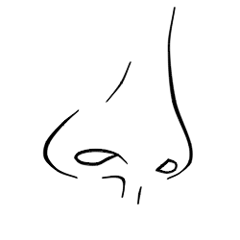

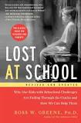

### Extend learning to transform behavior-shaping

Join the SEL Book Study to review the book, ***Lost at School.***

The book study will be moderated through Twitter @SELHISD

in an online format and is appropriate for administrators,

teachers, counselors, social workers, or ANYONE on your

team. Access <http://www.houstonisd.org/Page/153364> to learn more.

**Contact:** Michael Webb. Director, Social and Emotional Learning. Mwebb3@houstonisd.org.