Name:________________________ Period:___________
Activity Sheet 3–1k Review 11

1. Order Least to Greatest: {–7.399, –7.393, –7.903, v7.930, –7.39} 2. √ 172 is between:

__________________________ A. 11 and 12 ; B. 12 and 13; C. 13 and 14; D. 85 and 87

3. 5(2x – 10) = 35 x =__________ 4. √ .64 = _____________

5. 1.4 X 10⁶ ÷ 7 X 10⁹ =_____________ 6. Domain of y = –x : Range{–8,–4, 0, 4, 8}
(scientific notation)
7. 5(–9x + 1) – 2(–6x – 4) = _____ Let x = 2 (For # 6.) _____________________

8. 38 is ____________% of 380 9. What number is 2.5% of 500? ____________

10. Jose spent $260 on tickets to three events, the first event cost x plus 2 dollars and the second event cost $12 less than 4 times first event. The third event cost 3 times the first event. Find x. x = ____________
Perimeter (5x)m Area = 20 m² 11. 12 m 12.
x
x=_____________
6 m x = 10m 5m
Perimeter: = _____________ Area:= Perimeter: = ___________
(Bonus) _________ (Bonus)
13. 3x = 10x x = ________ 14. How many times greater is the dilated area
10 18 and volume of a shape using the scale factor
of 3.5? Area________ Volume _________
(Bonus)
15. What is the Slope and Equation of following sequence: {1, –1, –3, –5, –7,… }?
Slope: ________________ Equation: ___________________
(Bonus)
16. Find the Slope and Equation: x ⏐ y Slope: _____________

of the line that created the Table – 2 ⏐ – 31 (Bonus)
1 ⏐ 5 16. Equation: ___________
4 ⏐ 41
17. A bag contains 6 blue, 2 red, 5 green, and 7 white marbles. Two marbles are drawn at the same time. Probability of drawing both Red marbles with only one draw? P(R,R)=__________
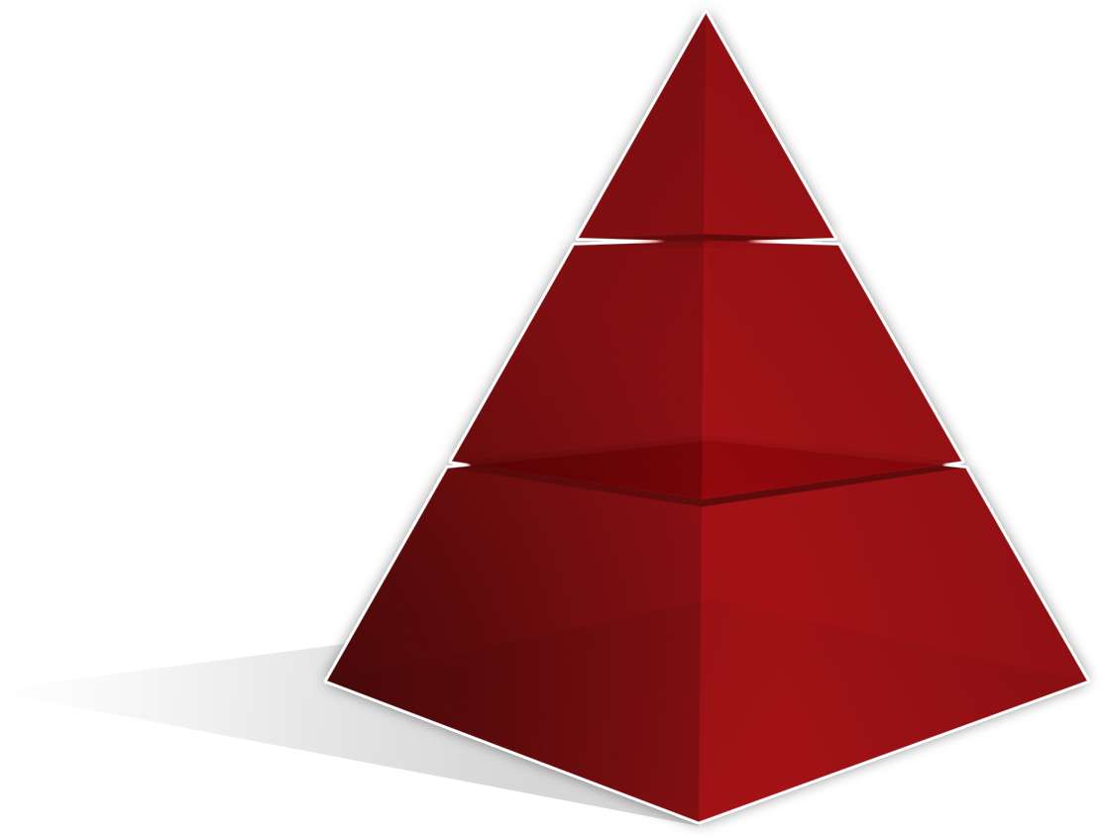
Find Volume and Surface areas of the Square Pyramid to the Right:
8 m
18. Volume: ___________ Height
19. Lateral Surface Area:__________ 12m
20. Total Surface Area _______________

