Page 9 in Spiral : Social aspects prior and during the civil war

Instructions: Analyze the songs and pictures for social aspects and significance: Differences between each examples? What does it implies about their society?

Bonnie Blue Flag-Confederacy

We are a band of brothers  
And native to the soil,  
Fighting for the property  
We gained by honest toil;  
And when our rights were threatened,  
The cry rose near and far--  
"Hurrah for the Bonnie Blue Flag  
That bears a single star!"

CHORUS:  
Hurrah! Hurrah!  
For Southern rights hurrah!  
Hurrah for the Bonnie Blue Flag  
That bears a single star.

As long as the Union  
Was faithful to her trust,  
Like friends and like brothers  
Both kind were we and just;  
But now, when Northern treachery  
Attempts our rights to mar,  
We hoist on high the Bonnie Blue Flag  
That bears a single star.   
CHORUS

First gallant South Carolina  
Nobly made the stand,  
Then came Alabama,  
Who took her by the hand.  
Next quickly Mississippi,  
Georgia and Florida  
All raised on high the Bonnie Blue Flag  
That bears a single star.   
CHORUS

Ye men of valor, gather round  
The banner of the right;  
Texas and fair Louisiana  
Join us in the fight.  
Davis, our loved president,  
And Stephens statesmen are;  
Now rally round the Bonnie Blue Flag  
That bears a single star.  
CHORUS

And here's to old Virginia--  
The Old Dominion State--  
Who with the young Confederacy  
At length has linked her fate;  
Impelled by her example,  
Now other states prepare  
To hoist on high the Bonnie Blue Flag  
That bears a single star.   
CHORUS

Then cheer, boys, cheer;  
Raise the joyous shout,  
For Arkansas and North Carolina  
Now have both gone out;  
And let another rousing cheer  
For Tennessee be given,  
The single star of the Bonnie Blue Flag  
Has grown to be eleven.   
CHORUS

Then here's to our Confederacy,  
Strong are we and brave;  
Like patriots of old we'll fight  
Our heritage to save.  
And rather than submit to shame,  
To die we would prefer;  
So cheer for the Bonnie Blue Flag  
That bears a single star.   
CHORUS

**Union version lyrics: Battle Cry of Freedom**

Yes we’ll rally round the flag, boys, we’ll rally once again,

Shouting the battle cry of freedom, We will rally from the hillside, we’ll gather from the plain, Shouting the battle cry of freedom!

The Union forever!  Hurrah, boys, hurrah!

Down with the traitor, up with the star;

While we rally round the flag, boys, rally once again,

Shouting the battle cry of freedom!

We are springing to the call with a million freemen more,

Shouting the battle cry of freedom! And we’ll fill our vacant ranks of our brothers gone before, Shouting the battle cry of freedom!

The Union forever!  Hurrah, boys, hurrah!

Down with the traitor, up with the star;

While we rally round the flag, boys, rally once again,

Shouting the battle cry of freedom!

We will welcome to our numbers the loyal, true and brave,

Shouting the battle cry of freedom!

And although he may be poor, he shall never be a slave,

Shouting the battle cry of freedom!

The Union forever!  Hurrah, boys, hurrah!

Down with the traitor, up with the star;

While we rally round the flag, boys, rally once again,

Shouting the battle cry of freedom!

So we’re springing to the call from the East and from the West,

Shouting the battle cry of freedom!

And we’ll hurl the rebel crew from the land we love best,

Shouting the battle cry of freedom!

The Union forever!  Hurrah, boys, hurrah!

Down with the traitor, up with the star;

While we rally round the flag, boys, rally once again,

Shouting the battle cry of freedom!

**Confederate version lyrics:**

Our flag is proudly floating on the land and on the main,

Shout, shout the battle cry of Freedom!

Beneath it oft we’ve conquered, and we’ll conquer oft again!

Shout, shout the battle cry of Freedom!

Our Dixie forever!  She’s never at a loss!

Down with the eagle and up with the cross!

We'll rally ‘round the bonny flag, we’ll rally once again,

Shout, shout the battle cry of Freedom!

Our gallant boys have marched to the rolling of the drums.

 Shout, shout the battle cry of Freedom!

And the leaders in charge cry out, “Come, boys, come!”

Shout, shout the battle cry of Freedom!--

Our Dixie forever!  She’s never at a loss!

Down with the eagle and up with the cross!

We'll rally ‘round the bonny flag, we’ll rally once again,

Shout, shout the battle cry of Freedom!

They have laid down their lives on the bloody battle field.

Shout, shout the battle cry of Freedom!

Their motto is resistance --“To tyrants we’ll not yield!”

Shout, shout the battle cry of Freedom!--

Our Dixie forever!  She’s never at a loss!

Down with the eagle and up with the cross!

We’ll rally ‘round the bonny flag, we’ll rally once again,

Shout, shout the battle cry of Freedom!

While our boys have responded and to the fields have gone.

Shout, shout the battle cry of Freedom!

Our noble women also have aided them at home.

Shout, shout the battle cry of Freedom!--

Our Dixie forever!  She’s never at a loss!

Down with the eagle and up with the cross!

We'll rally ‘round the bonny flag, we’ll rally once again,

Shout, shout the battle cry of Freedom!

Instructions for visual:

Describe what you see:

Infer about what you see:

Draw a conclusion about what you see

Northern City

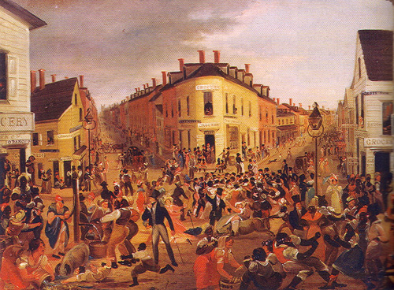

Southern Scene:

