

More HISD Students Graduate on Time as Dropout Rate Hits Historic Low

District’s graduation and dropout rates reach best levels under the modern accountability system

July 16, 2012 – HISD’s streak of declining dropout rates and increasing graduation rates hit four years for the class of 2011, according to preliminary Class of 2011 figures released by the Texas Education Agency.
HISD’s latest dropout rate of 11.8 percent and four-year graduation rate of 78.5 percent are the best they have been under the accountability system Texas put into place in 2007. And while the district’s overall enrollment has remained steady during that time period, the number of annual graduates has risen strongly from 6,978 graduates in the Class of 2007, to 9,070 graduates in the Class of 2011 – a 30-percent increase of 2,092 diplomas in just four years.
“Houston students are proving they are willing – and more than able – to achieve academically when we show faith in them and put them in a position to succeed,” said Trustee Michael Lunceford, president of the HISD Board of Education. “We all know the dropout rate remains a critical problem in our city, but we are making strong progress. The students, with help from the school administrators and teachers, have made a concerted effort to stem the tide of dropouts”
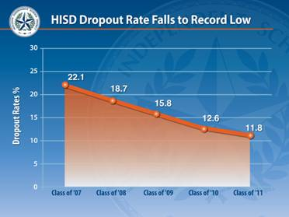

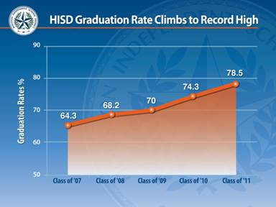

Progress coincides with district dropout prevention initiatives

The spike in the annual number of graduates coincides with HISD’s launch of Grad Labs in high schools across the district in January 2010. This computer-based credit recovery initiative lets students who have fallen behind academically make up courses at their own pace under the guidance of campus-based graduation coaches. Nearly 20 percent of HISD’s graduates in 2011 took at least one course through their schools’ Grad Labs, where they completed nearly 2,000 courses.
While the overall number of students in HISD high schools is roughly the same as in 2007, the number of freshmen has declined by about 1,260 students, or about 8 percent. Meanwhile, the number of sophomores, juniors and seniors is on the rise.
HISD Superintendent Terry Grier said the rising graduation rate is a credit to the district’s teachers, principals, and other staff.
“The Board of Education and administration come up with the initiatives to drive student achievement,” Dr. Grier said. “But it takes strong professional educators in the schools and classrooms to make these plans work and produce the kinds of results we are seeing in HISD.”
Some of HISD’s other efforts to reduce the dropout rate and help more students graduate on time include:

- Dropout Recovery, Intervention and Prevention (DRIP) committees on high school campuses bring staff together for regular strategy meetings to discuss plans for keeping students in school and for bringing back those who have left. Committee members include principals, guidance counselors, Grad Lab coaches, and social workers. Click here to see a video featuring the work of Lee High School’s DRIP committee.

- A dozen student case workers across HISD are assigned to specific at-risk students to help them overcome obstacles that could lead to them dropping out of high school. The case workers coordinate efforts and programs to keep at-risk students connected to a positive school experience and to re-connect students who have dropped out to opportunities to complete a high school diploma.

- Computer-generated Dropout Prevention Early Warning reports use student data (grades, attendance rates, documented behavioral problems) to alert schools when students are exhibiting risk factors that could lead to them becoming dropouts. This early identification tool helps school leaders intervene before students drop out.

- This summer, HISD partnered with the Houston Community College to launch Houston Innovative Learning Zone career and technical education programs inside six campuses -- Furr, Kashmere, Scarborough, Sterling, and Booker T. Washington high schools and Long Middle School. Graduates of these programs will leave high school with associate’s degrees and valuable professional certifications that will help them succeed in college or to immediately enter the workforce. Click here to read more about the HILZ initiative.

Literacy seen as key to making more graduation progress

Despite the graduation rate and dropout rate progress, far too many HISD students are leaving school without a diploma, Dr. Grier said. The district-wide literacy initiative is a key part of the district’s strategy for helping even more students make it to graduation day, he said.
“Students who cannot read on grade level have an uphill climb toward earning a diploma,” Dr. Grier said. “This fall, HISD will launch a revamped English language arts curriculum that was designed in partnership with teachers with training provided by the renowned Neuhaus Education Center. This strengthened approach to reading instruction includes research-based strategies for reaching the highest-achieving students, as well as those who have fallen behind their peers and need help getting back on track toward graduation.”
HISD teachers at all grade levels have received Neuhaus training on literacy intervention strategies. In the upcoming school year, HISD’s sixth- and ninth-grade students who are reading below grade level will receive an extra daily class period of reading instruction using a specially designed curriculum from Neuhaus.
HISD’s strong academic performance over the past four years led the district to be named among just four national finalists for the highly coveted Broad Prize for Urban Education. The winning district will be announced in October.

The Houston Independent School District is the largest school district in Texas and the seventh-largest in the United States with 279 schools and more than 203,000 students. The 301-square-mile district is one of the largest employers in the Houston metropolitan area with nearly 30,000 employees.
For more information, visit the HISD website at www.houstonisd.org.

