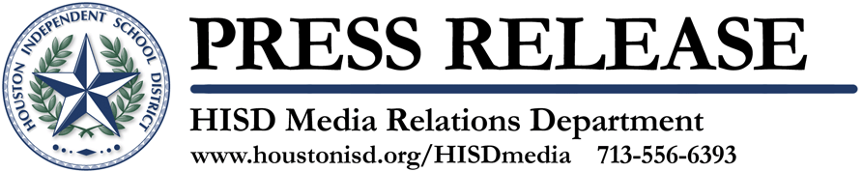

“Aprendamos Juntos” Program to Focus on Effective Teacher Initiative, Early Colleges and Free SATs

Who: HISD Southmayd Elementary Principal Siomara Saenz-Phillips and Teacher Mario Sandoval will participate in the community affairs talk show Aprendamos Juntos to discuss the district’s Effective Teachers Initiative which aims to put an effective teacher in every classroom. In addition, Challenge Early College High School teacher Frank Valle and student Yaritza Espinoza will talk about the importance of early colleges and AP/IB School Improvement Officer Esti Arriaga will join Chavez High School students Maria Reza and Wendy Diaz to discuss free SATs.

What: “Aprendamos Juntos” segment

When: Sunday, March 27 at 4:30 p.m. Channel 8.2 PBS &
Monday, March 28, at 7:00 p.m. Channel 18 Comcast

Where: KUHT Channel 8.2 PBS & HISD-TV Channel 18

Why: “Aprendamos Juntos” (or “Learning Together”) is an interview program where educational issues and initiatives are fully discussed with school administrators, teachers, students, parents and community members. Rebecca Suárez, HISD’s Senior Media Relations Specialist and HISD alumnus, hosts the show. Roaul Rodriguez-Zavala, HISD Instructional Media Producer, is the director and editor. The discussion program provides an inside look at HISD and its educational programs and plans to help students succeed in school.

The Houston Independent School District is the largest school district in Texas and the seventh-largest in the United States with 298 schools and more than 200,000 students. The 301-square-mile district is one of the largest employers in the Houston metropolitan area with nearly 30,000 employees.
For more information, visit the HISD Web site at www.houstonisd.org.

