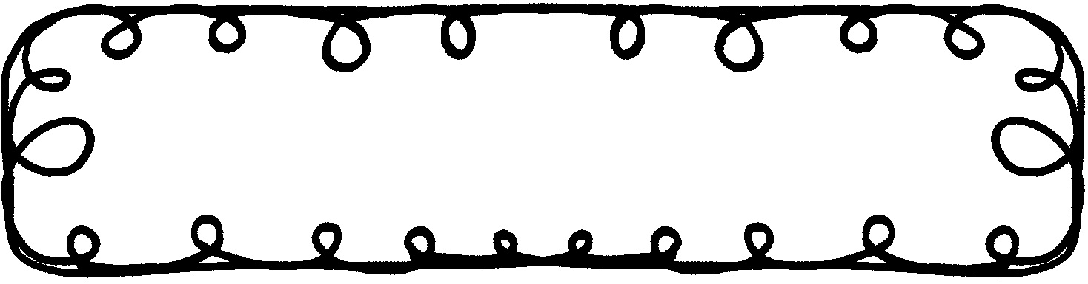
First Grade Gazette October 7, 2019

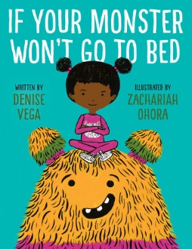
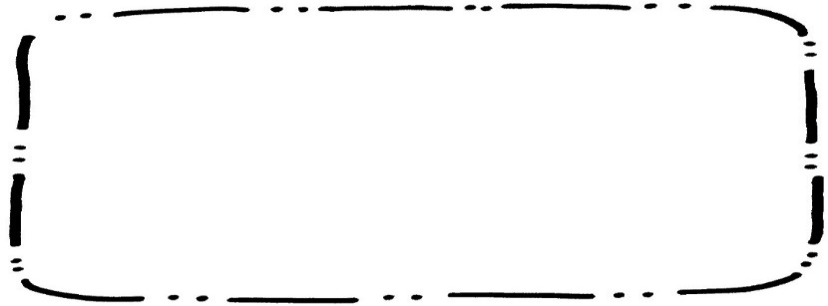
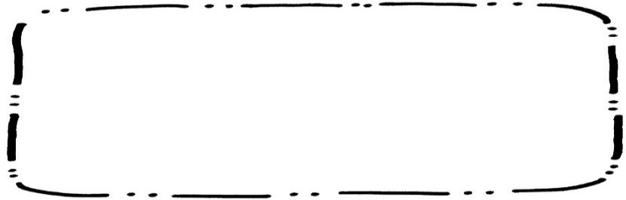
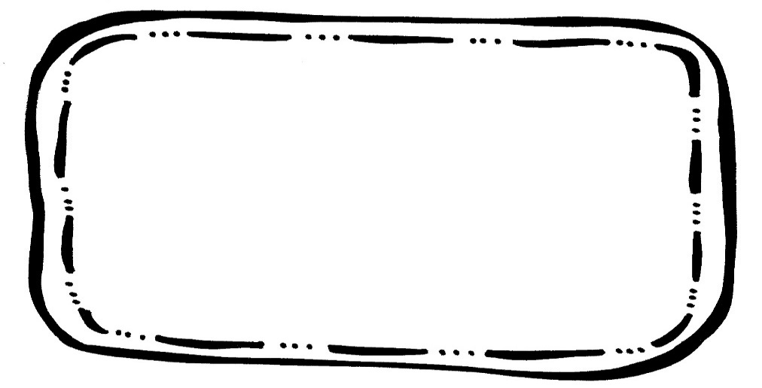

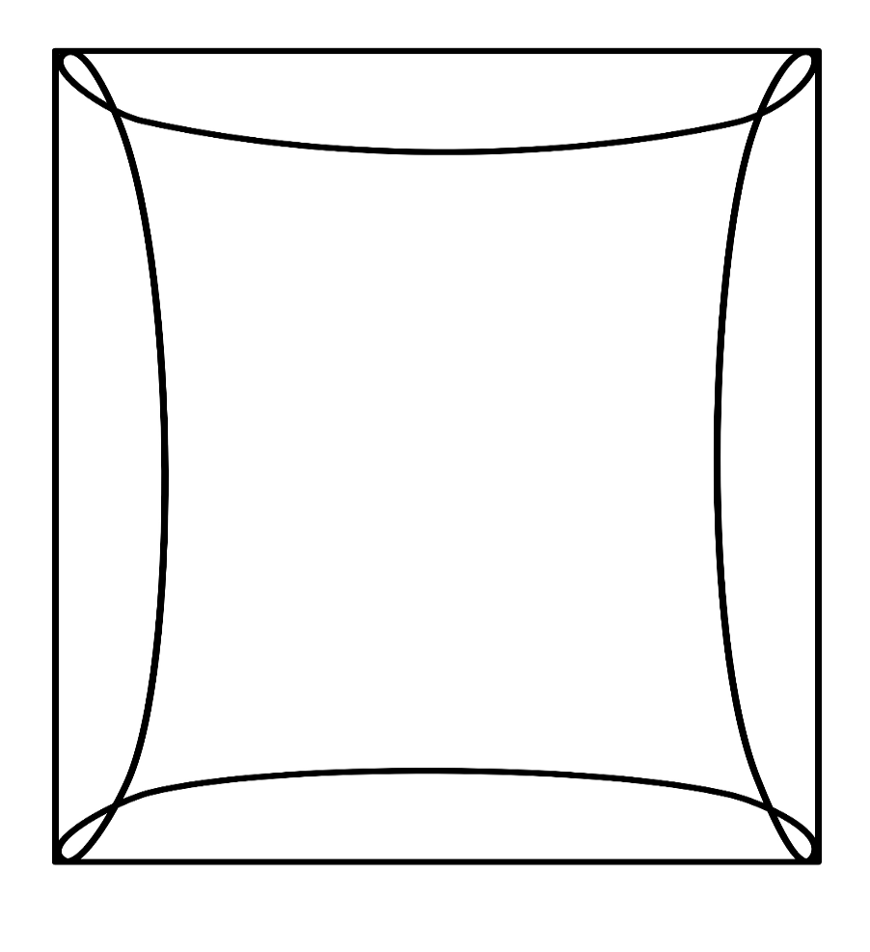
Math
We will finish up Chapter 4, Subtraction. Please continue to practice math facts.
Writing
We will learn about adjectives and how they make writing better.
Science & Social Studies
We will be learning about different bodies of water.
Spelling**Tested 9/13
Got hop lot pot top
Day did little very park
**I got a top for the pot.**

Reading Comprehension
If your Monster Won’t Go to Bed
- Retelling with key details

Vocabulary Words
Snarl – to growl and show the teeth
Bristly – covered with stiff, prickly hair
Massive – very large and heavy
Shiver – to shake because you are cold
Neighborhood – a group of people who live near each other

Upcoming Events
October
18 – Early Dismissal
21 – 25 – Red Ribbon Week

