Maps, Graphs, & Charts 6th/7th/8th Grade Invitational
MRC Jr. UIL Study Materials
Houston I.S.D.
November 19, 2016

Pts Answers Write answers in Answers column.(Do not mark in Pts column)

Atlas Questions -- Central Africa

___ ____________________ 1. What is the height of Jobel Marra in meters?

___ ____________________ 2. What is the capital city of Central African Republic?

___ ____________________ 3. Which city is NOT south of the Congo River?
- Kananga
- Uiga
- Diffa
- Geita

___ ____________________ 4. What is the approximate distance (round to nearest 100) from the capital of Nigeria
to the capital of Congo Republic in kilometers?

___ ____________________ 5. How many national capitals are found east of longitude 30° E?

___ ____________________ 6. Which two rivers form a natural barrier between Angola & Congo?

___ ____________________ 7. Which city has a larger population, Waw or Kaduna?

___ ____________________ 8. Libreville is the national capital of which country?

___ ____________________ 9. What city is located on the Congo river?
- Kusti
- Makurdi
- Kalemie
- Matadi

___ ____________________ 10. Traveling west, along latitude line 10°N, from Sudan to Nigeria, what mountain
range would a person cross?

True / False

___ ____________________ 11. Lake Rukwa is located in Cabinda.

___ ____________________ 12. The Bie Plateau is located in Chad.

___ ____________________ 13. Stanley Falls are located on the Nile R.

___ ____________________ 14. The capital city of Uganda is located on Lake Victoria.

___ ____________________ 15. Angola is located on the Indian Ocean.

__________ TOTAL POINTS THIS PAGE

Use the graph on this page to answer questions 16-30.
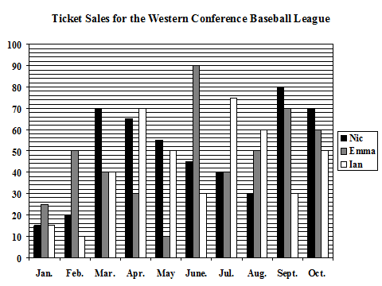

Ticket Sales Western Conference Baseball League

Pts Answers Write answers in Answers column.(Do not mark in Pts column)

___ ____________________ 16. How many years are represented by the bar graph?

___ ____________________ 17. How many total tickets were sold in May?

___ ____________________ 18. What month did Nic sell the most tickets?

- April
- January
- June
- September

___ ____________________ 19. What is the total number of tickets sold in the last three months?

- 460
- 457
- 467
- 474

___ ____________________ 20. Looking at February, how many more tickets did Emma sell than Ian?

___ ____________________ 21. Overall, which student sold the largest percentage of tickets?

___ ____________________ 22. How much larger a percentage of tickets were sold by Ian than by
“other students” ?

___ ____________________ 23. How many tickets were sold in August by Emma?

___ ____________________ 24. What month had the fewest total tickets sold?

___ ____________________ 25. From March through July, how many total tickets did Ian sell?

True / False - Locate the Answers

___ ____________________ 26. The Southern tip of South America receives between 10 to 20 inches of rain per
year.

___ ____________________ 27. The World’s leading producer of tin is China.

___ ____________________ 28. Dothan, Alabama is located in the Application Mountains.

___ ____________________ 29. Mexico’s land mass is almost as big as Great Britain .

___ ____________________ 30. The capital of Azerbaijan is located on the Caspian Sea.

__________ TOTAL POINTS THIS PAGE

Use the atlas to answer questions 31-60.

Pts Answers Write answers in Answers column.(Do not mark in Pts column)

Atlas Questions – World- Cultural Diversity

___ ____________________ 31. What is the majority language family for the United States?

___ ____________________ 32. Name the primary language family for most of North Africa.

___ ____________________ 33. Name the two language families found in Australia.

___ ____________________ 34. What is the predominate religion for India?

___ ____________________ 35. Mongolia, Myanmar, & Thailand have the same predominate religion. Name that
religion.

___ ____________________ 36. Which two languages are found in the Celtic language family?

___ ____________________ 37. Which of the following one of the following languages are found in the Germanic
language family?
- English C. Greek
- Polish D. French

___ ____________________ 38. All of the following languages are part of the Romance language family, except
_________?
- Romanian C. French
- Albanian D. Italian

___ ____________________ 39. South America has how many language families?

___ ____________________ 40. Name the language families found in South America.

___ ____________________ 41. Greenland’s primary language family is ___________?

___ ____________________ 42. Looking at the World’s major religions, how much larger is the percentage of
Christians than Hindus ?

Locate the Answers

___ ____________________ 43. What is the natural population growth of Laos?

___ ____________________ 44. What is the southernmost country on the Arabian Peninsula?

___ ____________________ 45. What is the leading cause of death in North America?

__________ TOTAL POINTS THIS PAGE

Pts Answers Write answers in Answers column.(Do not mark in Pts column)

Atlas Questions – South Central U.S

___ ____________________ 46. Which of the cities are not found in the South-Central region?

- Muskogee
- Houma
- Amarillo
- Tuscaloosa

___ ____________________ 47. All of the following cities can be found on Interstate 20 except ________?

- Vicksburg
- Lake Charles
- Abilene
- Pecos

___ ____________________ 48. In which state are the Boston Mts. found?

___ ____________________ 49. What reservoir is found on the Canadian river?

___ ____________________ 50. Which Interstate highway runs through the middle of the Edwards Plateau?

___ ____________________ 51. Which city is furthest South?

- Harlingen
- Woodward
- Hereford
- New Orleans

___ ____________________ 52. What is the distance (miles) from Beaumont, TX to Little Rock, AR?
(rounded to the nearest 50 miles)

___ ____________________ 53. Which city is not found in Oklahoma?

- Tulsa
- Durant
- Hot Springs
- Guymon

___ ____________________ 54. What is the latitude and longitude of San Antonio?

___ ____________________ 55. What two (2) man-made bodies of water are connected by the Sabine River?

___ ____________________ 56. If traveling from Laredo to Baton Rouge, what two (2) interstate highways would
a person travel?

True / False

___ ____________________ 57. Amarillo is further west than Fort Stockton.

___ ____________________ 58. Houston and Bastrop, LA are located along the Gulf Coastal Plain,

___ ____________________ 59. The Double Mountain Fork of the Brazos River crosses the Llano Estacado.

___ ____________________ 60. Nacogdoches and Natchitoches are both cities in Oklahoma.

__________ TOTAL POINTS THIS PAGE

Use this weather map and the U.S. political map in the atlas to answer questions 61-75.

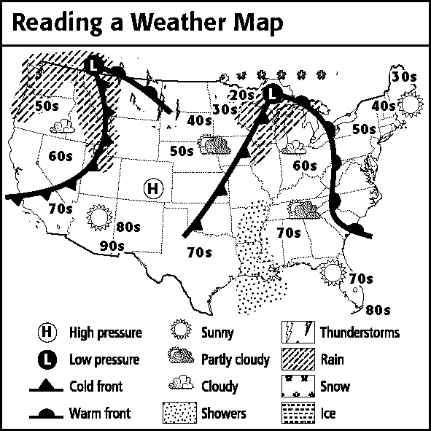

Pts Answers Write answers in Answers column.(Do not mark in Pts column)

Weather map and Political Map Untied States

___ ____________________ 61. What is the meaning of the following symbol ?

___ ____________________ 62. According to the weather map, which of the following states has a temperature
in the 50s?
- Maine
- Arizona
- New York
- Texas

___ ____________________ 63. How many cold fronts are shown on the weather map?

___ ____________________ 64. Name two of the four states that is experiencing showers.

___ ____________________ 65. How many areas of rain are shown on the weather map?

___ ____________________ 66. What is the temperature in Ohio?

___ ____________________ 67. The high pressure is located directly over what state?

___ ____________________ 68. What state is experiencing partly cloudy conditions?
- Washington
- Florida
- Maine
- Tennessee

___ ____________________ 69. What type of front is found in southern Nevada?

___ ____________________ 70. What state is experiencing icy conditions?

___ ____________________ 71. What is the temperature in most New Mexico?

___ ____________________ 72. What type of weather conditions is Oregon is experiencing?

___ ____________________ 73. Western Montana is experiencing what type of weather conditions?

___ ____________________ 74. True or False, on the weather map, Texas is warmer than Minnesota.

___ ____________________ 75. On the weather map, what is the temperature for South Dakota?

__________ TOTAL POINTS THIS PAGE

Maps, Graphs, & Charts-Houston 6th/7th/8th Invitational
November 19, 2016
Answer Key
MRC Jr. UIL Study Materials

- 3088 m
- Bangui
- C. Diffa
- 1700 km
- 2 (Kigali, Kampala)
- Kwango R, Kasai R
- Kaduna
- Gabon
- D. Matadi
- Mandara Mts.
- False
- False
- False
- False
- False
- One (1)
- 15 tickets
- D. September
- D. 474
- 40 tickets
- Emma
- 18%
- 50
- January
- 265
- False
- True
- False
- False
- True
- Indo-European
- Afro-Asian
- Indo-European & Australian
- Hinduism
- Buddhism
- Welsh, Gaelic
- A. English
- B. Albanian
- Two (2)
- Indo-European, American Indian
- Inuktitut
- 19.7%
- 2.4%
- Yemen
- cardiovascular diseases
- D. Tuscaloosa
- B. Lake Charles
- Arkansas
- Lake Meredith
- Interstate 10
- A. Harlingen
- 350 miles
- C. Hot Springs
- 29° N, 97° W
- Lake Tawakoni, Toledo Bend Reservoir
- Interstate 10 & 35
- False
- False
- True
- False
- Ice
- New York
- Two (2)
- 2 of 4- Missouri, Arkansas, Mississippi, Louisiana
- Two (2)
- 60s
- Colorado
- D. Tennessee
- Cold font
- NONE
- 80s
- Cloudy
- Rain
- True
- 40s

