Dear PK Families,

Because there is information about things needed in PK for next week that you might want to prepare for this weekend, we are sending out this email early.

From the Teachers:

* Pre-K and Kindergarten classes are planning to hunt eggs on Thursday, March 28th. We invite you to donate 6 plastic eggs (filled with small toys or individually wrapped chocolate) and to send your child with a basket for collecting eggs during the hunt. Please send filled eggs and a basket to school by Wednesday (3/27) so that we can have everything organized and ready to go for Thursday. Please be sure that baskets are marked with child's name. Thank you!
* Field Day for PK-1st grade students will be on Thursday, April 4th from 9:00-11:30. The students will be participating in outdoor activities, so please outfit your child accordingly that day. Please send them in athletic shoes and clothing. Please also send your child with a towel specifically for field day that morning. We will carry the towels with us and use them to sit on if we are waiting for an activity or enjoying a snack/drink outside. Also, just a reminder that you may want to apply sunscreen and/or bug spray at home if needed - we will be unable to apply any of that at school. We are looking forward to a really fun day for the kiddos!
* Just a friendly reminder to please put lunch money in an envelope or ziploc bag marked with your child's name. Thank you!
* In English and Mandarin classes next week, students will be studying travel and transportation. We'll be reading lots of good books and using new vocabulary in both languages. In math, students will be working with 4 quadrant grids. They'll be playing games in which they'll be locating each quadrant (upper and lower left, upper and lower right) and beginning to find specific intersections by counting over and then up on very simple x and y axes.
* As we continue with Cookies: Bite Sized Life Lessons in English class next week, we'll be studying the terms "proud" and "modest." If you are following along with us at home, we hope you are enjoying the book!

* Chinese: transportation chapter and continuing on zodiac characters

Thanks to you all! Have a wonderful weekend!

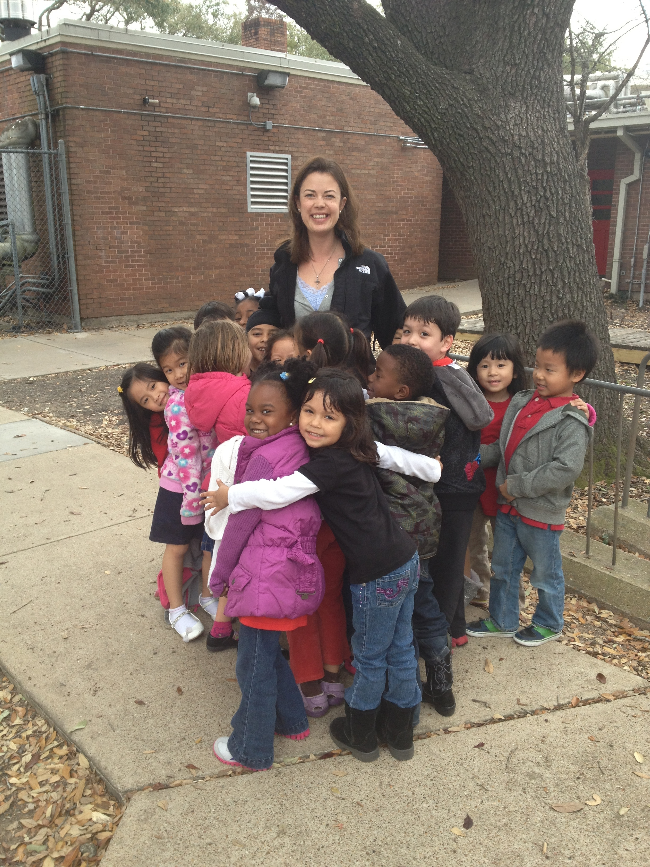
Recess fun...Group hug! :)

