  2024
Sunday | Monday |  | Tuesday |  | Wednesday | Thursday | Friday | Saturday
 |  | November is Gratitude Month |  |  |  |  | 1  Gardening Volunteer Day @ 8:00 am | 2  Piano Festival @ Parker  9:00-12:00
3  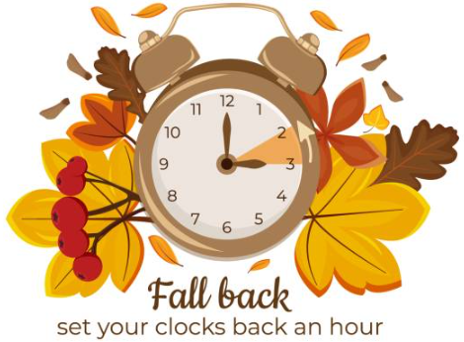 |  | 4 November is    Month |  | 5   | 6 | 7  Magnet Tour 9:00  Apex Fun Run | 8  Staff PD Day  No School for Students | 9  
10  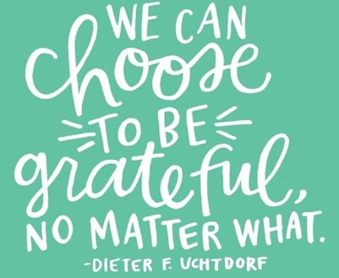 |  | 11    Guitar Workshop Week – November 11-15 |  | 12  Title I Meeting  6:00 pm | 13 | 14  Magnet Tour 9:00  PTO Meeting 6:00 | 15  -Title 1 Meeting 8:00 am  -Guitar Workshop Concert 2:30 | 16  Muffins w/Mom 9:30 am  Black Belt Extravaganza 11-3  Spirit Week with Tomfoolery Toys and Books Nov. 16-24
17  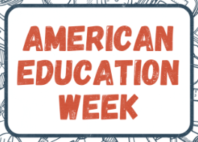 |  | 18  College Week – Wear College Shirts |  | 19  Spirit Night @  Los Tios in Meyerland | 20  Strings Matinee 3:00  Thanksgiving Luncheon for PK, 1,3,5 grades | 21  -Magnet Tour 9:00  -8:30 3rd grade to Agricultural Literacy Center  -Thanksgiving Lunch for K,2,4 grades  -5:00 Family Bingo Night | 22 | 23  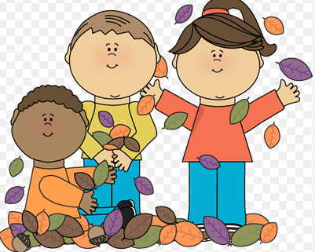
24   |  | 25  THANKSGIVING BREAK – NO SCHOOL |  | 26 | 27 | 28   | 29 | 30  

