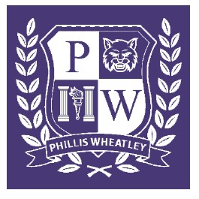
SDMC Agenda
October 27, 2022, 9:30 AM
Main Office Conference Room

- Roll Call & Affirmations
- Attendance Comparisons 2021-2022 vs. 2022-2023
- Enrollment Numbers 2021-2022 vs. 2022-2023
- Re-Tester Numbers and Support
- P-Tech Updates
- Open

