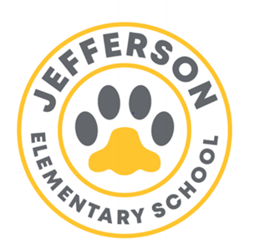
Jefferson Elementary School Year 2022 -2023
SDMC Agenda
06/01/2023 3:30 p.m.
Room 6
SDMC Agenda

- Staffing/ Vacancies:
- Kinder
- SLC
- 3rd grade
- Media Specialist
- Office Clerk

- Budget- As of now Budget- Status on Big Projects- Fence, water fountain, popcorn Machine, Garden School

- Academic Programs- Vontoure, Imagine Math/Reading, Freckle, Waggle, Really Great Reading, Rice University, Neuhaus
- School Culture- School Committees; Teacher moral committee, School Event Committee,
- Data-Test Results
          - TELPAS;
          - STAAR Preliminary data
          - EOY Assessments
- End of the Year Event
- Summer School.
June 13 – July 7
Mon. thru Thurs. 7:30-2:30
Last day July 7th 7:30-11:30
- Meeting was adjourned at 4:30pm


- Parents are encouraged to visit our many platforms with information and updates: @JeffersonES2,

@Jeffersonelementaryhisd, https://houstonisd.org/Domain/21593.

