# SUMMER BRIDGE

**Essential question**

How do you know if a news source is reliable?

1. Complete the PBS NewsHour Extra Daily News Story activity

[**Did fake news influence the outcome of Election 2016?**](http://www.pbs.org/newshour/extra/daily_videos/why-is-it-important-for-news-sources-to-be-trustworthy/)

# 

2. Read Craig Silverman’s [**story**](https://www.buzzfeed.com/craigsilverman/viral-fake-election-news-outperformed-real-news-on-facebook?utm_term=.gkK7qeMvl#.yw4PNrjKA) from Buzzfeed, which is the subject of the NewsHour piece.

## **Main Activity**

1. Listen to the NPR story (4:14) [**Stanford Study Finds Most Students Vulnerable To Fake News**](http://www.npr.org/2016/11/22/503052574/stanford-study-finds-most-students-vulnerable-to-fake-news)

Question: Why do you think this piece made front page headlines?

Think about this: Prof. Wineburg says one mistake schools make is to block certain websites from students while they are at school. “In many schools there are internet filters that direct students to previously vetted sites and reliable sources of information. But what happens when they leave school and they take out their phone and they look at their Twitter feed? How do they become prepared to make the choices about what to believe, what to forward, what to post to their friends when they’ve given no practice in doing those kinds of things in school?”

Do you agree with Dr. Wineburg? Should schools block certain websites? Why or why not?

1. The News Literacy Project and Checkology created a checklist of[**“Ten questions for fake news detection.”**](http://www.thenewsliteracyproject.org/sites/default/files/GO-TenQuestionsForFakeNewsFINAL.pdf)**Look at this list.**

Do you have any questions about the checklist?

Which points will help students the most when it comes to detecting fake news?

1. Next, explore the following top fake news stories from Craig Silverman’s Buzzfeed article. Using the checklist above–just based on the headline alone–how could students detect the likelihood of these stories being fake?

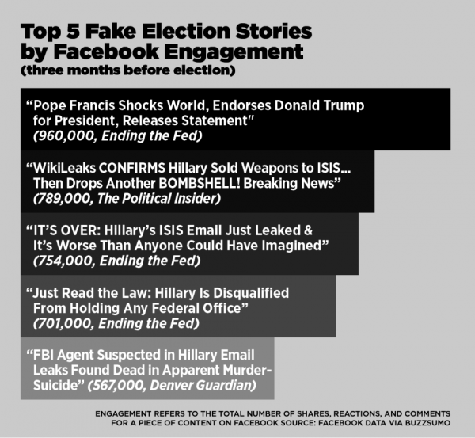

Study two stories from the chart above by looking at the fact checking and debunking Internet rumor website[**Snopes**](https://en.wikipedia.org/wiki/Snopes.com)[:](http://www.snopes.com/pope-francis-donald-trump-endorsement/)

* [Nope Francis: Reports that His Holiness has endorsed Republican presidential candidate Donald Trump originated with a fake news web site](http://www.snopes.com/pope-francis-donald-trump-endorsement/)
* [FBI Agent Suspected in Hillary Email Leaks Found Dead: Reports that an FBI agent investigating Hillary Clinton’s use of a private e-mail server killed himself after murdering his wife are just fake news.](http://www.snopes.com/fbi-agent-murder-suicide/)

How do you figure out that these are fake news stories?

What points from News Literacy Project’s checklist apply to these pieces?

What should you do if you still have questions about the legitimacy of a source?