**MCLIMS Pre-Kindergarten Homework**

**Assigned: Friday Nov. 9 Due: Thursday, Nov. 15**

This week’s homework is an opportunity for your child to be artistic AND to help us fill a classroom need!

When student work needs to dry (wet paint or glue), we’d like to be able to line them up along the walkway outside the classrooms…without having them blow away! We need some fun, creative paperweights, and we know some little artists that are perfect for the job!

**The assignment:**

Find a smooth, flat rock and paint it. Bring it to school and we’ll keep it handy for you to use as your very own paperweight!

Paint your rock any way that you would like. Make sure it’s something that will stand out to you, so that you’ll know it’s yours. You may paint your name or initials on it, paint it to look like your favorite animal, decorate with stripes or polka dots, make a pattern, create your own design…the possibilities are endless!

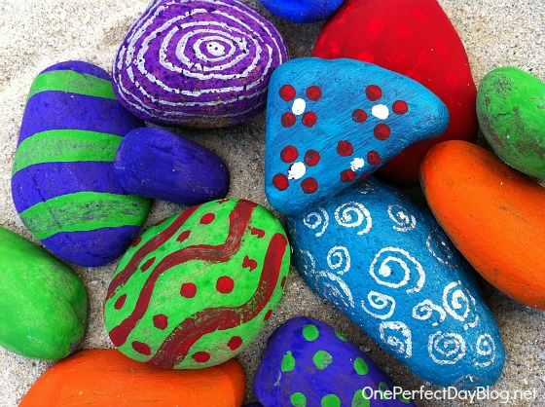Parents, remember that in addition to this being just fun and a nice creative outlet, this is a great opportunity for fine motor development, oral language development, something cool to journal about later, etc. Enjoy!

**Bonus activities:**

* **How many uses for a rock can you think of? Brainstorm together!**
* **Make a list (shared writing between parent and child) of some rockin’ ways to use a rock! ☺**
* **Illustrate a creative way to use a rock (include lots of details in your illustration). Sounds words out to add labels to your drawing or write sentences to tell about what you drew.**