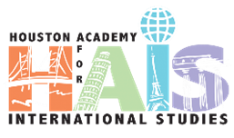

**SDMC Meeting**

**Quarter IV**

**May 9, 2023**

Roll Call (gain signatures of all present)

Begin and end on time

Silence cell phones

Make sure all voices are heard

If you wonder, ask.

**Specific Agenda Items**

**Professional Development**

* Khan Academy SAT Prep- Award
* TEACH – Final PD
* Plans for Pre-Service in August

**Magnet Update**

* This Year’s Process
  + K-12 Phase 2: April 5, 2023 – June 15, 2023
* Plans for Freshman Camp

**Budget 2022-23**

* Close out for this Academic Year

**Staffing**

* Maintain

**HCC Updates**

Fall Course Requests Due

Projected Associate Degrees Class of 2023

**Attendance Update**

**Upcoming**

Graduation- HCC and HAIS