[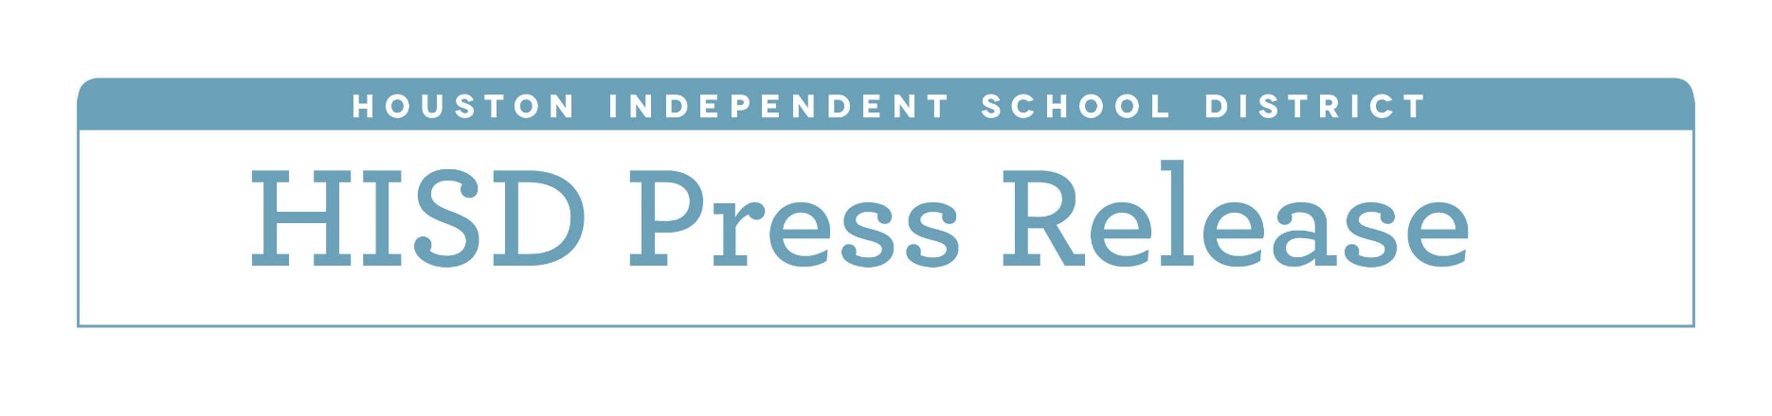](http://www.houstonisd.org/HISDmedia)

**Two HISD schools nominated for national Blue Ribbon Schools award**

*Eastwood Academy and Lyons Elementary nominated among exemplary, high-performing schools*

*Jan. 12, 2017 —* Two Houston Independent School District schools have been nominated for the U.S. Department of Education’s prestigious national 2017 Blue Ribbon Schools designation.

The National Blue Ribbon award is given annually to high-performing schools to showcase the hard work of students and educators. Eastwood Academy and Lyons Elementary are among 26 public schools in Texas to be nominated by the Texas Education Agency.

Eastwood Academy is a college preparatory high school that provides students with an accelerated, challenging, college-preparatory curriculum. In addition to completing dual-credit courses, students also complete 80 hours of community volunteer work before graduation.

“Earning this nomination for the second time since Eastwood’s establishment means the world to the Eastwood family,” said Eastwood Principal Brandi Lira. “We are incredibly delighted at the fact that the hard work and determination of our students, staff, and parents has been recognized. I am honored to represent our school as the principal, but the credit belongs to all of those individuals who have served our campus over the last few years, including our former principals Dr. Paula Fendley and Dr. Rolando Trevino.”

Lyons Elementary is a school where teachers work diligently to provide their students with an education that enables them to thrive. Lyons administrators believe their students should take advantage of every opportunity given to them in order to achieve lifelong success.

“We are proud of our second nomination because it validates our work,” said Lyons Principal Cecilia Gonzales.  “Every sleepless night, every minute of every day, coming together as a faculty and staff to improve our students is what we are about. Being recognized for the work that we do every day for our students is an honor.”

To earn a nomination, schools must be deemed exemplary and high performing as measured by state assessments. Also, each nominated school must have an economically disadvantaged population of at least 22 percent.

The nominated schools will now work with the U. S. Department of Education to complete the application process. National award winners will be announced in September. The winners will then be recognized in Washington D.C. at the National Blue Ribbon Schools awards ceremony.

For more on Eastwood Academy, go to <http://www.houstonisd.org/Domain/11083>

For more on Lyons Elementary School, go to <http://www.houstonisd.org/Domain/20236>