1. Click on the Windows Start Orb and type Outlook, click on Outlook 2013 listed under programs.

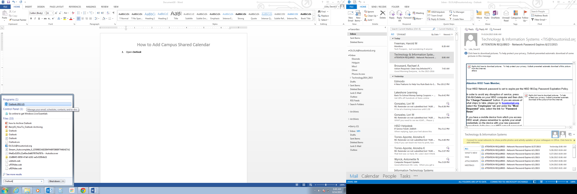

1. After your Outlook 2013 is done loading click on Calendar down at the bottom.

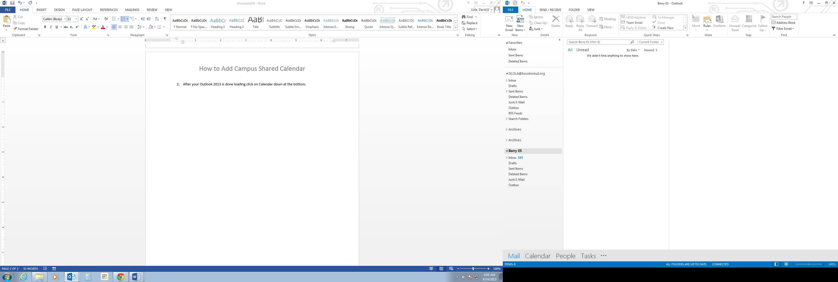

1. Click on Open Calendar from the ribbon at the top and select Open Shared Calendar.

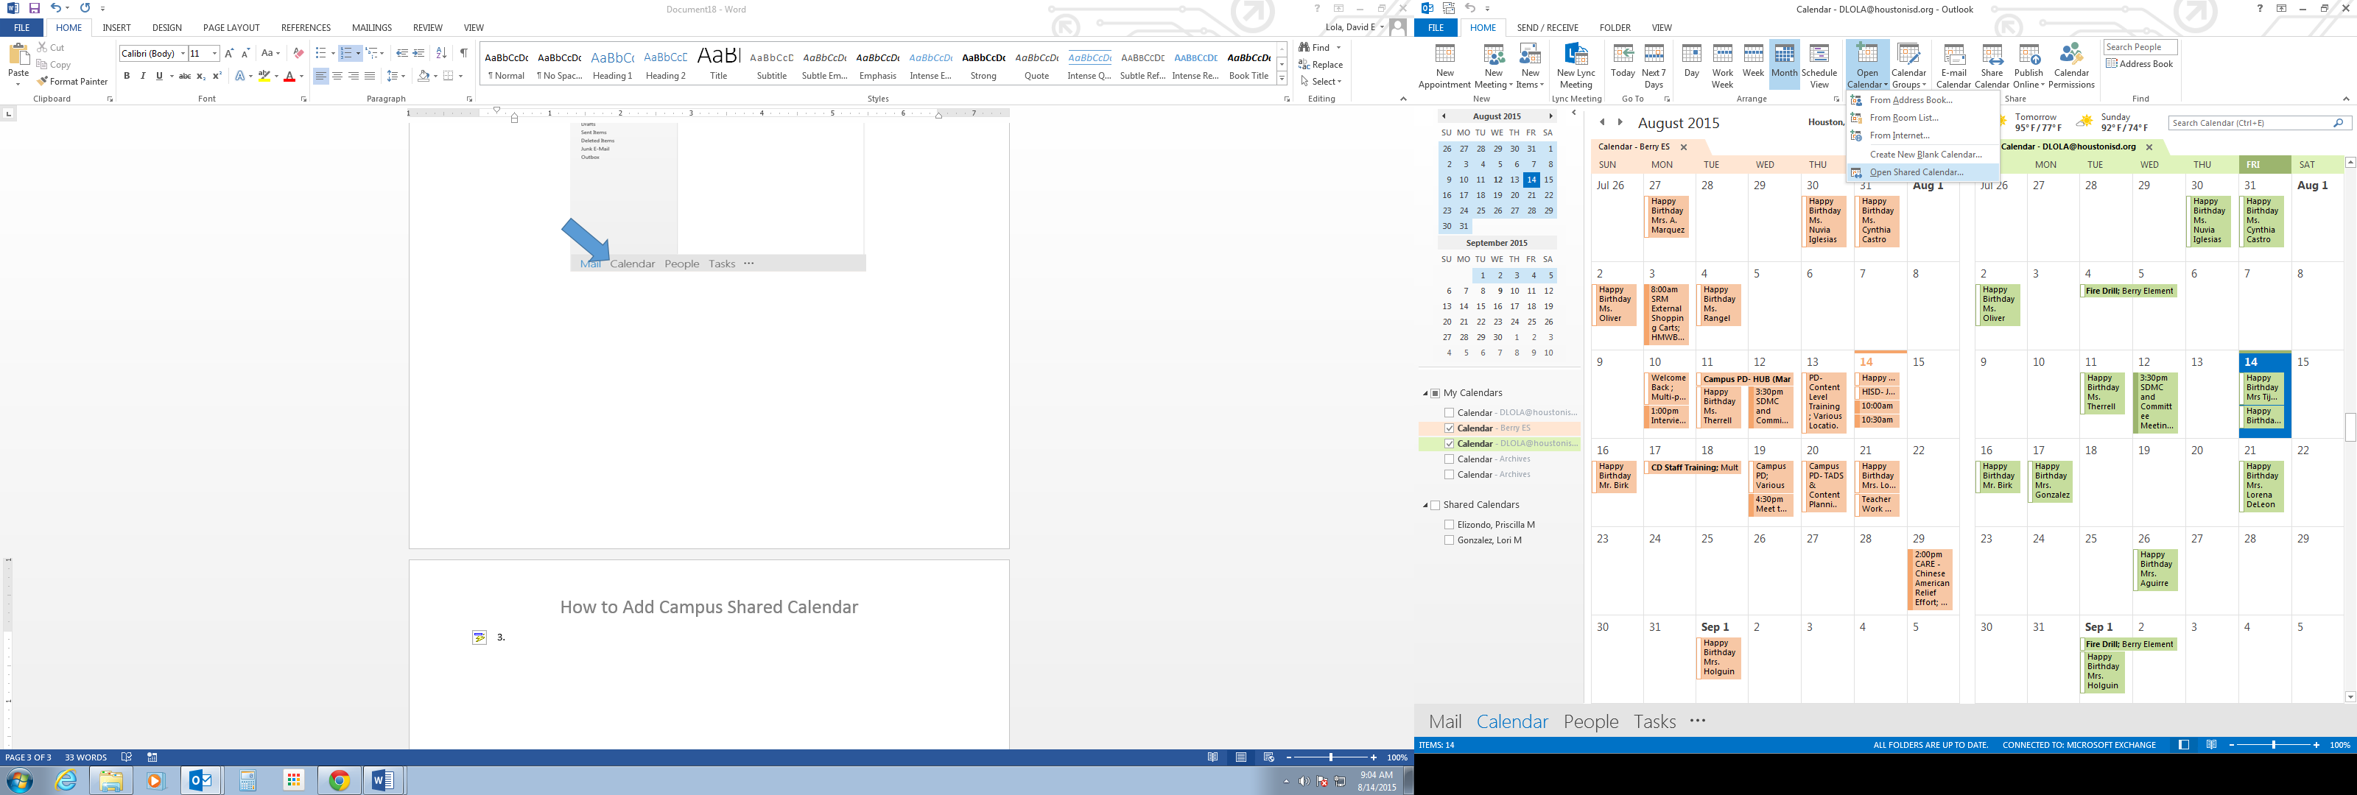

1. Next Type Berryes in the dialogue box and click Ok.

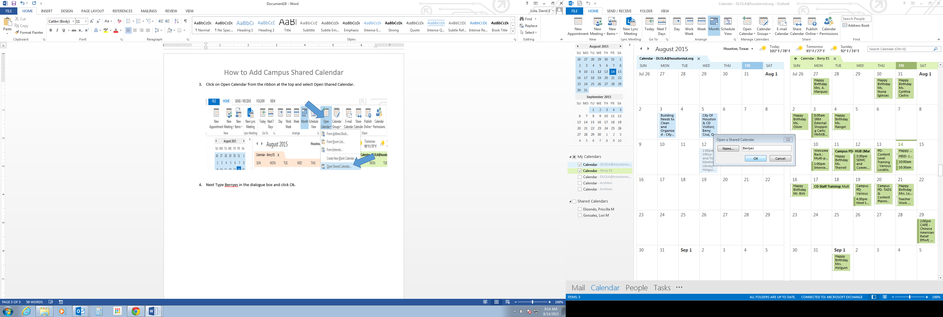

1. You should now see the Berryes shared calendar under your Shared Calendars in the left navigation.

