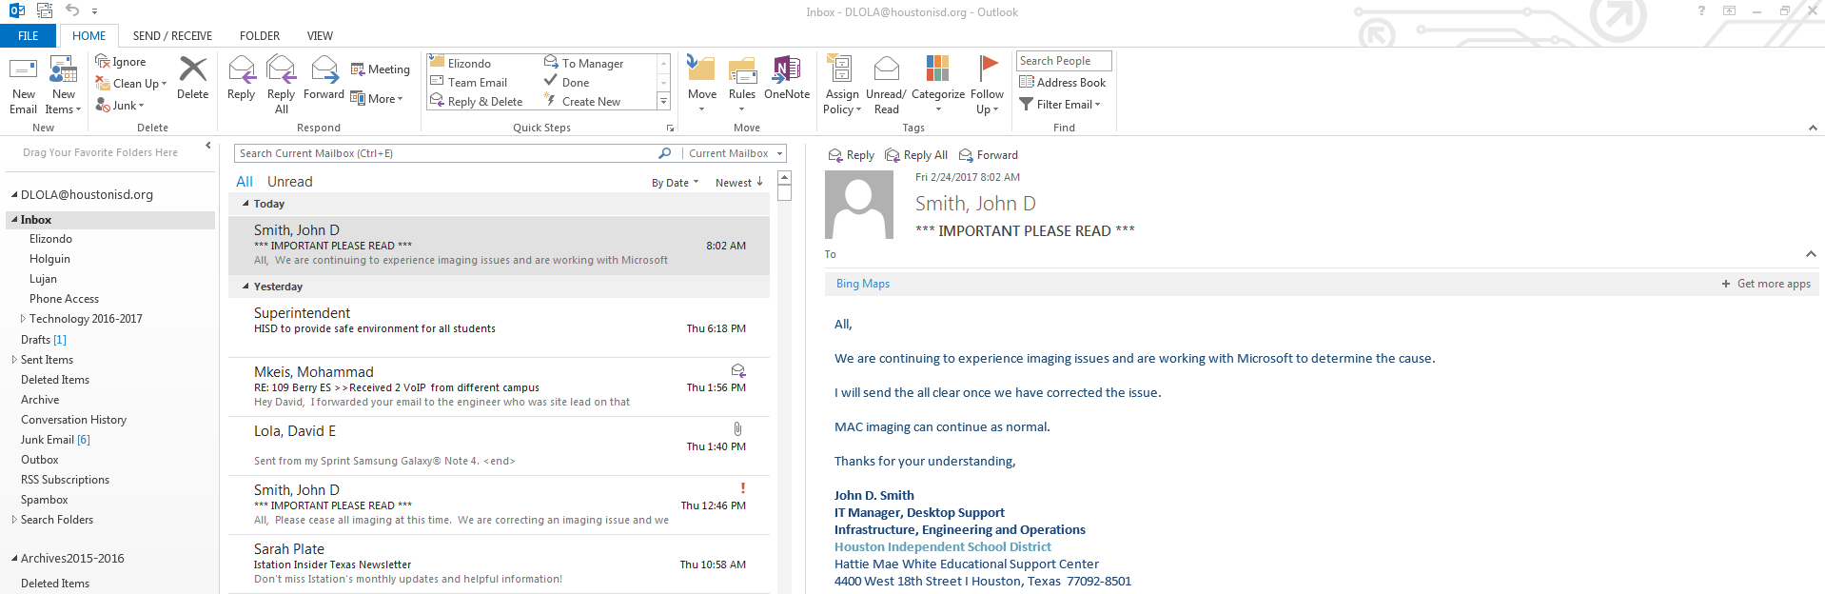

First Open your desktops native Outlook App.



Once your Outlook has opened scroll through to select the *Suspicious email* and highlight it.

Left click to highlight/select the email.

DO NOT DOUBLE CLICK as this will open the email.

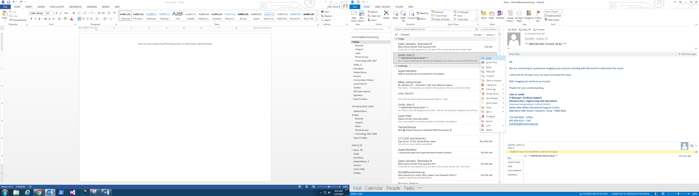

Now that the suspicious email is selected simply right click and select >> Copy.

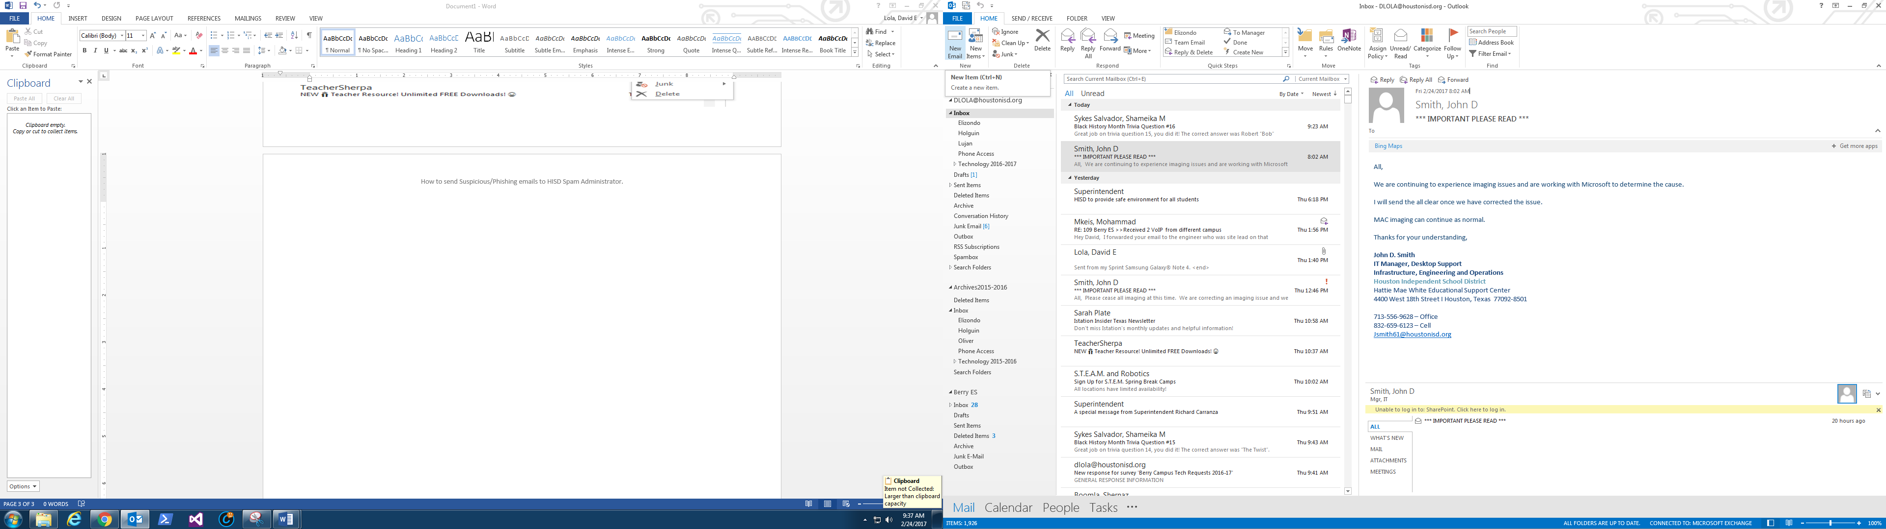

Finally, once you have copied the email it is time to paste.

First open a NEW email (blank Email).

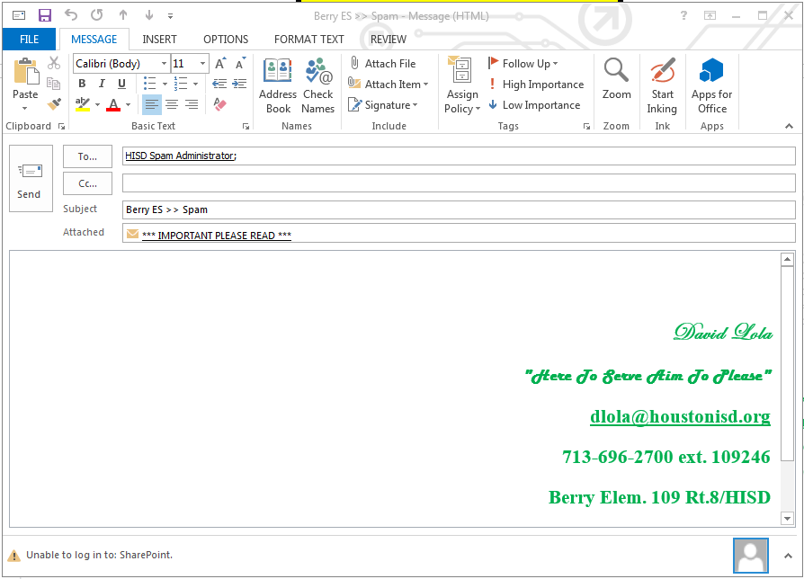

When your new email opens simply right click and paste or use the paste button found at the top left corner under the file tab.

Now send to>> [HISDSPAM@houstonisd.org](mailto:HISDSPAM@houstonisd.org)

For subject use the naming convention suggested by the HISD IT dept. e.g. School Name >> Issue (BERRYES >> SPAM)

That’s it you did it!!!! Don’t forget to HIT SEND.

-Lola

Campus

INT IT CSR