### Your HCC e-mail address:

Logging into Canvas and E-mail for HCC Dual Credit ENGL 1301

[**W________________________________________@student.hccs.edu**](mailto:W________________________________________@student.hccs.edu)

You will need it for Canvas and to receive my class-wide e-mails through the college e-mail system. Only use Chrome or Firefox

for Canvas.

# For Canvas

## Getting Started

1. Go to [www.hccs.edu](http://www.hccs.edu/)  and click on the link “MyEagle Student Sign-In” located at the top left hand corner.

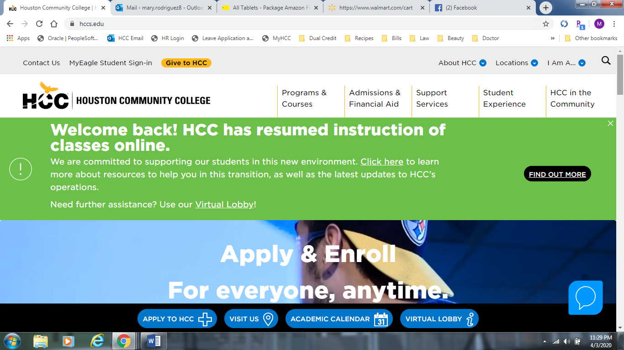

1. The “MyEagle Student Sign in” link from the HCC homepage will take you to this screen. Click on “Student Sign-Ins” square on the top row.

### NOTE: If this is your first time using canvas, click the link “Student System sign-in” under PeopleSoft. Go to Step 4 in this handout.

**If you have already received your e-mail and password, click on the “Eagle Online Canvas” link.**

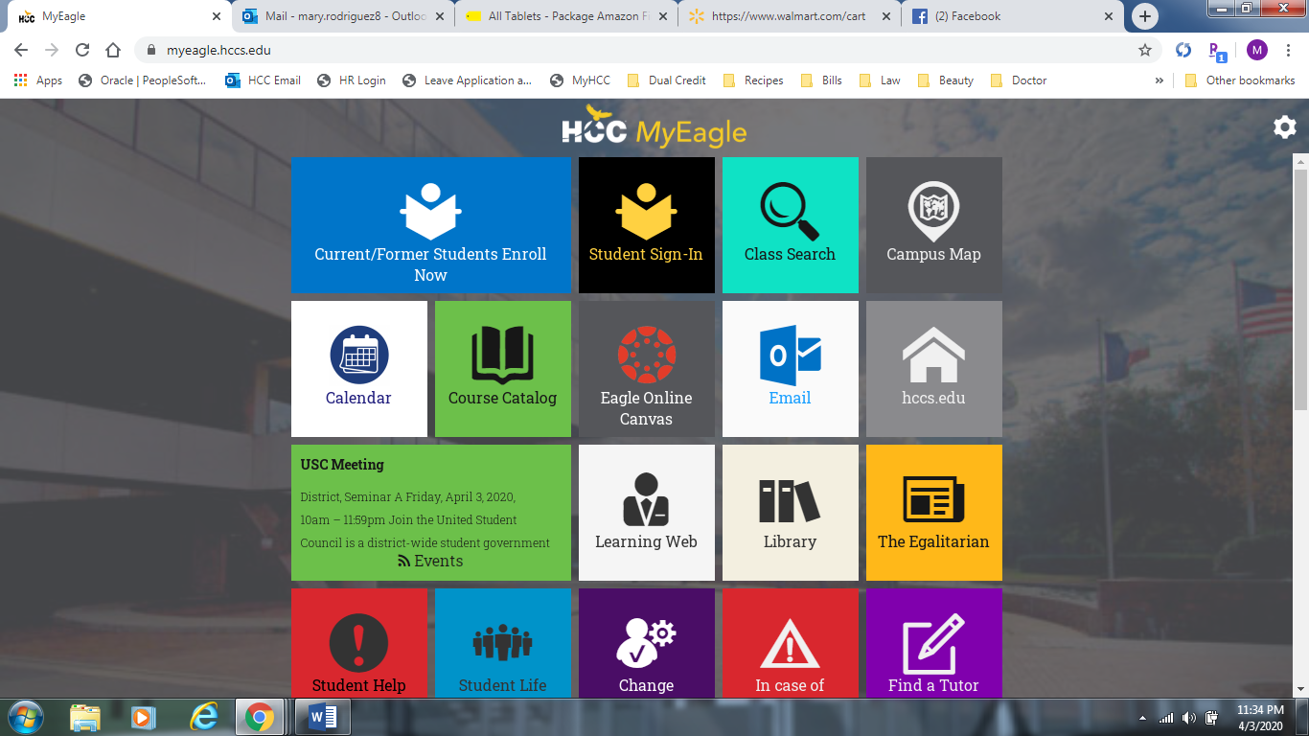

## PeopleSoft / HCC Password

1. Your PeopleSoft screen will look like this and you will need to click the “First Time User” link.

You will be asked for your full Social Security Number and date of birth to verify your identity. If you did not use your social security number when completing your HCC application you will need to get with your Dual Credit Success Coach to retrieve your P# so that you may use that in place of the social. This should take you to a screen with a system-generated password. This is the password HCC has for your PeopleSoft, Canvas, and e-mail accounts. (Take time, later, to explore your information in PeopleSoft.) **If you see a password, copy it and skip to Step 5.**

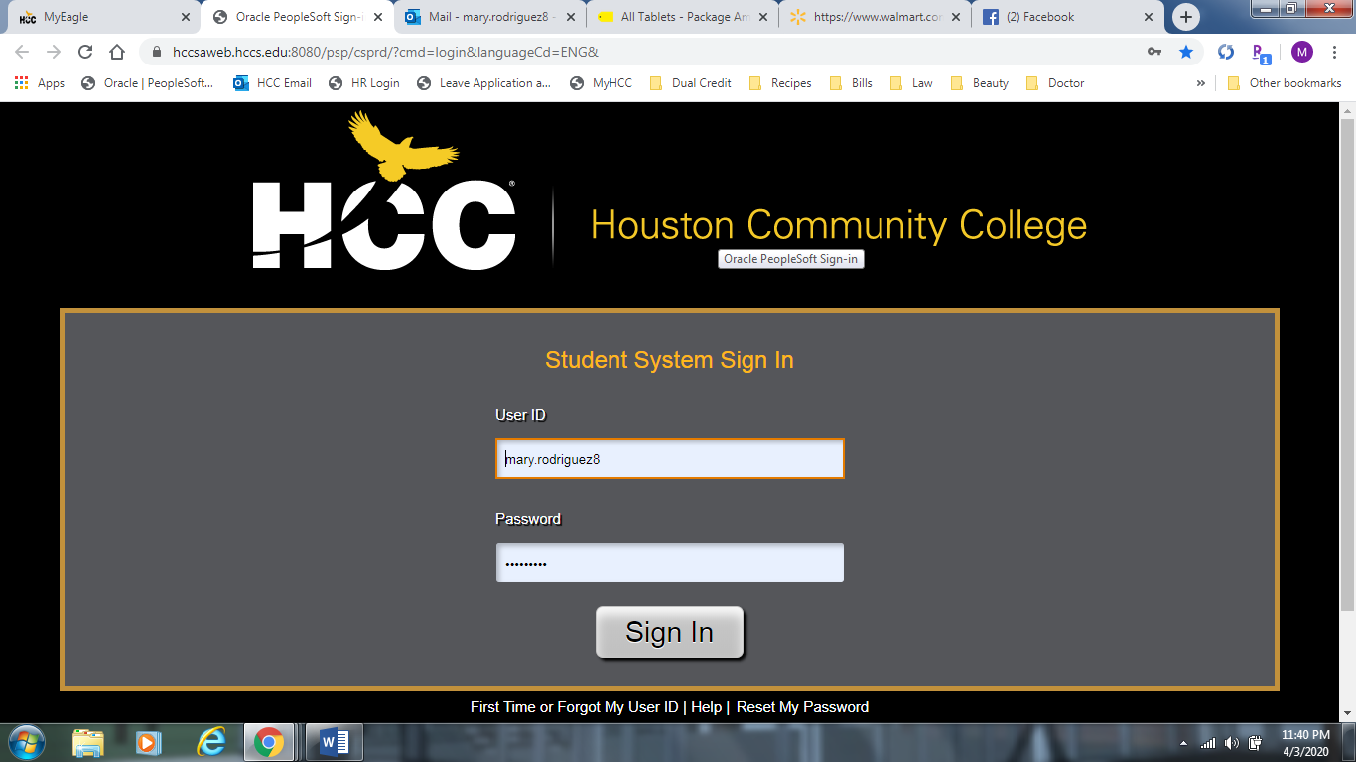

### If you do NOT see a password, you need to contact the HCC IT Help Desk. Phone 713-718-8800 option 1.

**You can also fill out a Technical Help ticket, here.** [**http://de2.hccs.edu/eo2help/**](http://de2.hccs.edu/eo2help/) Although there is a “Password Reset” option, some students weren’t able to reset their passwords this way.

## Canvas Login Page

1. You will be directed to this page. Input your email address as directed above the blank space.

Your student e-mail will be the **W+the 9 digit HCC ID number@student.hccs.edu** Make sure “student” is singular. Your W-number is also in the e-mail you received from HCC, after you had registered for this course. Depending on what e-mail was used it might have been sent to your parents’ e-mail, so check with them.

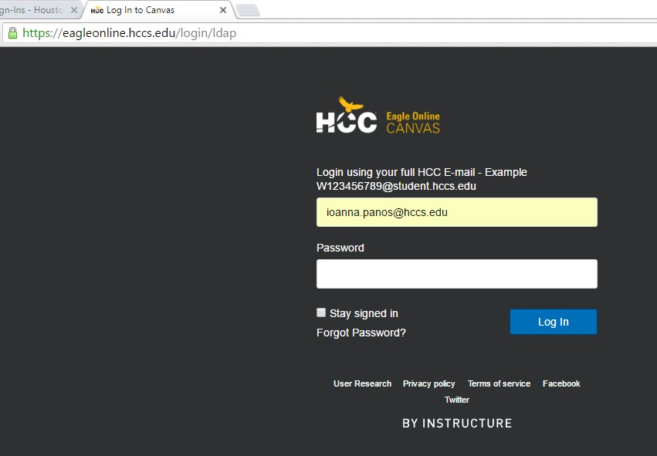

## Shell for 1301

1. Your page will look like this. If you are enrolled in any dual credit courses using Canvas, all of them will appear on one dashboard. Here is what it would look like.
   * If you log in and do not see the course you are to have been registered for, you must immediately get with your High School counselor as well as HCC Dual Credit department to determine why your course is not visible.

If you have technical difficulties with Canvas itself—not with a Module—click on the “Help” button or call HCC’s IT department.

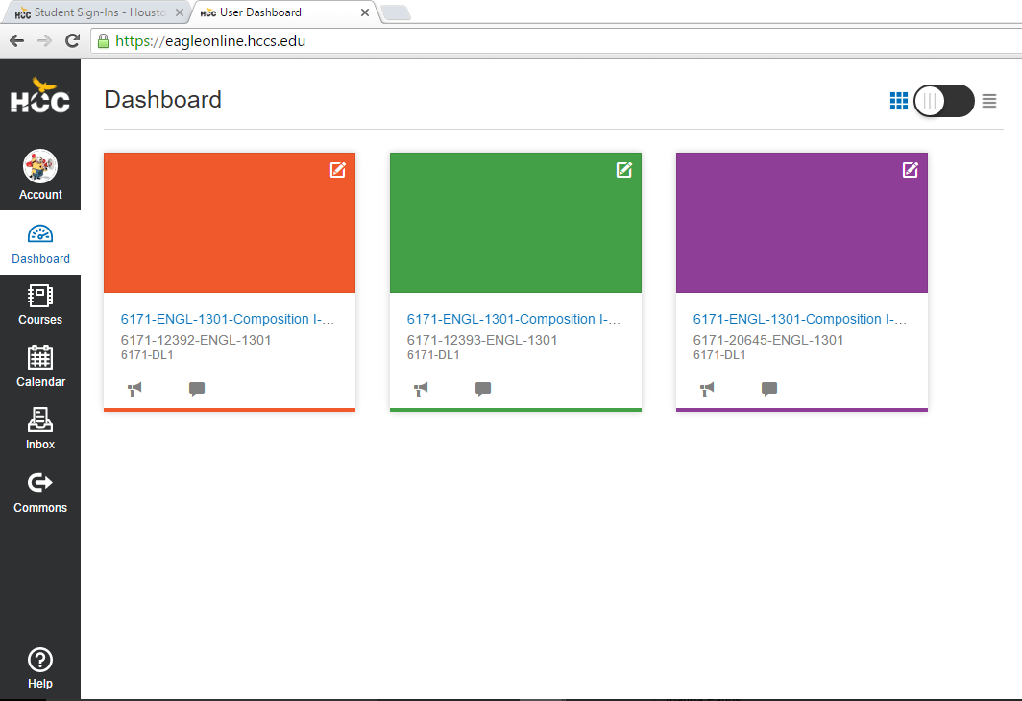

1. Once you click on the course you want to work on your homepage will look like this, regardless of your class period. Follow any of the Module links or “Start Here” link to get to your first module.

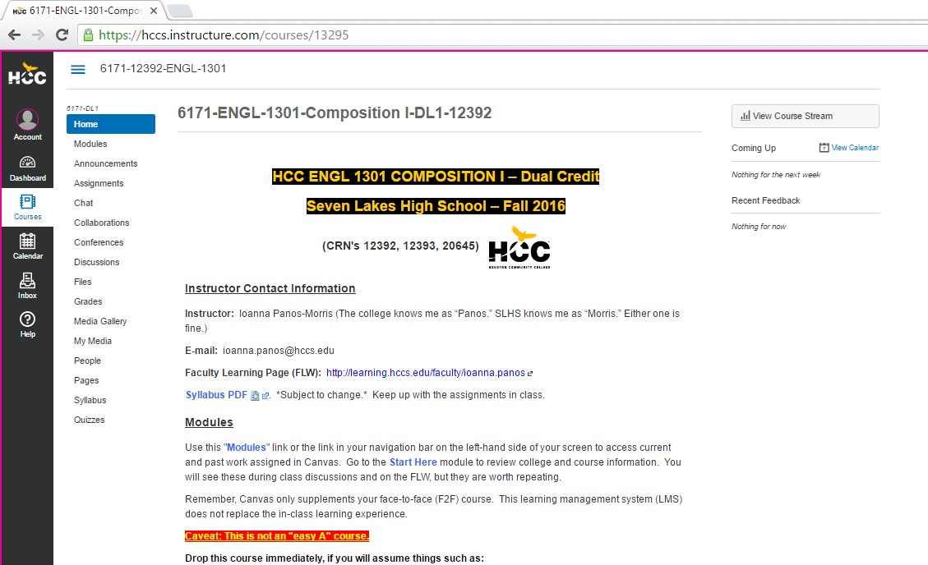

1. Your “Start Here” module looks like this. The quiz is indented. Disregard the original date in the instructions. Note the correct date is September 14, the day after the rosters close. Check the time. ☺

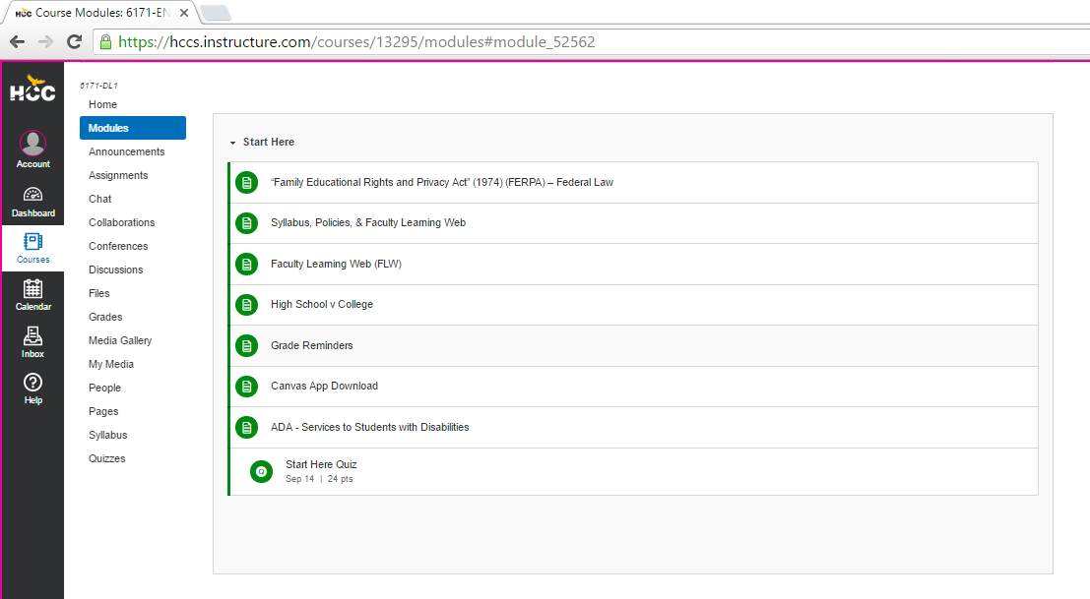

* **Please review each course syllabus as well as deadlines for your assignments as they will all need to be completed by those dates and times.**

# HCC E-mail (Outlook 365)

If you already have an Outlook 365 e-mail account, youcan simply go to that screen. Youcan also access the link on this screen:



At the login screen, type your new e-mail address *in full.* [**W-number@student.hccs.edu**.](mailto:W-number@student.hccs.edu) Your password is the one HCC gave you in PeopleSoft.

NOTE: If you change your password in Outlook, your password doesn’t change in PeopleSoft. You have to manually change your passwords. For security purposes, HCC makes everyone reset their passwords every 120 days. To change your password you will need to log into your Student Sign-In page and once you reset your password there it will take about 15-30 minutes to change on all other HCC log-in accounts. Should you get locked out or are in need of assistance please contact our IT department at 713-718-8800