WHIDBY ELEMENTARY SCHOOL

# For Leadership in Health Sciences

7625 Springhill Houston, Tx. 77021

Phone: 713-746-8170 Fax: 713-746-8173

First Grade 2024-2025 School Supply List

5 composition books (marble covered, 100 sheets) 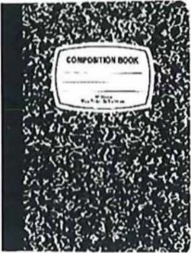

1 spiral notebook- wide ruled

5 poly plastic-pocket folders with the prongs (blue, green, red, yellow, and orange)

1. pack of copy paper
2. 24 pack of #2 pencils

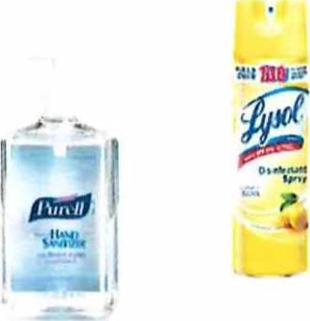1 pencil- zipper bag

1. pack of HI-POLYMER ERASERS Pentel
2. boxes of tissue

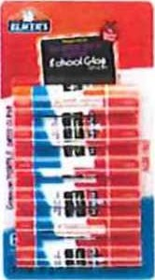2 bottles of hand sanitizer

1 hand soap

1 box of Quart size Ziploc bags

1. 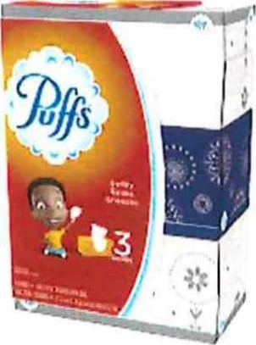box of Gallon size Ziploc bags
2. can of Lysol

1 3 pack of Clorox or Lysol wipes

1. pair of scissors
2. pack of Manila paper
3. 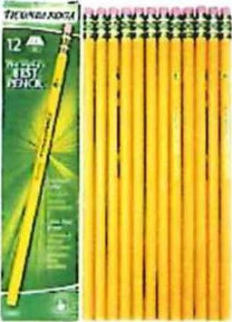pack of construction paper
4. boxes of crayons
5. glue sticks

|  |
| --- |
| Crayola |
|  |

|  |  |  |
| --- | --- | --- |
|  |  |  |
| LORD  DISINFECTIN<  WIPES..  V•ynr. |  |  |
|  | | |

WHIDBY ELEMENTARY SCHOOL

For Leadership in Health Sciences

7625 Springhill Houston, Tx. 77021

Phone: 713-746-8170 Fax: 713-746-8173

Lista de útiles escolares de primer grado 2024-2025

1. cuadernos de composición (cubierta de mármol, 100 hojas)

1 cuaderno de espiral de rayas anchas

5 carpetas con bolsillos de plástico polivinílico con las puntas (azul, verde, rojo, amarillo y naranja)

1 paquete de papel de copia

1. 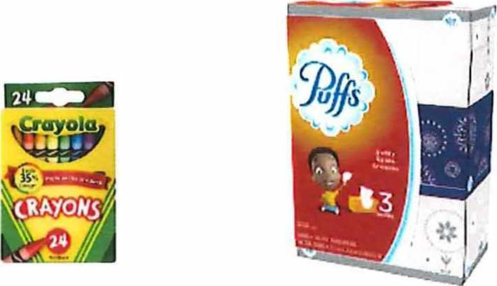paquete de notas adhesivas
2. paquetes de papel manila

2 24 paquetes de lápices #2

1 bolsa con cremallera para lápices

1 paquete de BORRADORES DE Hl-POLíMERO Pentel

4 barras de pegamento

2 cajas de crayones

1. 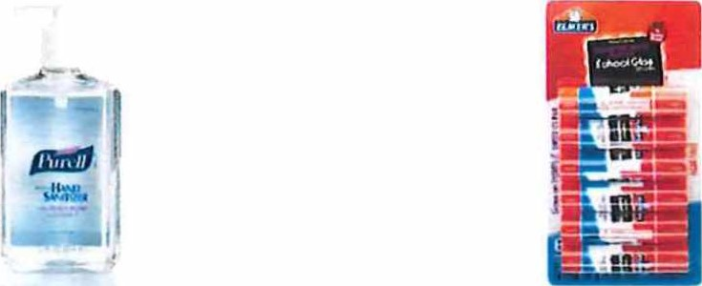par de tijeras
2. cajas de pañuelos

2 botellas de desinfectante para manos

1. jabón de manos
2. 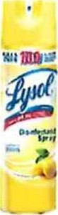latas de Lysol

1 (3) paquete de toallitas Clorox o Lysol

1 caja de bolsas Ziploc de un cuarto de galón

1 caja de bolsas Ziploc tamaño Galón