New Employee Orientation FAQs and Information
Text YES to enroll in district text alerts to 68453
Website Information:
http://www.houstonisd.org/onesource- main system that houses all personnel information, paycheck stubs, W2, W4, leave time, appraisals, professional development and more
- Employee Self Service (ESS) page has all personnel info
- The resignation, conflict of interest and contracts are in OneSource as well
- OneSourceMe - appraisals/goal setting, professional development, annual compliance courses
www.HoustonISD.org/NewHires - New hires website with all info and resources
Houstonisd.org/myHISD - Employee portal with quick links and frequently used sites, applications, forms and more
Board Policy can be found by visiting www.houstonisd.org and hover over Board
For Benefits-Related Questions Contact: Benefits Office | BenefitsOffice@HoustonISD.org | 713–556–6655 www.hisdbenefits.org.
If you have questions regarding the Teacher Appraisal training, please email TeacherEval@houstonisd.org
Performance Management Team Contact: 713-556-3093 | AppraiserHelpDesk@Houstonisd.org
Link to Non-Teacher Appraisal Resources Non-Teacher Appraisal System - Home
SEL Department (For Students or Employees in Emotional Crisis) Contact: Crisis Intervention & Social and Emotional Learning | HISDSEL@HoustonISD.org | 713-967-5235
For Reporting EEO Violations, Harassment & Discrimination Contact: Employee Relations | EmployeeRelations@HoustonISD.org | 713–556–7333 or 713-556-7313
For Hardware/Software Technical Issues Contact: (Network Access, HISD provided technology)
IT Service Desk | ServiceDesk@HoustonISD.org | 713–892–SERV (7378)
Contact the HISD Service Desk at 713-892-7378 or ServiceDesk@HoustonISD.org
Safety and Emergency Management Contact Information SEM@houstonisd.org | 713- 556-7933
Office of Ethics and Compliance Contact: 713-556-6095 | Ethics@houstonisd.org
For Reporting Suspected Fraud, Waste, Abuse, or Other Impropriety Contact: Ethics Hotline | 1–800–455–9551
ID Badges
Q: Can you send badges to campus?
A: For security purposes you must come to Hattie Mae White to pick up the badge unless your AP or Principal comes themselves to do a group pick up.
HISD Badge Request Form:
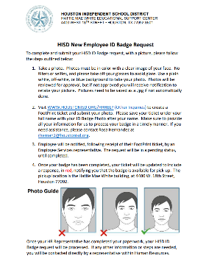
www.HoustonISD.org/HRHelp --> Click ‘All Other Inquiries’ to request ID badges online.
For ID Badges Support Contact: Badge Desk | 713–556–7019

Payroll Questions
Q: When is Payday?
A: Payday is every other Wednesday via direct deposit or money card.
Q: When do I get my first paycheck?
A: Please note that your first paycheck depends on your date of hire. Payroll Calendar
Salary Tables Salary Tables (houstonisd.org)
Escrow - Monies collected and stored to pay you during the months not worked for all employees less than 12 months. ESCROW IS NOT OPTIONAL and only applies to employees less than 12 months.
For questions regarding payroll, leave, balances, direct deposits, and more contact: Human Resources Employee Services | HRAnswerLine@HoustonISD.org
All questions pertaining to stipends, bonuses, or pay in any regards will need to be directed to compensation, we cannot answer those questions for you here. compensationdept@houstonisd.org 713-556-7323
Please see the link below for more detailed information about HISD’s leave policy and practices
COMPENSATION AND BENEFITS - LEAVES AND ABSENCES (tasb.org)
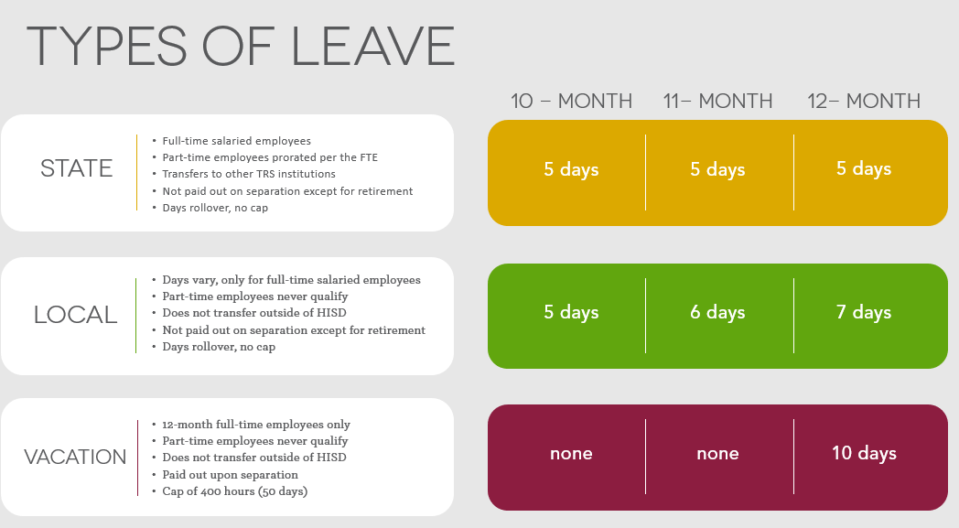

Hiring Process Questions
Q: Where do I get my username and password or ID number and password?
A: That information is in your Welcome Letter sent by your Employee Services Analyst.
Q: I never got my Welcome Letter how do I get it?
A: You need to contact your Employee Services Analyst at 713-556-6559 hiring@houstonisd.org
Q: Does HR offer fingerprinting services at the Hattie Mae White?
A: Yes, but you must have an appointment with another identigo location first to be logged into the system.
Q: I have a fingerprinting appointment somewhere else in the future, can I come up to Hattie Mae sooner to get them done?
A: Yes
You may contact HR Employee Services via email at hranswerline@houstonisd.org or by phone at 713-556-7400, option 6 from 8 a.m. to 5 p.m. CT Weekdays (except holidays). www.HoustonISD.org/HRHELP

Technology Questions
Q: I have not received my HISD email address.
A: That information is in your Welcome Letter sent by your Employee Services Analyst.
For Hardware/Software Technical Issues Contact: (Network Access, HISD provided technology)
IT Service Desk | ServiceDesk@HoustonISD.org | 713–892–SERV (7378)
Contact the HISD Service Desk at 713-892-7378 or ServiceDesk@HoustonISD.org

Benefits Questions
For ALL questions related to Benefits, please contact the Benefits Department:
For Benefits Enrollment/Changes Contact: Benefits Service Center | 1–877–780–HISD (4473)
For Benefits-Related Questions Contact: Benefits Office | BenefitsOffice@HoustonISD.org | 713–556–6655 www.hisdbenefits.org.
Aetna On-site Representative Joselyn Hernandez jhernandez6@houstonisd.org
713-203-4789
She can help with any medical plan information, claims, EOBs, and much more.
Edward Garza - dental onsite: edward.garza@cigna.com 713-556-8207

Retirement Questions
For Teacher Retirement System of Texas (TRS) Contact: Teacher Retirement System of Texas | https://www.trs.texas.gov/ | 1–800–223–8778
For Optional Retirement Plans & TRS Retirement from HISD Contact: Retirement Storefront | BenefitsESS@HoustonISD.org | 713–695–5561

