

# SUGAR GROVE ACADEMY MIDDLE SCHOOL

8405 Bonhomme Rd, Houston, TX 77074

(713) 271-0214 FAX (713) 771-9342

Shared Decision-Making Committee (SDMC) Meeting

Minutes

Date: June 7, 2022

Location: Virtual Zoom Meeting

Time: 1:00 - 1:17 p.m.

Meeting called to order at: 1:10 p.m.

Present Participants Indicated TEAMS Participation List.

|  |  |
| --- | --- |
| Desai, Nimisha | Teacher |
| Griffin, Alfarata | Teacher |
| Helmy, Islam | Teacher |
| Romel, Illiana | Counselor |
| Tijerina, Diana | Receptionist |
| Whitfield, Laquita | Administrative Assistant |

Austin, Ericka Principal

Principal Austin opened meeting and discussed the following:

* Target STAAR Assessment — Students met goals:



60% TELPAS•, Reading Growth 65%; Math 71% o TELPAS Goals— Students were successful and exceeded goal!

* Out-of-School Suspensions Goals — We met the goal of meeting less than 250 fewer outof-school suspensions which was a concerted effort.
* Mr. Helmy spearheaded the curriculum along with Mr. Griffin. Both implemented ESL SEL (Social Emotional Learning) lessons. o This curriculum is not vetted at other schools.
* Students had to be present and write on How to Manage Themselves and they also participated in character education.
* Attendance Goals — The attendance of students was challenging due to COVID-19, just this week nine staff members tested positive, and next week should be 95% higher in attendance.

SDMC Minutes

Page 2

June 7, 2022

* Attendance was over projection of 790 students which increased our enrollment. We had 725 students enrolled last school year 2020-2021 and 850 students actually enrolled for 2021-2022. Additional funds PUA and Rise were given to add on an administrator, counselor, and an art teacher for next year. Class sizes will have to be reduced and more teachers employed. Adding electives for next year: Art, Spanish, Principal of Info Technology. More hourly employees will be hired to push in aides and tutors.

0 21 st Century Summer School Program began today.

o New Appraisal System — moving away from TADS (Teacher Appraisal and Development System) to T-TESS (Texas-Teacher Evaluation and Support System). Teachers received an information packet to complete if not returning to SGA.

Congratulations and Departures o Ms. Desai has been promoted to Multilingual Class Leader for the district o Ms. Josey who has 30 years in the district is transferring from SGA to HISD

Community Services School to meet the needs of the community in a non-traditional setting. We will miss her!

The meeting adjourned at 1 : 17 p.m.

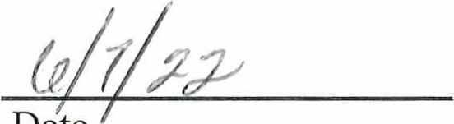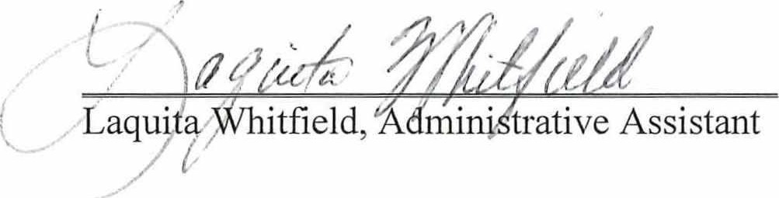 Date