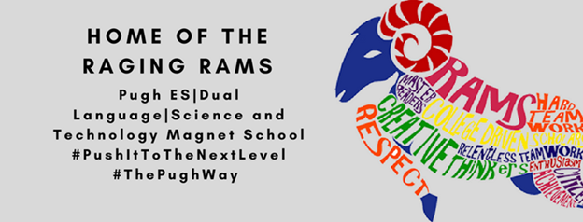
SDMC Minutes
Monday, January 31, 2022
Agenda items:

ESSER funding
- Magnet Awareness
- Providing shirts for students
- Gardening Club
- Special Education "Sensory Objects"
- Flexible Seating
  - Small group chairs
- Cones for Safety
- Fix the key card by the library
- Small white Post-Its
STEAM Lab Position
- 2 potential grants to fund STEAM

STEAM Magnet
- Partnering with Fine Arts
- Meeting with parents
- Parent volunteers
- Training for teachers
- Ms. Halphen is our Magnet Coordinator
- Afterschool Club

Opening of 3rd PreK and Kindergarten classes

Let Ms. Saldana: Open the Teacher Workroom in the morning

