

SDMC Meeting
Quarter III
February 18, 2025

Roll Call (gain signatures of all present)
Begin and end on time
Silence cell phones
Make sure all voices are heard
If you wonder, ask.

Specific Agenda Items

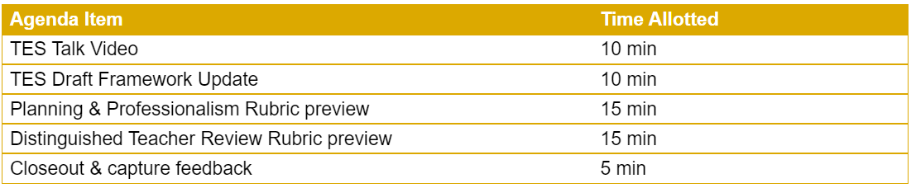

Magnet Update
- 1st Application Window Closed on February12
- Approximately 550 applications
Upcoming Events
- Feb 21st- Senior Ranking
- Feb 21& 28 - TELPAS
- Feb 28th – Black History Month Program
- March 1^{st-} -Job Fair
- March 10-14th -Spring Break
- March 21st SAT- IN school 11th Grade

