AP Capstone: Seminar 2024-2025 Carnegie Vanguard High School
Instructor: Ms. Jane Schulz E-mail: jschulz1@houstonisd.org
COURSE DESCRIPTION
AP Seminar is a foundational course that engages students in cross-curricular conversations that explore the complexities of academic and real-world topics and issues by analyzing divergent perspectives. Using an inquiry framework, students practice reading and analyzing articles, research studies, and foundational, literary, and philosophical texts; listening to and viewing speeches, broadcasts, and personal accounts; and experiencing artistic works and performances. Students learn to synthesize information from multiple sources, develop their own perspectives in written essays, and design and deliver oral and visual presentations, both individually and as part of a team. Ultimately, the course aims to equip students with the power to analyze and evaluate information with accuracy and precision to craft and communicate evidence-based arguments. Through this inquiry-based, interdisciplinary course, students will develop skills that allow them to effectively question, explore, understand, analyze, examine, synthesize, team, transmit, and transform. To understand how to holistically examine a particular issue or problem, we will evaluate the issues through a myriad of perspectives and lenses. Teacher provided resources, as well as student research, will function as the means through which we explore both the topic and perspectives. The resources we examine should be from multiple primary and secondary sources (e.g., articles, speeches, art, opinion pieces, etc.). Looking at said perspectives, students will realize how to uncover the complexity of answering research questions.
NOTE:
- The inquiry-based nature of the Seminar course requires activities and assessments from a variety of resources (library/Internet research, audio/video equipment, etc.).
- Information used to address a problem may come from various print and nonprint secondary sources (e.g., articles, other students, analyses, reports) and/or primary sources (e.g., original texts and works or personally collected data such as experiments, surveys, questionnaires, and interviews).
- Students will be expected to use technology to access and manage information from online databases (e.g., Google Scholar, EBSCO, GALE) that grant access to secondary and primary sources.
- As the AP Program engages students in college-level work, the AP Seminar course may include perspectives that could be considered controversial, including references to ethnicity, nationality, religion, politics, race, dialect, sexuality, gender, or class. AP Seminar requires students to have the level of maturity and skill to thoughtfully consider and analyze diverse perspectives. The inclusion of topics, readings, texts, and other source material is not intended as an endorsement by the College Board of the content, ideas, or values expressed in the material.
Expected Student Learning Outcomes
Throughout the program, students consider multiple points of view to develop their own perspectives on complex issues and topics through inquiry and investigation. The AP Capstone program provides students with a framework that allows students to develop, practice, and hone their critical- and creative-thinking skills as they make connections between issues and their own lives. While helping students to develop and strengthen their critical- and creative-thinking skills, students will learn to consider multiple points of view to develop their own perspectives on complex issues and topics through inquiry and investigation.
The inquiry process will expose students to a variety of primary and secondary print and nonprint sources such as articles, research studies, foundational, literary, and philosophical texts; speeches, broadcast, and personal accounts; and artistic works and performances. The wide variety of academic sources will provide the opportunity to gain a rich appreciation and understanding of issues as students collaboratively or independently analyze and evaluate the evidence to consider options, alternatives, solutions, or resolutions to real-world or academic problems.

GRADING CATEGORIES

40% Written Analysis: Students will complete written analysis that mimics some portion of the AP EOC Exam (Task #3) – Parts A and/or B, as well as mock/draft IRR and IWA activities.

40% Synthesis Skills: Students will take short quizzes on assigned reading material and will periodically be tasked with putting together a presentation for class (individual and/or group). These presentations will follow portions of the scoring rubrics from the Individual Media Presentation (IMP) and Team Multimedia Presentation (TMP).

20% Academic Skills & Daily Participation: This category includes participation in daily discussions, quick writes, article annotations, and reading/work that is assigned for completion at home.
LATE WORK POLICY
Students will have one school day to submit a late assignment for a maximum grade of 70. The student MUST notify the teacher via an email letting the teacher know that the late assignment was submitted. If the student does not get a reply confirming the receipt of the email from the teacher, then it is the student’s responsibility to check in with the teacher to confirm.
If the student never emails the teacher, then the late work will not be accepted, and the student will receive a 0 for the late assignment.
The teacher will not remind students to submit late work. It is entirely up to the student to be aware of the due dates for EACH assignment (these will be posted in Canvas and the board in class). Being away from school for any school-related activity does not excuse you from turning in any due assignment at assigned times.
Submissions
Students who remove the meta data/time stamps from their documents or in Canvas will receive an automatic zero for that assignment. It is imperative that students do not do anything that manipulates data on things submitted for a score. It is essential that you keep all original documents saved to Canvas, Google Drive and/or computer hard drive in case the metadata or time stamp is missing
It is your responsibility to plan for any missed work outside of class time. If a student has an absence, they will be allowed to turn in the missed assignment according to district policy. If a student is absent on a class discussion day, it is the student’s responsibility to discuss with me ways to complete the discussion assignment.
Semester 1 Goals: Learn & master skills needed to exceed the expectations of AP Seminar Assessments
In Class | Culminating Activities
Cycles 1-3 | - Introduction to Proficiencies and Critical Thinking Skills
PERFORMANCE TASK 1  STUDENTS ARE NOT TO WORK DURING HOLIDAY BREAKS | - Individual Research Report 1200 words (+/-) 10% of word count  - 6-10 min Team Multimedia Presentation

Semester 2 Goals: Apply learned & mastered skills to AP Seminar Assessments
In Class |  | Culminating Activities
PERFORMANCE TASK 2  AP EXAM EOC  INTRODUCE AP RESEARCH/TPSP  STUDENTS ARE NOT TO WORK DURING HOLIDAY BREAKS |  | Upload AP Task 1  - Individual Written Argument 2000 words (+/-) 10% of word count  - 6-8 min Individual Multimedia Presentation  - Upload AP Tasks 2  - Review for EOC Performance Task 3  After the AP Exam:  - Decide on a potential topic for Research/TPSP  - Create a working thesis for research next year.
 | COMPONENTS OF THE STUDENT’S AP SCORE  Performance Assessment Task #1  Team Project & Presentation  Task Overview  Students work in teams of three to six to identify, investigate, analyze, and evaluate an academic or real-world problem, question, or issue. Each team designs and/or considers options and evaluates alternatives; develops a multimedia presentation to present the argument for their proposed solution or resolution; and provides a defense to questions posed by the teacher. |  | 20% of total score
 | Individual Research Report (IRR)  (approximately 1,200 words) |  | 10% | College Board Scored
 | Team Multimedia Presentation (TMP)  (8-10 minutes) with follow-up questions |  | 10% | Teacher scored
 | Performance Assessment Task #2  Individual Research-Based Essay & Presentation  Cross-curricular Stimulus Material Provided  Task Overview  The College Board’s AP Program will annually release cross-curricular source materials (texts) representing a range of perspectives focused on a single theme.  Students will read and analyze these texts to identify thematic connections among them and possible areas of inquiry; compose a research question of their own; conduct research; analyze, evaluate, and select evidence to develop an argument; and present and defend their conclusions. The final must paper must refer to and incorporate at least one of the provided sources. |  | 35% of total score
 | Individual Written Argument (IWA)  (approximately 2,000 words) |  | 24.5% | College Board scored
 | Individual Multimedia Presentation (IMP)  (6-8 minutes) |  | 10.5% | Teacher scored
 | Assessment Task #3  End-of-Course Exam (2 Hours)  Task Overview During the AP Exam administration window, students will take the AP seminar written exam. The exam consists of four items:  - Part A: Three Short Answer Questions (EOC A)  Assesses student’s analysis of argument in a single source or document  - Part B: One Essay Question (EOC B)  Assesses student’s skills in synthesizing and creating an evidence-based argument  Important Dates:  Tasks #1 and #2 are due in the digital portfolio by April 30, 11:59 EST  Task #3 (AP EOC Exam Parts A & B) will be on Monday, May 12, 2025 |  | 45% of total score  13.5%  31.5% | College Board scored

We will spend the first half of the year developing the skills that will enable you to be successful on all three components of your AP score. After Thanksgiving break, we will begin to work on your team projects, and by the beginning of February, we should be moving on to your individual research projects.
Students work collaboratively with a team to identify, investigate, analyze, and evaluate a real-world or academic problem or issue; consider and evaluate alternatives or options; propose one or more solutions or resolutions; and present and defend the argument for their solutions through a multimedia presentation.
Students work independently to identify a research question based on provided stimulus material; research the issue; analyze, evaluate, and select evidence to develop an argument; present and defend a conclusion; and produce a multimedia presentation to be delivered to their peers.
AP Capstone Policy on Plagiarism and Falsification or Fabrication of Information
Participating teachers shall inform students of the consequences of plagiarism and instruct students to ethically use and acknowledge the ideas and work of others throughout their course work. The student’s individual voice should be clear, and the ideas of others must be acknowledged, attributed, and/or cited.
A student who fails to acknowledge the source or author of any and all information or evidence taken from the work of someone else through citation, attribution or reference in the body of the work, or through a bibliographic entry, will receive a score of 0 on that particular component of the AP Seminar and/or AP Research Performance Task. In AP Seminar, a team of students that fails to properly acknowledge sources or authors on the Team Multimedia Presentation will receive a group score of 0 for that component of the Team Project and Presentation. A student who incorporates falsified or fabricated information (e.g. evidence, data, sources, and/or authors) will receive a score of 0 on that particular component of the AP Seminar and/or AP Research Performance Task.
AP Seminar, a team of students that incorporates falsified or fabricated information in the Team Multimedia Presentation will receive a group score of 0 for that component of the Team Project and Presentation. Students develop an understanding of the AP Capstone Policy on Plagiarism and Falsification or Fabrication of Information.
GUIDANCE FOR ARTIFICAL INTELLIGENCE TOOLS (FROM THE COLLEGE BOARD WEBSITE)
Generative AI tools must be used ethically, responsibly, and intentionally to support student learning, not to bypass it. Accordingly, all performance tasks submitted in AP Seminar and AP Research must be the student’s own work. While students are permitted to use generative AI tools consistent with this policy, their use is optional and not mandatory.
Students can use generative AI tools as optional aids for exploration of potential topics of inquiry, initial searches for sources of information, confirming their understanding of a complex text, or checking their writing for grammar and tone. However, students must read primary and secondary sources directly, perform their own analysis and synthesis of evidence, and make their own choices on how to communicate effectively both in their writing and presentations. It remains the student’s responsibility to engage deeply with credible, valid sources and integrate diverse perspectives when working on the performance tasks. Students must complete interim “checkpoints” with their teacher to demonstrate genuine engagement with the tasks.
Required Checkpoints and Attestations for AP Capstone
To ensure students are not using generative AI to bypass work, students must complete interim checkpoints with their teacher to demonstrate genuine engagement with the tasks. AP Seminar and AP Research students will need to complete the relevant checkpoints successfully to receive a score for their performance tasks. Teachers must attest, to the best of their knowledge, that students completed the checkpoints authentically. Failure to complete the checkpoints will result in a score of 0 on the associated task.
- In AP Seminar, teachers assess the authenticity of student work based on checkpoints that take the form of short conversations with students during which students make their thinking and decision-making visible (similar to an oral defense). These checkpoints should occur during the sources and research phase (IRR and IWA), and argument outline phase (IWA only). A final validation checkpoint (IRR and IWA) requires teachers to confirm the student’s final submission is, to the best of their knowledge, authentic student work.
- In AP Research, students must complete checkpoints in the form of in-progress meetings and work in the Process and Reflection Portfolio (PREP). No further checkpoints will be required.
College Board reserves the right to investigate submissions where there is evidence of the inappropriate use of generative AI as an academic integrity violation and request from students copies of their interim work for review.
Students and Parents: Please note that the teacher cannot write, revise, correct, or provide specific feedback to individual students on work related to tasks #1 and #2. It is a violation of CB policy and the nature of a student-led independent research course.
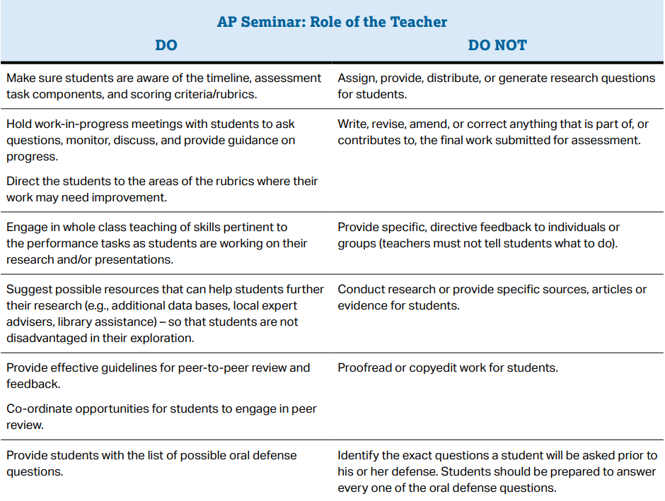

From the College Board Website, 2024

AP CAPSTONE: SEMINAR CARNEGIE VANGUARD HS 2024-2025

The signatures below acknowledge that both the student and parent/guardian understand the expectations of the class and college board.

Parent/Guardian name: ________________________________________________________________

parent/guarding signature: ____________________________________________________________

student name: _________________________________________________________________________

student signature: ____________________________________________________________________

STUDENTS – RETURN THIS SIGNED SYLLABUS SHEET BY FRIDAY, AUGUST 16 FOR A GRADE!

