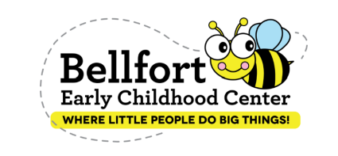
SDMC Meeting
March 5, 2023
3:30 pm – 4:00 pm
Minutes

WELCOME

MOY CAMPUS DATA
- Circle
  - 84% of students meet HISD goal on CLI
- Dibels /Lectura
  - 67% of students Composite Scores was At or Above Benchmark
- NWEA Math May
  - 76th Median growth for kindergarten students
  - BOY Achievement 51st to MOY Achievement 71st

ACTION PLAN
- Pre-Kindergarten
  - 60% of students will score 10 points higher on MOY CLI Math assessment.
  - 70% of students will score 10 points higher on MOY CLI Phonemic Awareness total score assessment.
- Kindergarten
  - 60% of students will score at or above the 50th percentiles on NEWA Math assessment by MOY
  - 70% of students will score 20 points growth from BOY to MOY on the composite scores Dibels /Lectura assessment.

CAMPUS TRAGETED NEXT STEPS
- Pre-Kindergarten
  - Identify all letters upper and lowercase
  - Letter sound 30 or more
  - Counting Sets over 10
  - Operations
- Kindergarten
  - Blending letters to make CVC word
  - Phonemic segmentation

UPCOMING EVENTS
- Field Trip
- Field Day
- Promotion

