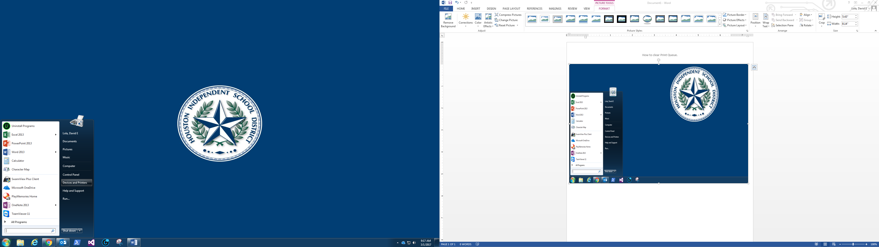

In this How-To you will learn how to access your printers/copiers print queue.

* First Click on the Start Orb in the bottom left corner.
* Next locate Devices and Printers and click on it.
* Once you have clicked on it a list of printers/copiers that you are mapped to should populate.

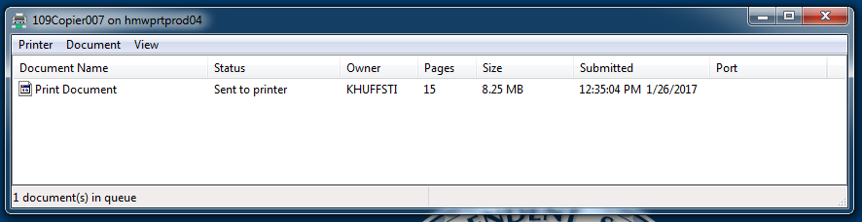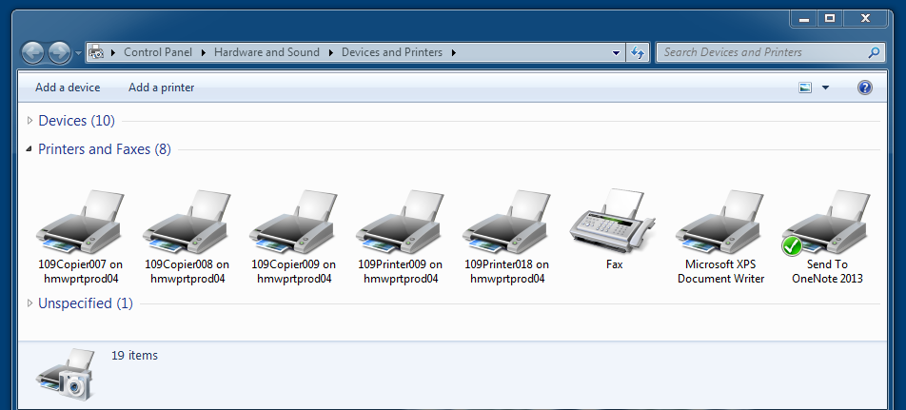

NOTE: You can NOT Cancel or Restart print jobs that are not Owned by you. If you see someone else owns the document, do them the courtesy of letting them know that they have a document in a virtual paper jam and should be cleared ASAP. That’s it You DID IT !!!

-LOLA

In the print queue select/highlight the Print Job you would like to cancel by left clicking.

Once highlighted right click and select cancel or highlight and select the Document Tab then Cancel.

Now that the list of printers /copiers are shown select the one that you sent your print job to, by Double clicking on it.

Once you have done that you should NOW see the selected printers/copiers print queue.

