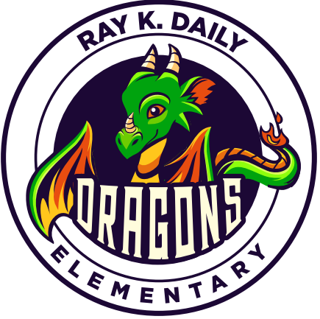
Ray K. Daily Elementary
Houston Independent School District
12909 Briar Forest Houston, TX 77077
281-368-2111
Fax: 281-368-7463

Principal: Cindy Tiet

School-Parent Compact

We believe that for our school to be effective all families of our school and the school staff must work together to ensure that our children are successful in school. A compact is a voluntary agreement between two groups that firmly unites them. Ray K. Daily invites you to be involved in this partnership.
As a school, we will:
- provide a safe, caring environment and facility that is conducive for learning
- provide highly qualified teachers that are well-prepared and equipped with strategies that will make learning fun, interesting, and engaging
- provide curriculum learning and materials to promote educational growth
- explain assignments clearly and provide homework that supports the curriculum
- encourage students and parents by providing information about student progress
- provide after school programs to promote social and emotional development
As a parent, I will:
- provide a safe and caring environment
- get my child to school every day unless he/she is ill or observing a state recognized religious holiday
- get my child to school on time every day and pick him/her up on time
- provide correct information (emergency telephone number) in case the school need to contact me
- provide quiet time each evening so my child can study, read or complete his/her homework
- communicate regularly with my child’s teacher so I will be aware of what my child is learning
- support parent meetings/ workshops that will enlighten me on how to help my child’s academic or social growth
- promote the importance of reading by reading to my child, listening to him/her read, and providing appropriate reading materials
- promote appropriate and adequate sleep habits allowing my child the doctor recommended eight to ten hours of sleep each night Get my child to school daily, unless he/she is ill or observing a state recognized religious holiday
As a student, I will:
- go to class on time every day and be prepared to learn.
- Participate during virtual lessons.
- demonstrate my best effort in class assignments and projects.
- complete homework to the best of my ability
- respect the culture, personal space, and property of others
- respect and cooperate with all adults and students in the school
- spend time daily studying and reading
- inform an adult if I feel unsafe
- inform an adult if I am or see someone being bullied

