
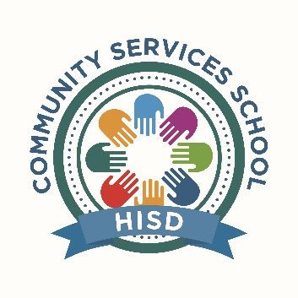

Houston Independent School District
Community Services School

SDMC Meeting – Friday, November 12, 2021
Meeting was called to order at 3:31 p.m.
Attendees Present:

Cicely Williams, Principal and Chairperson
Brian Wilson, Assistant Principal and Co-Chairperson
George Caldwell, Teacher
Tabitha Hobbs, Special Ed. Chairperson
Jaime Mardis, Teacher
Margarita Castaneda, Non-Instructional Staff
Roel Garcia, Community Member
Brandi Gipson, Business Partner

Absent:
Mauricio Gonzalez, Parent
Approval of Agenda:
The agenda was unanimously approved and distributed.
Approval of Minutes:
Previous minutes approved.
Business:
- Meeting began with role call of all SDMC members welcome/introductions

- Principal Williams inquired with SDMC member about any needed resources for class

- Community Services has received donations of car seats for PRS students through the HISD police department.
- Mr. Mardis shared that the needs of teachers and students vary depending on the student diagnosis or circumstance.
- Administrators and office personnel present reported no unfulfilled requests from teachers at this time.
- STAAR Assessment

- Community Services students will test in December.

- Wellness Check

- Principal Williams would like to create a wellness check for faculty/staff members to check on participants and their well-being.
- Assistant Principal Wilson suggested using an app that creates a QR code that is easy to use and faculty/staff members would be able to let us know how they are doing or feeling and if they have any special requests needed from the office personnel.
- Principal Williams offered her services to Mr. Garcia and Ms. Sullivan and did inform them that if they have any needs our school can always assist them with our services and our doors are always open to them.

- Thanksgiving Luncheon

- Community Services will hold the Thanksgiving Luncheon on Friday, November 19, 2021, the luncheon will be catered and pre-packaged, all SDMC members were invited.
- Mr. Garcia expressed his gratitude as a former teacher he knows all teachers appreciate all the recognition given to them by campus principal.

- Next SDMC meeting will be in 2022

Meeting adjourned at 3:45 p.m.

