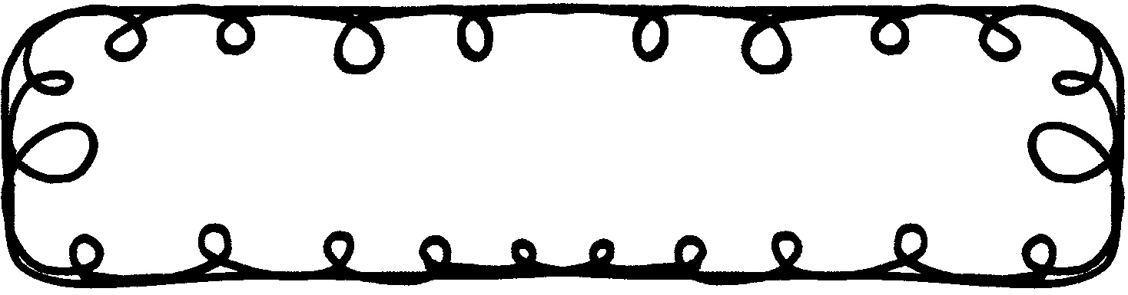

First Grade Gazette September 9, 2019

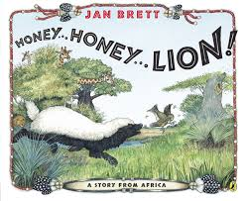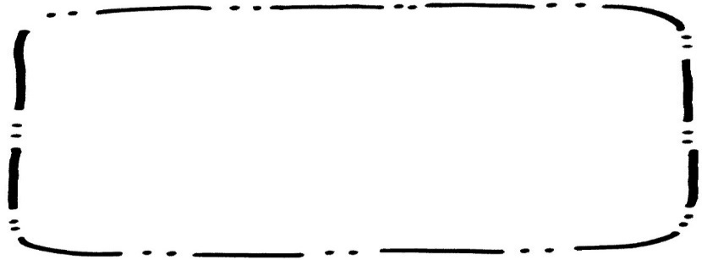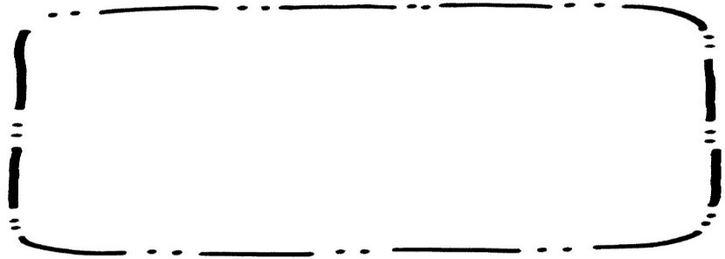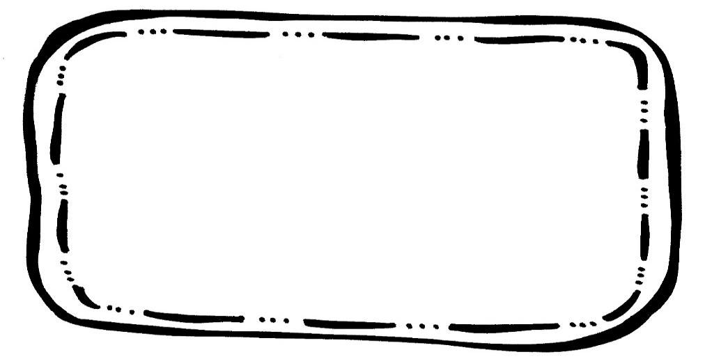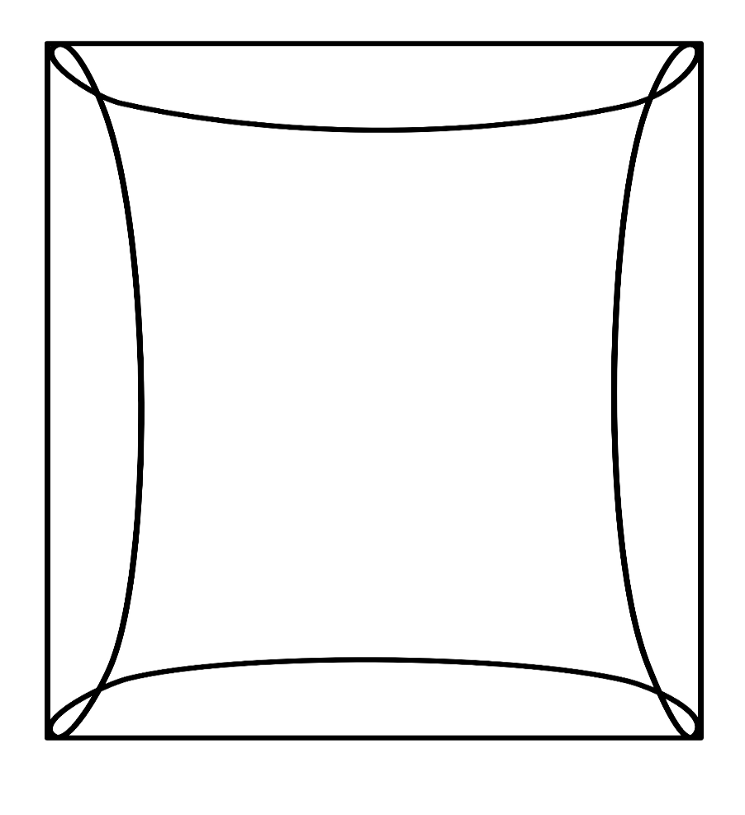

Writing

We will continue working on nouns. We will also work on writing stories.

Social Studies

We will be identifying American Symbols and learning their importance.

Math

We will focus on counting, building, and writing numbers to 50.

Spelling**Tested 9/13

at bag can ham sad was have from but what

**Sentence Dictation Coming Soon**

**Reading Comprehension**

* Retelling using beginning, middle, and end

**Vocabulary Words**

Glide – to move smoothly

Scold – to speak or yell in an angry way at someone

Waddle – walking in short steps with a swaying motion

Burrow – a hole or tunnel dug by a small animal

Hollow – having a hole or empty space inside

**Upcoming Events**

**September**

9 – Music Choice Due

23 – Grandparent’s Lunch

27 – Early Dismissal (No Extended Day)

30 – 10/4 – Book Fair