1. Video Instructions Available @ >>>> <https://www.screenr.com/weGN>

First click on your ***Berry Common Drive*** shortcut. You should now see Berry Common Drive contents.

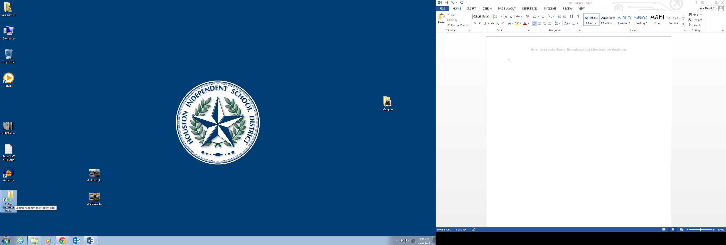 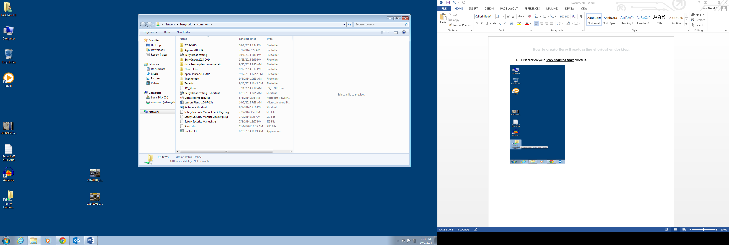

2.Find the ***Berry Broadcasting*** icon and right click on it. Next navigate down to ***Copy*** and left click. Minimize or close your window after you have copied the ***Berry Broadcasting folder***.

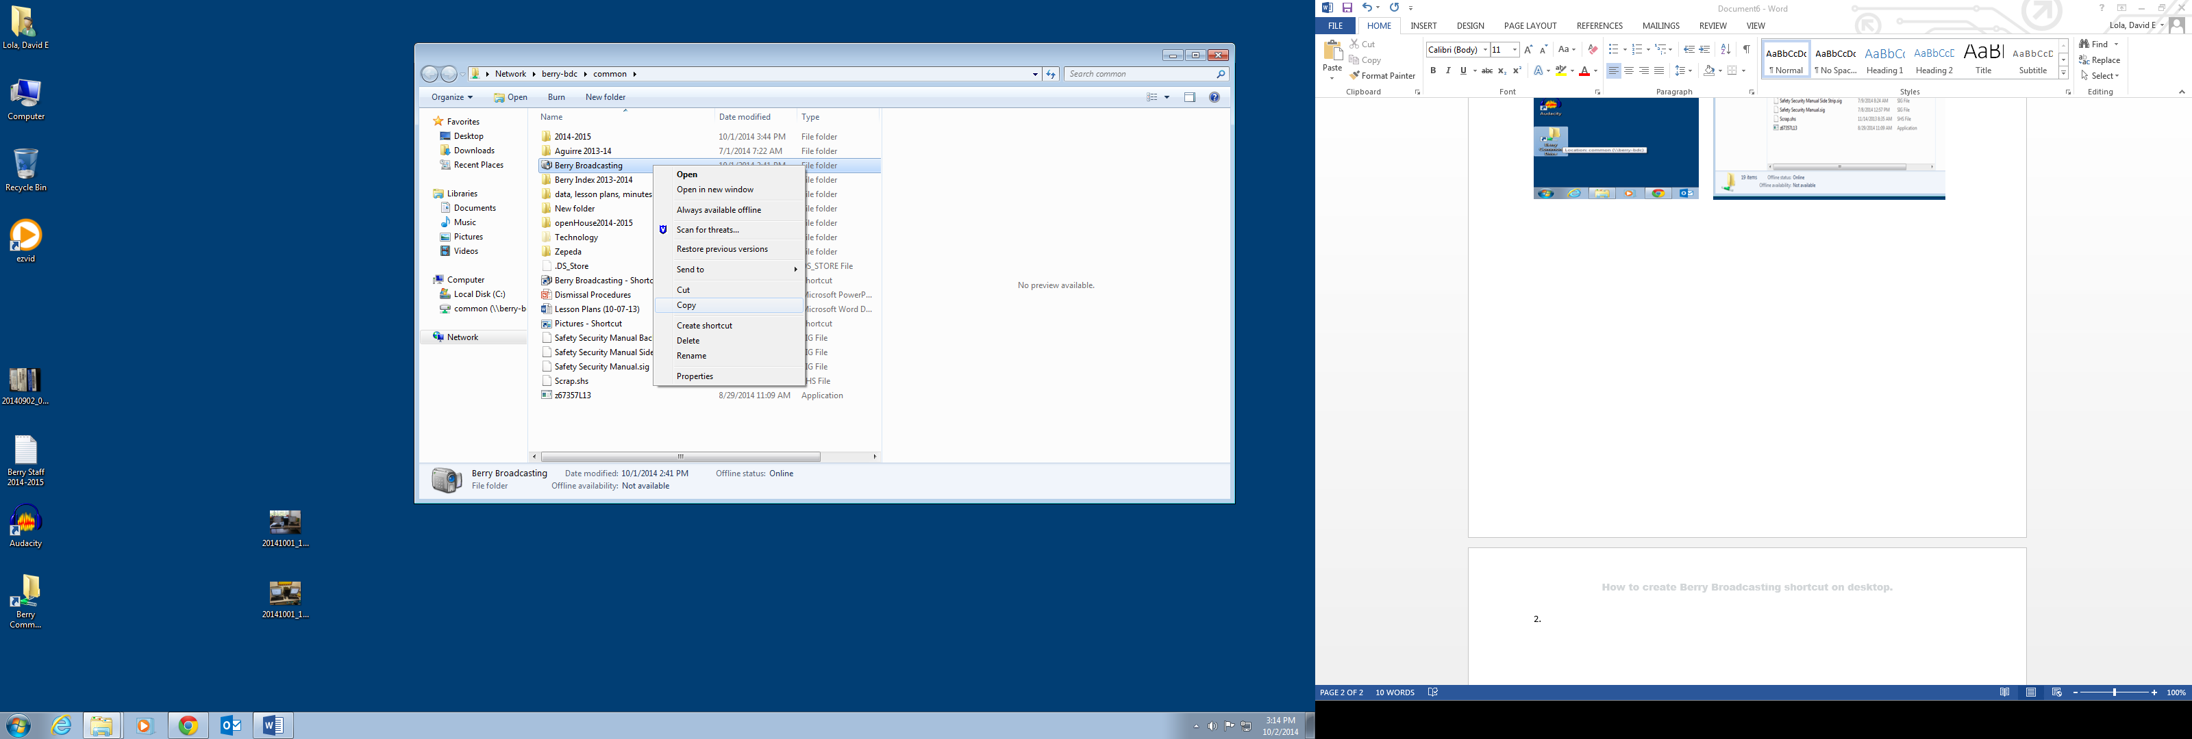

1. Now right click anywhere on your desktop and ***Paste***.

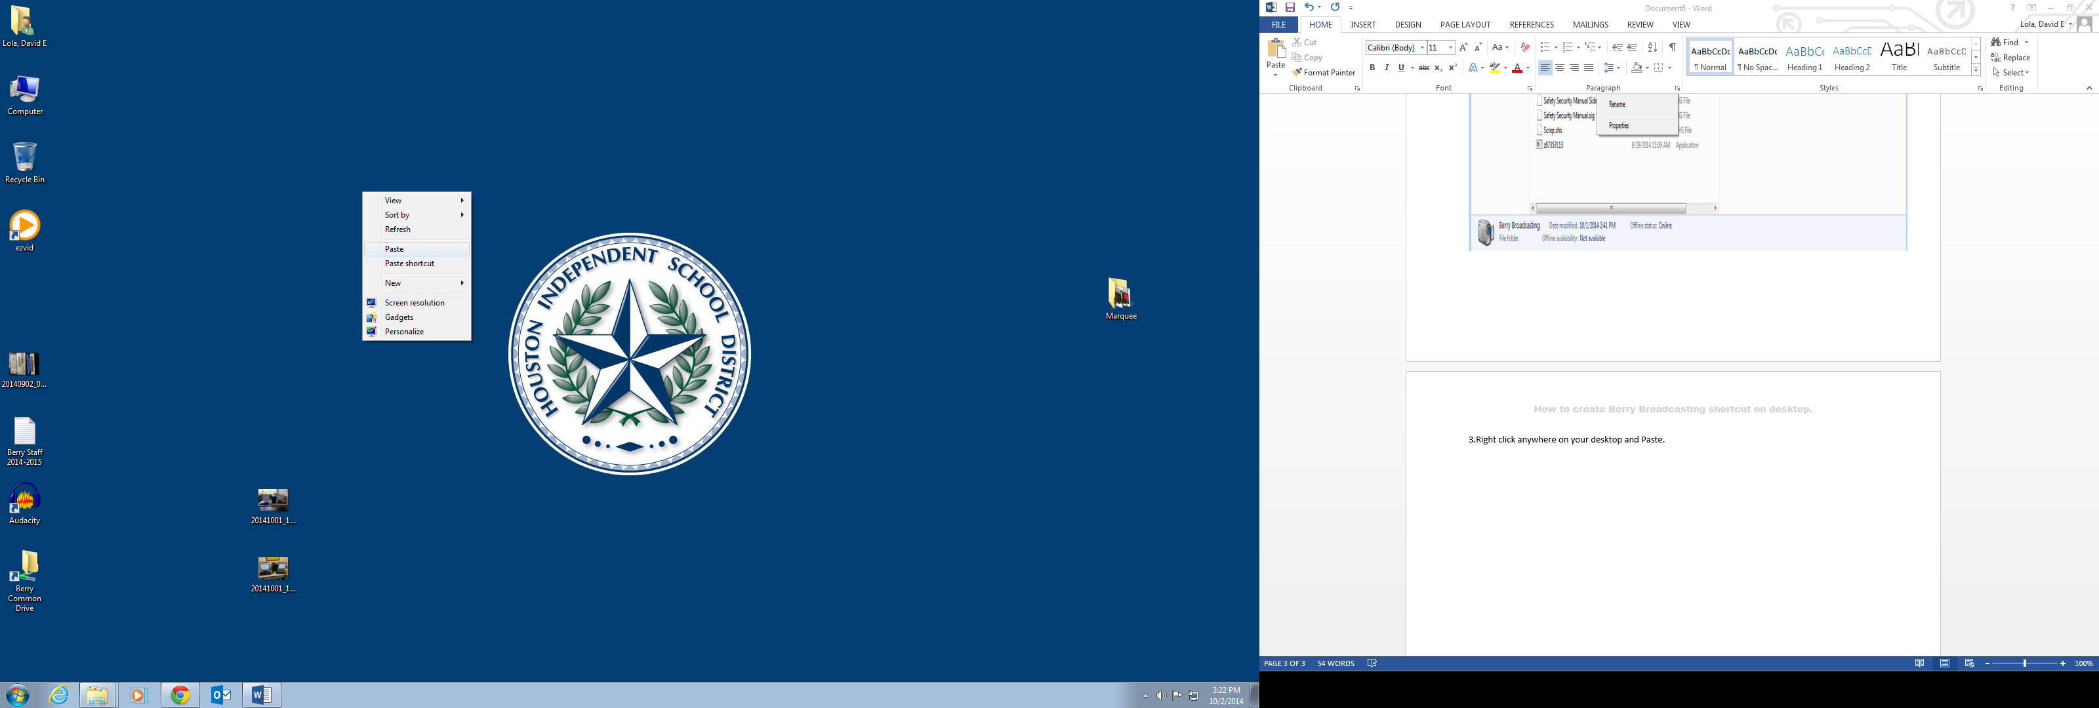

1. After pasting you will now see the ***Berry Broadcasting*** shortcut on your desktop. **Congratulations!!!!!** **You did it!!!**

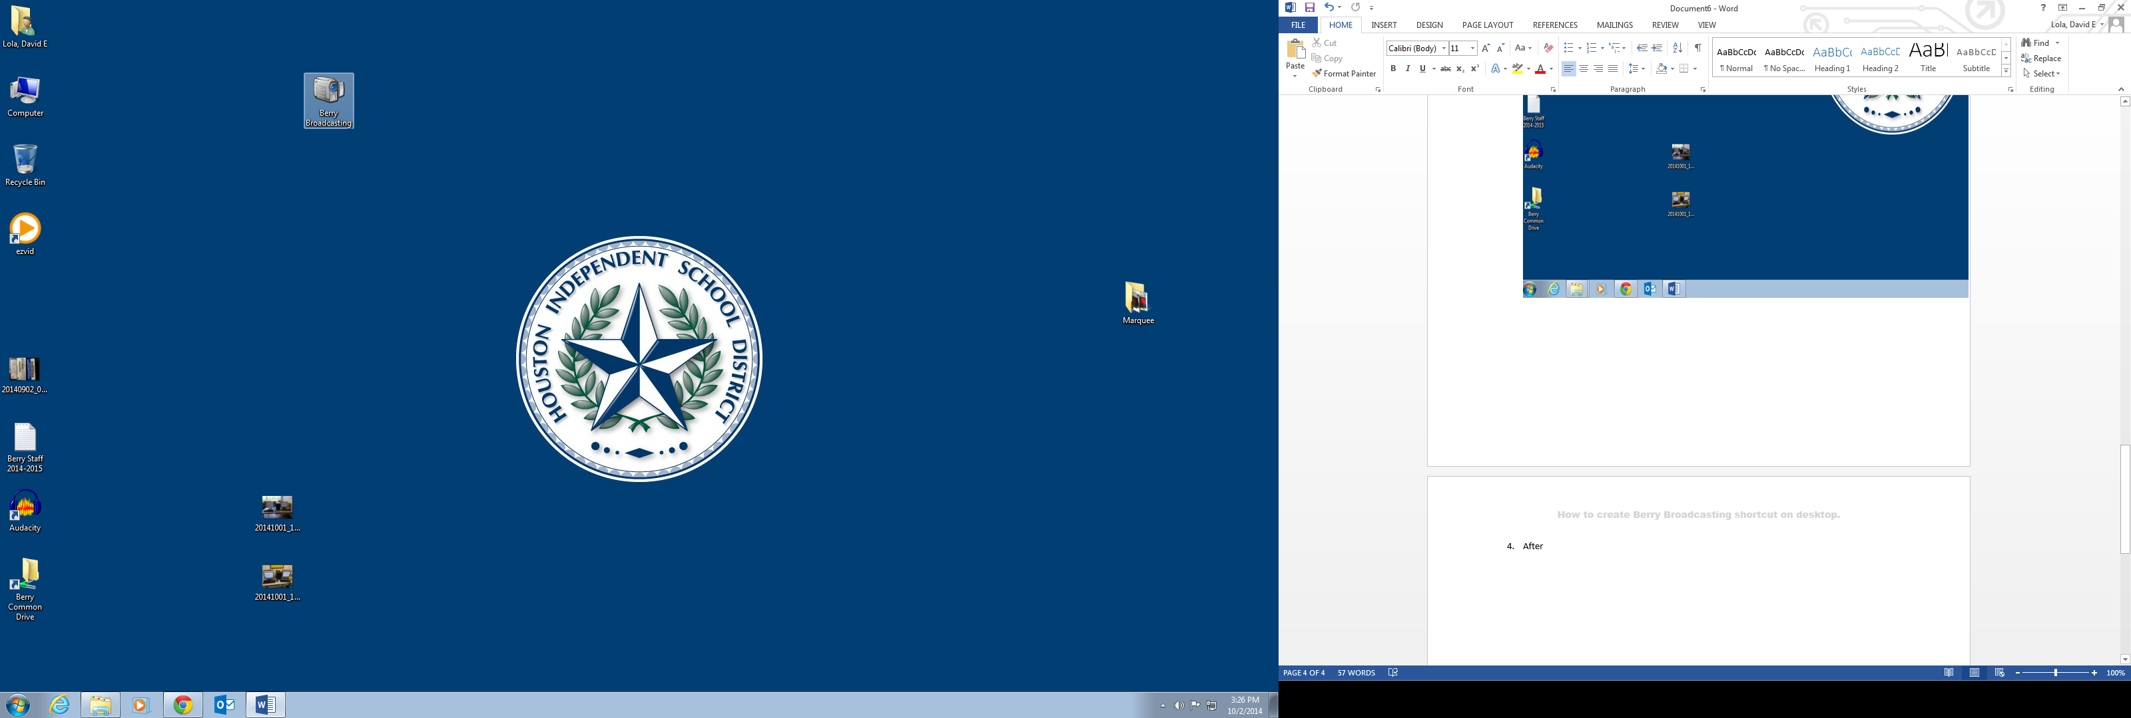

Video Instructions Available @ >>>> <https://www.screenr.com/weGN>