Isaacs Elementary
Pre-K Lewis Choice Board May 18-22
Reading  Here Comes Spring  - Introduce Spring and talk about the changes in the environment during this season  - Read a book about Spring  - Explain how this is the season of changes for the weather, plants, and animals  - Make a bubble map and write vocabulary words related to Spring in each bubble (example:  flowers, insects, warm, sunny, etc.)  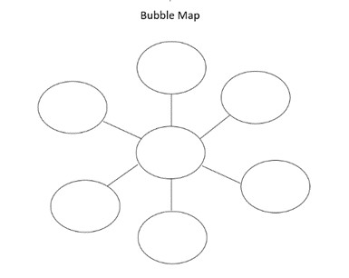  Bubble Map created by Curriculum Department HISD with Microsoft Word | Math  Spring Counting Song  - Introduce poems and chants about Spring  - Use manipulatives or toys to count up to 5 while singing the songs  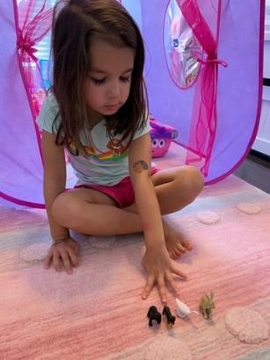  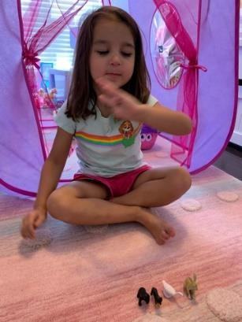  Pictures spring song activity with permission from Ms. Coronado taken with iPhone  Counting Songs use can use:  - Flower Counting: https://www.youtube.com/watch?v=HsfJ95BHeWY  - 5 Little Speckled Frogs: https://www.youtube.com/watch?v=6wM0AIb3BTE https://www.youtube.com/watch?v=ziGG_L9C12o  - 5 Little Ducks: https://www.youtube.com/watch?v=pZw9veQ76fo  Imagine Math for 20 minutes | Science  Life Cycle of a Plant  - Introduce the life cycle of a plant  - Read a book about the life cycle of a plant  - Draw the life cycle of a plant on a paper (seed, roots, stem, leaves, flower)  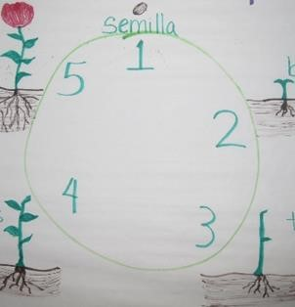  Life cycle of a plant anchor chart created by Ms. Castruita with her permission, taken with Nikon  Upload to Seesaw
Reading  Plant a Seed  - Have your child plant a seed (bean, flower) in a container or Ziplock bag  - Have a journal to record their observations each day  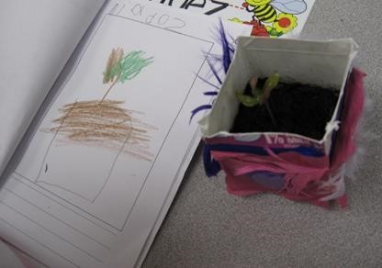  Plant journal picture created by Ms. Castruita with her permission, taken with Nikon  Literacy Resources  - journal/composition notebook/paper stapled together  - crayons  - pencil  - beans  - container/Ziplock bag for the plant  - soil from the backyard or wet napkin  Reading  Flower Child  - Use a picture of your child to create a flower with construction paper and crayons  - Label the parts of the plant (root, stem, leaf, flower)  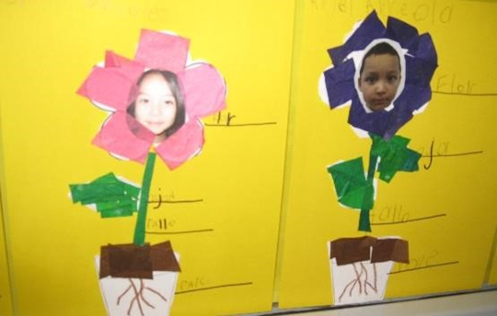  Picture of a flower craft with media release forms and permission from Ms. Castruita taken with Nikon  - Upload to Seesaw | Math  Counting Flowers  - Play a Math game  - Roll a die or make dot cards to count and put the same number of flowers on a strainer  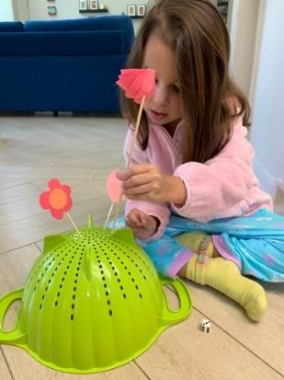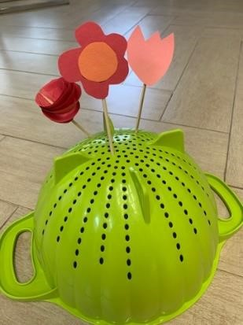Pictures of counting flowers with permission from Ms. Coronado taken with iPhone  Questions for children:  1. How do you know the total number of flowers?  Math Resources  - die/dot cards  - strainer  plastic or real flowers/sticks or pipe cleaner  Math  5 Little Speckled Frogs  - Draw 5 pictures of a lily pad with a number from 1 to 5  - Draw 5 pictures of a frog with 1 to 5 spots  - Play a game matching the lily pad to the frog with the same number of spots  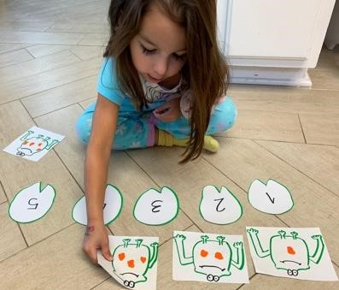  Picture of frog activity with permission from Ms. Coronado with iPhone  Questions for children:  - What strategy did you use to figure out how many spots were on the frogs?  - How many more to complete five frogs?  - How many frogs are left in the lily pad?  Imagine Math for 20 minutes  - Upload 5 Little Speckled Frogs Activity to Seesaw | S. Studies  Friends  - Discuss with your child what makes a friend  - Discuss how to be kind to your friends  - Read a book about friends  - Have your draw a picture of them being a good friend  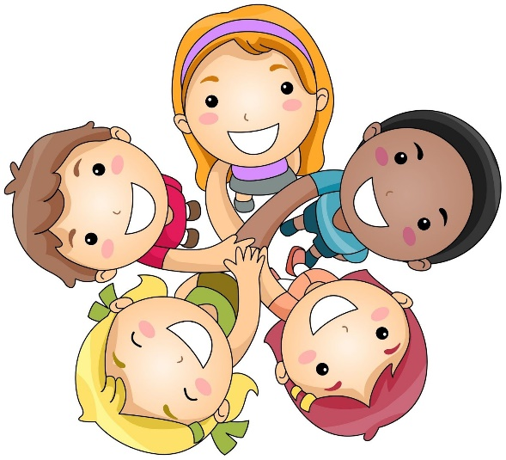  - Upload to Seesaw  SEL  Breathing Strategies  - Explain to your child that they can use breathing techniques when they are feeling upset  - Practice the S.T.A.R breathing (Stop, Take a deep breath And Relax)  - Another strategy to practice is balloon breathing  - Practice breathing and pushing all the air down and fill up the balloon so that their belly puffs out  - You can put their hand on their belly so that they can feel it fill up with air as they inhale  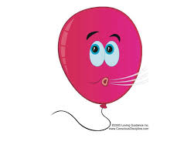
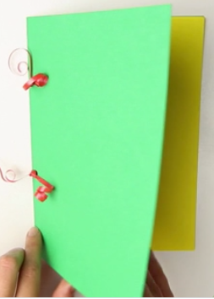
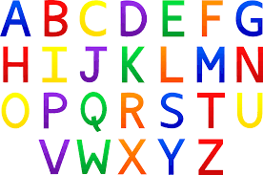
Weekly Project (ABC Journal)

Monday- We will continue our ABC Journals from last week. Have your child to think of things that begin with the letter “P”, they can also find items around your home that begin with the letter. They should then write the letter at the top of the first page in their journal and draw and practice sounding out and labeling the items that they drew that begin with the Letter P.

Tuesday- Have your child to think of things that begin with the letter “Q”, they can also find items around your home that begin with the letter. They should then write the letter at the top of the first page in their journal and draw and practice sounding out and labeling the items that they drew that begin with the Letter Q.

Wednesday- Have your child to think of things that begin with the letter “R”, they can also find items around your home that begin with the letter. They should then write the letter at the top of the first page in their journal and draw and practice sounding out and labeling the items that they drew that begin with the Letter R.

Thursday- Have your child to think of things that begin with the letter “S”, they can also find items around your home that begin with the letter. They should then write the letter at the top of the first page in their journal and draw and practice sounding out and labeling the items that they drew that begin with the Letter S.

Friday- Review letters P, Q, R, and S in the journal. Discuss what things you were able to find that begins with the letters, review the pictures and the sounds each letter makes.

You should be uploading the letters of the week to Seesaw when complete.

