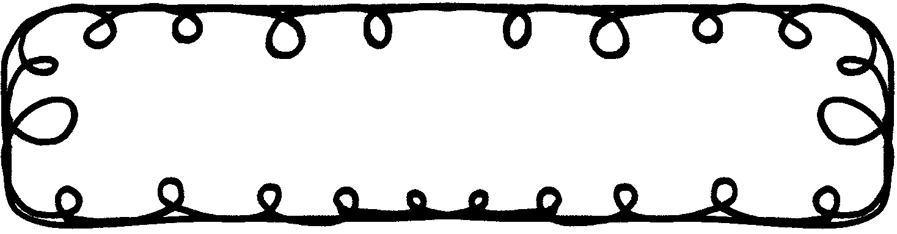

First Grade Gazette September 16, 2019

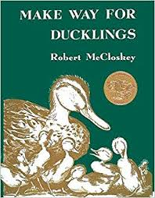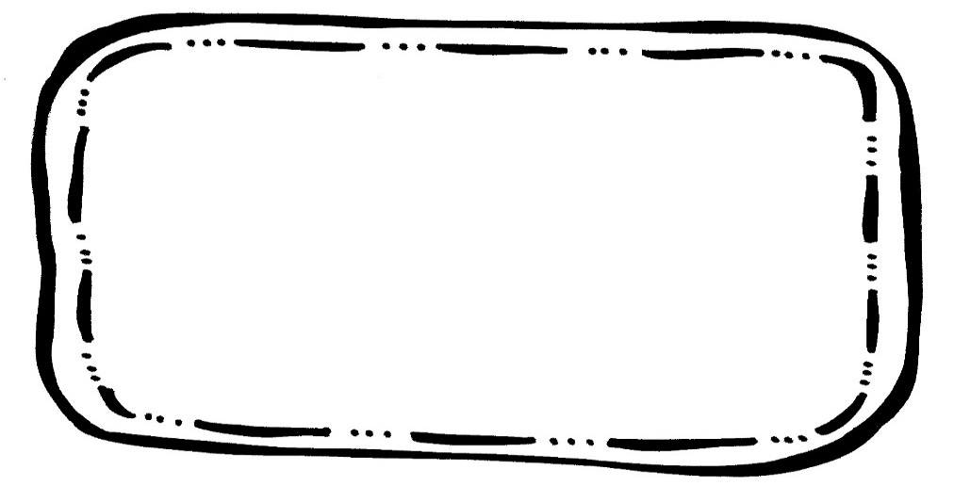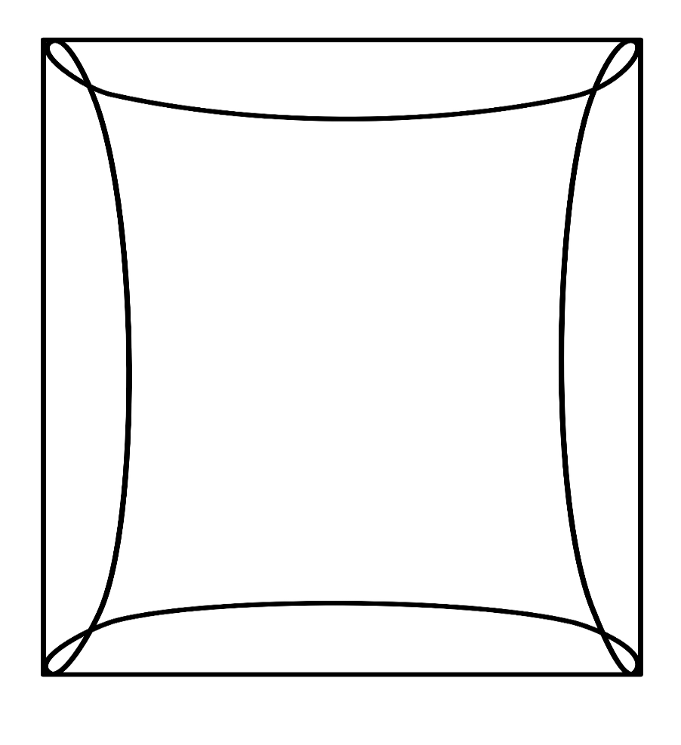

Writing

We will learn about verbs. We will also work on writing stories.

Science

We will learn about how objects move and motion.

Math

We will finish up Unit 1 on Place Value Review.

Spelling**Tested 9/13

cat fat rat fan pan

one will some into out

**That fat cat is sad. **

**Reading Comprehension**

* Describing Characters

**Vocabulary Words**

Island – an area of land that is surrounded by water on all sides

Wade – to walk slowly through water

Mallard – a common wild duck; the male has a shiny dark green head and neck

Dither – a state of excitement or nervousness

Hatch – to come out of an egg; to be born from an egg

**Upcoming Events**

**September**

23 – Grandparent’s Lunch

27 – Early Dismissal (No Extended Day)

30 – 10/4 – Book Fair