***EMBARGOED: Information embargoed until 10:45 a.m. on Thursday, Feb. 18***

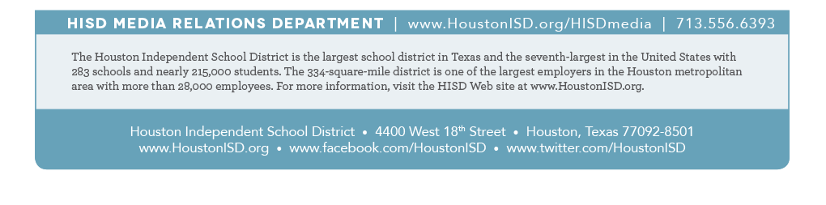**HISD to announce district principals of the year on Thursday during surprise campus visits**

|  |  |
| --- | --- |
| **What:** | The Houston Independent School District will surprise two HISD campus administrators with news that they have been named the district’s elementary and secondary principals of the year.  ***EMBARGOED: This is a surprise presentation. The release of information about winners is embargoed until after each surprise announcement has been made.***   * Bush Elementary School Principal Theresa Rose will be named HISD’s Elementary Principal of the Year. * Lanier Middle School Principal Felicia Adams will be named as HISD’s Secondary Principal of the Year.   Note: Media interested in attending the surprise announcements should arrive at the school at least 10 minutes prior to the scheduled time. If you need more information, please contact HISD Media Relations at 713-556-6393. |
| **Who:** | HISD Interim Superintendent **Ken Huewitt**, HISD Chief Elementary Schools Officer **Sam Sarabia**, HISD Chief Secondary Schools Officer **Michael Cardona**, Bush Elementary School Principal **Theresa Rose**, and Lanier Middle School Principal **Felicia Adams**, as well as teachers and students from both Bush and Lanier |
| **When/Where:** | **Thursday, Feb. 18, 2016, at 9:30 a.m.**  Bush Elementary School, 13800 Westerloch Dr., 77077  **Thursday, Feb. 18, 2016, at 10:30 a.m.**  Lanier Middle School, 2600 Woodhead St., 77 |