

**HISD to standardize school start times for the 2018-19 school year**

*Jan. 10, 2018* – HISD will implement standardized school start times for the 2018-19 school year to better deliver efficient, reliable, and affordable transportation to our students.

Currently, HISD manages 67 different school start times – the highest in the state – as it transports nearly 36,000 students on almost 1,200 different routes each day. Beginning next fall, the district will operate with two standardized start/dismissal times:

* 7:30 a.m.-2:50 p.m. for elementary schools and K-8 campuses
* 8:30 a.m.-3:50 p.m. for all secondary campuses (middle school, high school, and grade 6-12 campuses)

*(Some specialty campuses may have alternate start/dismissal times that will be communicated directly from the campus.)*

HISD gathered parent and principal input on the new start times through surveys conducted in October, and the results support the new start times, which were listed as Option 4 in the surveys. Of the 154 respondents to a survey of principals, 78, or 51%, chose Option 4. Of 17,138 respondents to a survey of parents, 7,932, or 46%, chose Option 4.

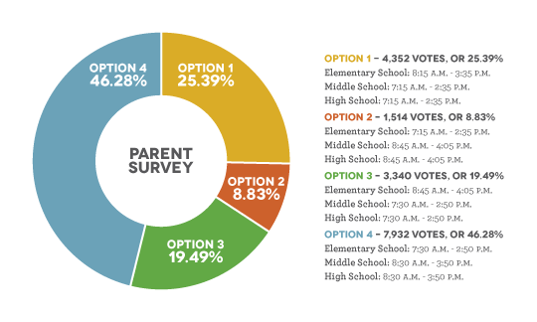

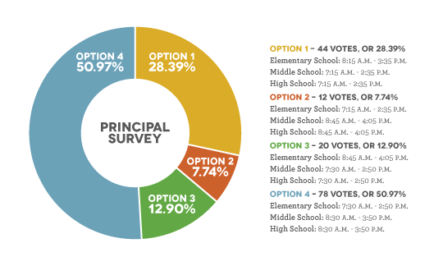

Standardizing school start times will bring efficiencies to the district’s bus routes and ensure that students arrive to campus and depart on time, resulting in fewer interruptions to teaching, learning, and family schedules. The new start times will also extend the life of the district’s bus fleet and reduce maintenance and fuel costs.