

SDMC Meeting Minutes
Quarter III
February 18, 2025

Roll Call (gain signatures of all present)
Begin and end on time
Silence cell phones
Make sure all voices are heard
If you wonder, ask.

Specific Agenda Items

The committee watched the video and the slide presentation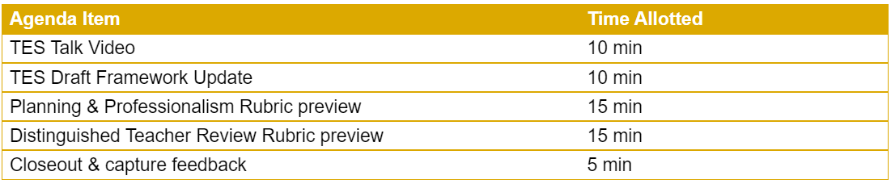
Principal Jacobs asked the committee members to write their questions for submission to the TES form.
Magnet Update
- Principal Jacobs Shared that the 1st Application Window Closed on February 12
- Principal Jacobs shared that approximately 550 applications had been received
The following Upcoming Events were shared
- Feb 21st- Senior Ranking
- Feb 21& 28 - TELPAS
- Feb 28th – Black History Month Program
- March 1^{st-} -Job Fair
- March 10-14th -Spring Break
- March 21st SAT- IN school 11th Grade

