Reading (fiction example)  Read/listen to a story of your choice and summarize it by telling what happened at the beginning, middle, and end. Draw a picture of each part and write one sentence below.  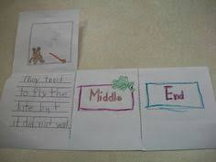 | Math  Count as you walk, skip, march, or go up the stairs.  Do one movement for each number.  Count from 1 to 30.  *Challenge: Sing/move as you “Count to 100 Everyday”; Let’s Get Fit with Jack Hartman on You Tube.  Parents: If you don’t have “you tube”, your child already knows this song. Ask them to sing it to you.  Record them singing and send to teacher. |  | Science  Draw and color a picture of a plant (find them outside or draw them from your memory). Then label each part of the plant.  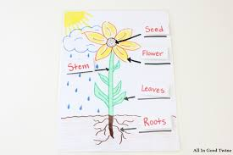  Send teacher a picture of student with flower or drawing.
Reading (non-fiction example)  Read/listen to a book about animals. Name animals from the book. Then, say the beginning letter sound for each animal’s name.  Next, tell your parent/guardian your favorite animal and draw it.  Record them telling you about their favorite animal and send to teacher. | Math  Write numbers 1-10 across the top or side of the page. Use small objects (beans, pasta, crackers, Legos) to count out the correct number of objects.  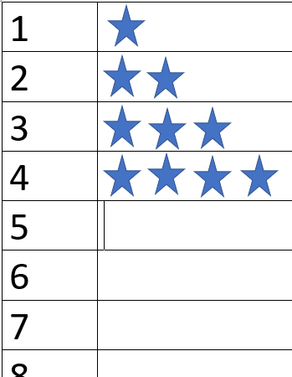 |  | SEL  Gratitude Walk  Take a walk outside or around your home with a parent/guardian. As you are walking, say 10 things you are grateful (thankful) for. You can take turns saying what you are grateful for with your parent/guardian. (Use your fingers to count to 10.)  Repeat this sentence for each thing:  I am grateful for _____________.
Reading (alphabet practice)  Go on a letter sound hunt! Find an object in your house for each letter in the alphabet. The object should match the letter sound. If you can’t find an object, draw a picture.  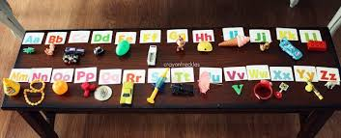 | Math  Make a t-chart.  Forks Spoons  (Tell/write how many) (Tell/write how many)  Count how many forks and spoons you have. Which pile has more? |  | Social Studies  Draw and label a map of your room.  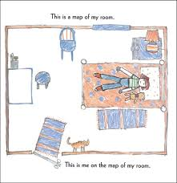
Weekly Project: “My Moment in History”
A journal of your experience during COVID-19
You are living during a historic time. Create a journal where you can write and draw about your experiences every day. To set up your journal, you can staple together several pieces of paper (or fold them in half together) or use a notebook/journal you have at home. Then decorate the outside with the title, your name, and pictures. You will create 4 entries for this week and a few more entries in the weeks to come. Every entry should have the date, a picture, and at least one sentence of what you did that day.  Day 1: Make your journal and color the cover page.  Days 2-5: Make an entry for the day, by drawing a picture and writing a sentence about it.  Options:  - Your favorite activity you did that day (inside game, outside play, school work, TV you watched)  - How you felt that day  - What you ate that day  - Anything else that was important for you that day.  ** Try to make each day’s entry different** |  | 