**Ray K. Daily Elementary School**

**12909 Briar Forest Dr. Houston, TX 77077**

**Cindy Tiet – Principal**

**CAMPUS PARENT AND FAMILY ENGAGEMENT POLICY 2021 – 2022**

If students are to be successful, families must be actively involved in students' education. Ray K. Daily Elementary School is committed to providing a quality education for all students. We actively expose our students to concepts that facilitate lifelong learning. Our parents are valued partners in this educational process. Parents play an extremely important role because they serve as the child's first teacher. It takes the home and school to assist the student in extending learning beyond the classroom and in improving classroom achievement. We need the support of all parents for our students to achieve academic excellence.

**Policy Involvement**

Throughout the school year, we invite and encourage parents of all children who participate in the Title I program to a series of meetings and family activities. Flexible meeting dates and times are set providing parents the opportunity to attend, with meetings being in-person or virtually using the Microsoft Teams application. These meetings and activities include Parent & Family Engagement Meetings, FACE, Parent, PTO Meetings, Open House, Meet the Teacher Night, Family Learning Nights (Literacy, Math, and STAAR), College & Career Events, Multicultural Celebrations, Parent-Teacher Conferences, and Grade Level Parent meetings. At these meetings, we discuss Title I information, upcoming school events, and the rights and benefits to parents of children involved. The principal gives parents an update on school test data, adequate yearly progress status, and facilitates a review of the school's improvement plan. Parents are invited and encouraged to participate in parent-teacher conferences throughout the year to discuss their child's progress. Teachers may conduct these conferences by phone or through the Microsoft Teams application.

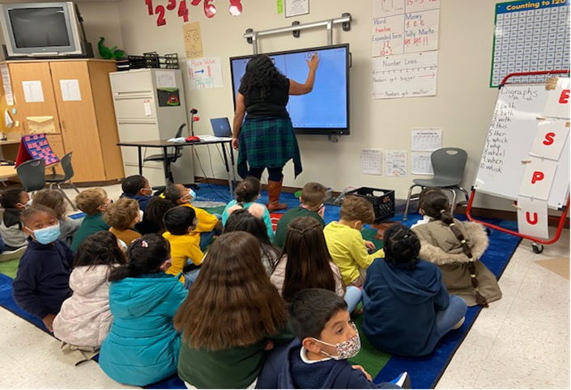

**Program Involvement**

At these meetings, we give parents timely information about our school programs, Title I pull-outs, Reading and Math Interventions, afterschool tutorials, testing calendars, and a variety of topics. We describe and explain curriculum and the Houston ISD curriculum, review our expectations for students, and explain how we measure student performance. The education of a student is not only the responsibility of the teacher, but also of the parent and the child. For this reason, a School-Parent-Student Compact has been developed and is utilized in our school. This document serves as an agreement between all parties that they will adhere to certain duties and responsibilities to ensure the success of the student. It is reviewed and signed by all at the beginning of each school year. These compacts are also used to motivate students and parents to become more involved in the educational process and to let parents know that they are equal partners in their child's learning.

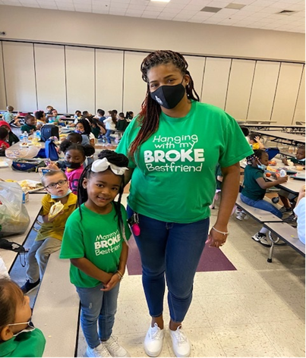

**Parent Training and Involvement**

Our school communicates with parents the state's curricular and assessment expectations, school wide requirements in relation to the delivery of instruction, the techniques utilized to evaluate student work, and individual classroom rituals and routines pertinent to the academic success of our students. We use a variety of communicative techniques such as Microsoft Teams application, The Hub, Wraparound Services, Power School Parent Portal, Classroom Newsletters, School Newsletters, Ray K. Daily Elementary School Website, ClassDojo, Classroom Websites, Parent-Teacher Conferences, Meetings for Special Populations, Houston ISD's FACE meetings, Parent University, PTO meetings, individual notes/calls home, Family Fun Nights, Surveys (paper and phone), parent workshops, Open House, Progress Reports, Report Cards, benchmark results, fluency scores, social media, campus marquee, etc. to encourage parent participation and deliver important information in hopes of creating productive dialogue between home and school concerning improved student achievement.

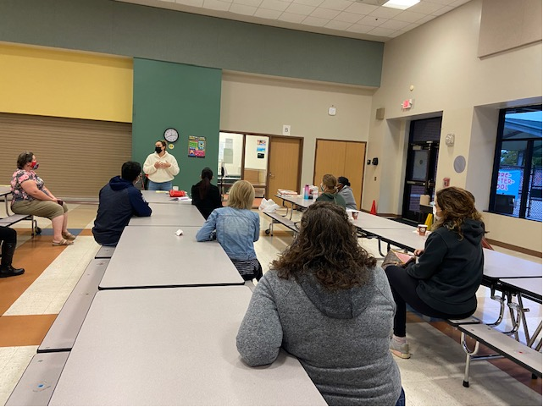

Ray K. Daily Elementary will implement these and other activities that will encourage parent involvement through the Title I Program. Staff will assist in carrying out these activities as well as participate in workshops and meetings. We will do this in a safe manner, following Covid guidelines.