Reading  Let’s Make up a Story  - Make an animal puppet with a sock or paper bag  - Draw eyes, nose, mouth, ears, and part of the upper body  - Use the puppet to tell a story about the zoo  Picture of two favorite animals with permission from Ms. Coronado taken with  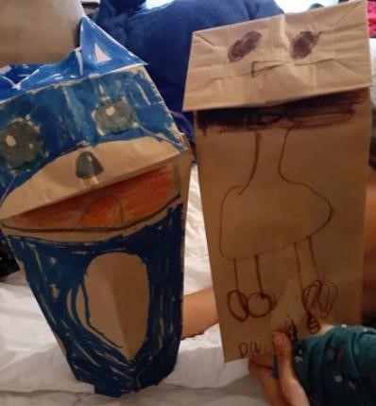  Ask:  1. Where is the story taking place?  2. Are there other characters in your story?  3. How does the story end?  Literacy Resources  - brown paper bag or sock  - crayons or markers Math Resources  - paper  - crayons  - scissors  Send your picture to your teacher. | Math  Comparing Carnivores and Herbivores  • Review: What is a carnivore? Animal that eats meat  • What is an herbivore? Animal that eats plants  • Make a T-chart  • List animals that are carnivores on one side and list herbivores on the other side  • Decide which list has more  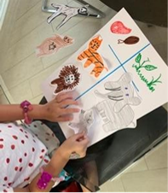  Ask:  1. What is the total number of carnivores on this list?  2. What is the total number of herbivores on this list?  3. How many more are in the longest list?  Picture of T-chart with animals with permission from Ms. Coronado taken with iPhone  *Challenge: Sing/move as you “Count to 100 Everyday”; Let’s Get Fit with Jack Hartman on You Tube.  Parents: If you don’t have “you tube”, your child already knows this song.  Send your picture to your teacher. |  | Math/Science  Sink or Float  - Gather 10 household objects  - Select two objects and drop them in the tub with water  - Ask your child “Which object sink and which object float?”  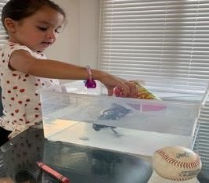  Picture of Sink or float activity with permission from Ms. Coronado with iPhone  Ask:  Questions for children:  - Which objects sink and which objects float?  - Do you think ____ will float or sink?
Literacy  Vowel or Consonant Sound Cup Game  - Using 3 cups, write a letter on each cup and set them up in a line  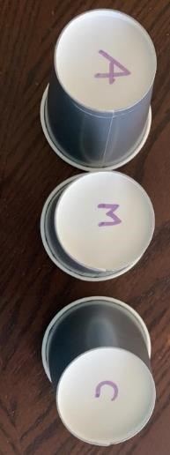  Picture of Sound Cup Game activity taken by HISD Curriculum Department with iPhone  - Take turns hiding the pom-pom under a cup and then switching the cups around like the old shell game  - Ask your child to guess under which cup the pom-pom could be  - Ask your child to say if this is a vowel or consonant sound  Picture of Sound Cup Game activity with permission from Ms. Azcarate with iPhone ginormous?  Ask:  1.Can you make the sound of this vowel___?  2.Can you make the sound of this consonant___?  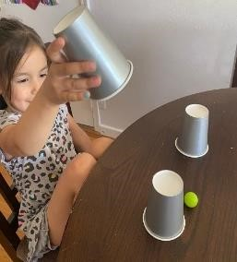  Resources:  •3 plastic cups  •marker  •pom-pom or cotton ball Math Resources  •10 household objects to test (e.g. cup, crayon, coin, egg, etc.)  • tub with water | Math/Science  Counting in the Jungle  - Draw a jungle on a piece of paper  - Draw 5 zoo animals that leave in the jungle (elephant, monkey, tiger, snake, and toucan) and cut them individually  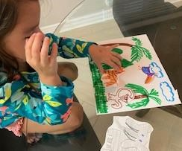  Create word problems using those animals (example: there is 1 elephant and 1 monkey in the jungle and 1 tiger comes by…how many do we have now?  Picture of jungle with permission from Ms. Coronado taken with iPhone  Ask:  How do you know the total number of animals in the jungle?  What happens if we have all 5 animals in the jungle and 2 leave? |  | SEL  Self - Awareness  Parent/guardian ask your child to name 5 things he/she is grateful  For.  Have your child use this sentence starter each for each thing they are grateful for…  I am grateful for______________.  Then have your child draw a picture of the one thing they are most grateful for.  .
Literacy Alphabet sound hop!  - Write between 5 to 10 letters on the sidewalk with chalk  - Ask your child to jump on each letter, shouting out the sound (e.g. the child jumps on the S and shouts “Sssss”) not the letter name  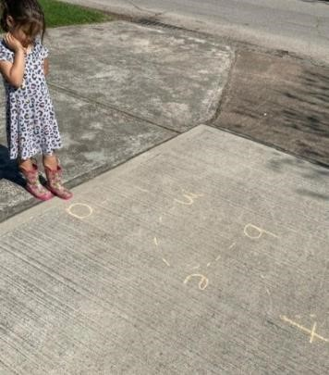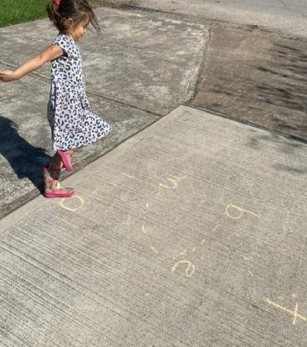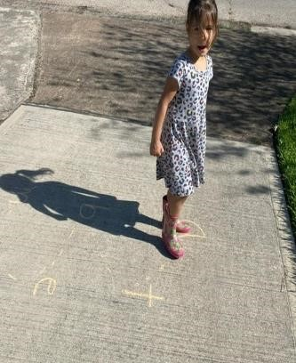  Picture of Alphabet Sounds activity with permission from Ms. Azcarate with iPhone  Ask:  Questions for children:  1.Can you tell me the sound of this vowel___?  2.Can you tell the sound of this consonant___? | Math  Sink or Float  - Gather 10 household objects  - Select two objects and drop them in the tub with water  - Ask your child “Which object sink and which object float?”  Picture of Sink or float activity with permission from Ms. Coronado with iPhone  Ask:  Questions for children:  Which objects sink and which objects float?  Do you think ____ will float or sink? |  | Math/Social Studies  Carnivores and Herbivores Animals  Parent /Guardian talk with your child about animals.  Show them a picture of an animal or a live animal outside.  Discuss the foods that animal eats.  (Carnivore animal that eats meat.)  (Herbivore animal that eats plants)  Have your child to draw and color the animal.  Ask:  What is the name of this animal?  Do you know what sound it makes?  Where does it live?  What does it eat?  Is it a carnivore or herbivore?  Example: A cow eats only plants.  A cow is a herbivore.  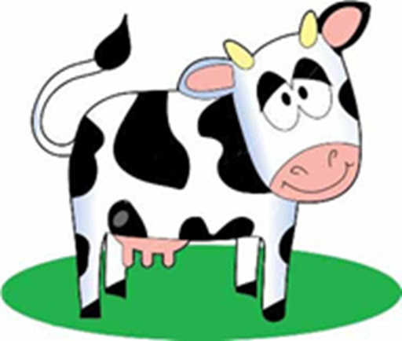
Weekly Project: “My Moment in History”  A journal of your experience during COVID-19 |  |  |  |  | Social Studies
PreK Parent/guardian,  *NOTE: Please remember, when asked to write, PreK students’ writing may look a bit like scribble. Allow child to draw/ write (scribble) their ideas in the journal. Then say, read your sentence to me. Next, you can rewrite their response under the sentence they wrote (scribbled).  . (New Idea: This week, write about your favorite activity you did that day (inside game, outside play, school work, TV you watched)  This week you will create 5 entries and a few more entries in the weeks to come. Every entry should have the date, a picture, and at least one sentence of what you did that day  Remember: Make an entry in your journal every day. * (Save your journal)  Days 1-5: Make an entry for the day by drawing a picture and writing a sentence about it.  Options:  - Your favorite activity you did that day (inside game, outside play, school work, TV you watched)  - How you felt that day  - What you ate that day  - Anything else that was important for you that day.  ** Try to make each day’s entry different** |  | 