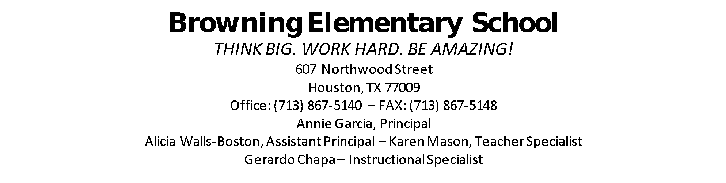
SDMC Agenda
2021-2022
Community of Builders and Learners!

- ESSR Funds
- Submit SAF
- SIP
- Budget for Afterschool

In Attendance:
Marissa Lopez Amaya Santo Toma
Jocelyn Moten Gerardo Chapa
Lauren Flegle Keitha McQueen
Karen Mason John Quinn
Annie Garcia Yvonne Cortina

