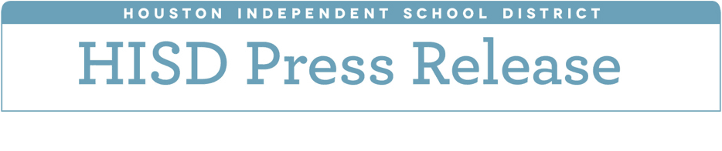

**HISD Board of Education approves**

**2018-2019 budget**

*June 25, 2018* – The Houston Independent School District Board of Education on Monday unanimously approved a $2 billion budget for the 2018-2019 school year.

The budget includes $17 million in increases for special education, dyslexia programs, and Achieve 180, the research-based program that will continue next school year to support underserved and underperforming schools. The budget also includes a performance review by the Texas Legislative Budget Board (LBB).

The board also voted to reduce the proposed performance review allotment from $2.5 million to $1 million, with the difference of $1.5 million being transferred immediately to the general fund reserve for operations. The total cost of the performance review to be conducted by the LBB has not yet been determined.  The LBB is expected to begin working on the performance review in fall 2018 so that findings may be used by the board in the decision-making process during the next budget cycle.

As other large school districts in Texas, HISD continues to face looming budget shortfalls in the coming years due to inadequate state funding and increasing recapture payments. HISD has been designated by the state as a property-wealthy school district under the state’s school finance system, despite the fact that almost 80 percent of students are considered low-income.

Recapture requires districts that exceed a certain per-student property wealth level to send local tax dollars to the state. The 2018-19 budget has a $272.5 million recapture payment budgeted.