**HISD to host college summit for historically black colleges, universities**

**What:** Hundreds of Houston Independent School District middle and high school students will have the opportunity to meet admissions representatives from regional historically black colleges and universities at the HISD College Summit for HBCUs.

                                Historically black colleges and universities (HBCUs) located in Texas and Louisiana will be represented, and general information will be provided on the more than 100 HBCUs across the country. Students in grades 6-12 along with their parents are invited to attend. The free event will include a college fair and breakout sessions focused on financial aid and college admissions.

                                Representatives will be in attendance from the following colleges and universities: Huston-Tillotson University, Jarvis Christian College, Prairie View A&M University, Southwestern Christian College, Texas College, Texas Southern University, and Wiley College.

                                The event is organized by the [HISD College Readiness Department](http://www.houstonisd.org/collegereadiness). Transportation will be provided from some campuses. This year, the district strengthened its college readiness efforts by deploying 28 new college success advisors and 10 college success managers to campuses across the district.

                                \****Media are invited to attend the event, where they can interview students and representatives from colleges.***

**Who:** HISD middle and high school students, HISD college readiness team, representatives from historically black colleges and universities

**When:                  Tuesday, May 10, 2016, 5:45 p.m.-8:30 p.m.**

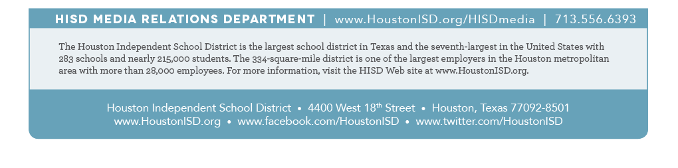**Where:** Texas Southern University, 3100 Cleburne St., 77004 (Free parking available for attendees in parking lot V1 located on Cleburne Street)