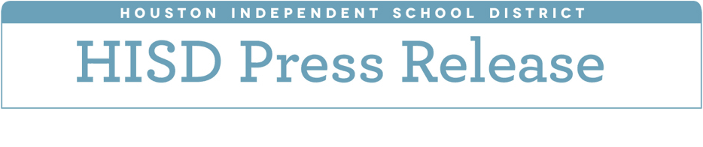

**HISD planning for possible November bond referendum to strengthen security across the district**

*May 10, 2018* – The Houston Independent School District is beginning to plan for a possible November bond referendum as part of a strategic capital plan designed to rebuild schools and strengthen security at campuses throughout the district.

Board of Education trustees were briefed at their May 10 meeting about the two options currently under consideration for the possible referendum. Both place a strong emphasis on safety and security.

“The safety and security of our students and staff is absolutely paramount, which is why we believe it should play a major role in any potential bond program going forward,” HISD Chief Operating Officer Brian Busby said. “Our students and teachers need and deserve safe, secure learning environments that allow them to thrive. Our goal is to provide that to them.”

Before beginning the planning process, HISD consulted with Rice & Gardner Consultants and PBK architects, which were tasked with reviewing facility needs and student growth data, as well as data related to planning for the district’s Capital Improvement Plan and future bond programs.

The two consulting groups also were tasked with placing a strong emphasis on safety and security, as well as energy and facility efficiency.

After reviewing their recommendations, HISD developed two options for a possible bond referendum.

The first option, which has a cost of $1.2 billion, focuses on replacing 18 schools, creating security vestibules at all campuses, upgrading building automation systems and district technology, and replacing school buses.

The second option, which has a cost of $1.7 billion, includes the above items, as well as two new relief schools, a new CTE high school for the southern portion of the district, a replacement district stadium and fieldhouse, a new professional development and training facility, and districtwide energy efficient lighting upgrades.

New relief schools would be strategically driven by student growth data, while facility repair and replacement would be driven by facility age and needs, number of temporary buildings on site, and cost of maintaining existing buildings.

The 18 schools slated for replacement are Bonham, Brookline, Burbank, Durkee, Elrod, Grissom, Kelso, Law, McNamara, Memorial, and Scroggins elementary schools, Cage Elementary School/Project Chrysalis Middle School, TH Rogers School, and Deady, Key, Henry, Lanier, and Revere middle schools.

As a next step, district administration plans to conduct site evaluations for all campuses and review demographic data to determine possible design and construction schedules. Trustees will be updated again later this summer.

“I’m a big believer that this type of work — building schools — is extremely important,” HISD 2012 Bond Oversight Committee member Phoebe Tudor said during a recent committee meeting. “The track record for [the 2012] bond program and what’s been accomplished is so great. I think that should give people confidence that HISD has the right team in place, and they know what they’re doing.”

More than 50 percent of projects in HISD’s voter-approved 2012 Bond Program are now finished and open to students, and that number is expected to jump to 80 percent by the end of this year. HISD has opened six new facilities and three new additions since January. Twelve more campuses are expected to open by the start of the 2018-2019 school year, and an additional six will follow in January 2019.

Follow @Build_HISD on Twitter for the latest updates on HISD bond and building programs.