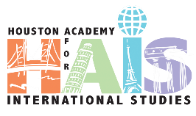

**SDMC Meeting**

**Quarter IV**

**May 23, 2022**

Roll Call: Alderete, E; Jacobs, M.; Sherman, J.; Devaney, E; Baltz, S; Khan, J.;

**Norms** Begin and end on time

Make sure all voices are heard

If you wonder, ask.

**Specific Agenda Items**

**Magnet Update**

* Current numbers: 156 incoming students
* Phoenix Camp: June 13-23, 2022 (Monday-Thursday), 8-1pm

**Budget**

* Continue PUA with Required Positions

**Programming and Scheduling**

* 77 HCC Graduates this year
* HCC Celebration went well.

**Professional Development**

* + August PD- Survey for input proposed
    - Reviewed the responses received thus far

**Attendance Updates:** n./a

**Student Handbook**

* Volunteers to review and revise
* Suggestions

**SDMC Nominations and Elections**

Nominations being collected through 5.24.22. Voting will take place after nominations are confirmed.

**Upcoming:**

Blood Drive - May 31st

Teacher Last Day of School - June 8th

Graduation- Barnett Fieldhouse June 12 @7 PM

Summer School June 13- July 7th

Phoenix Camp- June 13-23