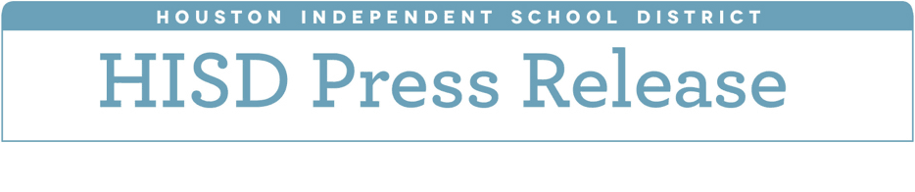

**HISD Board of Education approves to move forward**

**with performance review**

*June 14, 2018* – The Houston Independent School District Board of Education on Thursday voted in favor of requesting a performance review to be conducted by the Texas Legislative Budget Board (LBB).

After considering public input since the May regular board meeting, trustees voted six to three to request a performance review from the LBB and concurrently withdraw their previous approval to procure an external performance audit. The LBB will begin working on the performance review this fall. Its findings will be used by the board in time to make informed decisions during the next budget cycle.

The Board also voted by a five-vote majority against the proposed 2018-19 school year budget. State law requires the budget be approved by June 30.

Charter school negotiation contracts for the next school year were also approved. Trustees voted six-to-two to approve negotiation of contract renewals with Energized for Excellence, Energized for STEM and Inspired for Excellence academies, and eight-to-one to approve negotiation of contract renewals with Mount Carmel Academy, Texas Connections Academy, Texas Southern University Charter School, Young Learners Charter School (multiple campuses), and Young Scholars Academy for Excellence.

Trustees also voted unanimously to establish a districtwide student holiday and day of community service on March 31 or the Monday that precedes it in honor of César Chávez and Dolores Huerta, two major historical icons and symbols of empowerment for the Latino community. The holiday will be celebrated for the first time during the 2019-2020 school year.

During the final regular meeting of the 2017-2018 school year, trustees were also presented with preliminary results of the STAAR EOC exams. Key findings of the results show the proportion of first-time tested students who performed at or above the Approaches Grade Level Standard increased in four of the five subjects (Algebra I, Biology, English I, and English II) and remained steady in U.S. History. The district’s increases exceed those of the state in Algebra I and English II.

The results also show that the percentages of first-time testers at or above the Meets Grade Level Standard and the Masters Grade Level Standard increased in Algebra I, English II, and U.S. History when compared to the 2017 results. The percentage of students at the Masters Grade Level Standard increased in Biology, and the percentage of students at or above the Meets Grade Level Standard increased in English I.

The spring administration of the 2018 STAAR grades 3-8 results indicate the district showed increases in the percentage of students meeting the Approaches Grade Level standard for all grade levels in reading, math, science, and social studies.  The district’s increases exceeded those of the state in reading and math.

The board also approved the 2018-19 Code of Student Conduct, which features several changes, in accordance with David’s Law, that include updates to definitions of bullying and cyber-bullying, additional provisions to Level V offenses that permit expulsion or placement of students in a disciplinary alternative education program (DAEP) who engage in more serious bullying behavior, and updates to procedures for reporting and investigating bullying and harassment. David’s Law also mandates that Texas public schools have the authority to address cyberbullying that occurs off-campus and provides for requirements for reporting instances of bullying, including anonymous reports.

In addition, the Code includes notice to parents and students that HISD is prohibited from inquiring about the immigration status of students or parents enrolling their children in HISD or attending HISD schools. HISD does not produce or maintain records or any information with respect to immigration status and if requested is unable to provide information to any other governmental entity related to parents’ or childrens’ immigration status.